**Andreas Bäckman close to a medal in FIA Motorsport Games**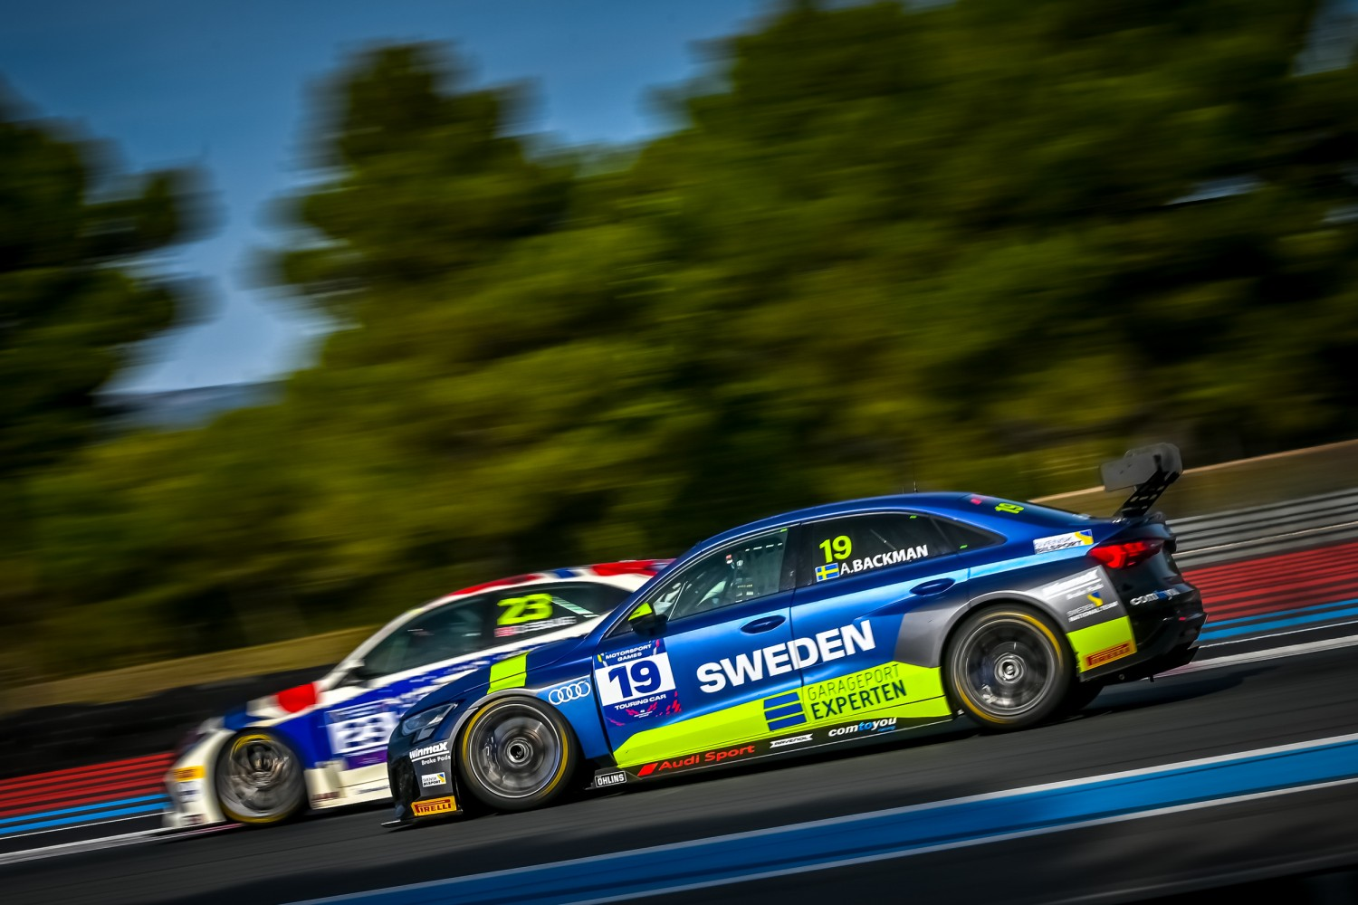Andreas Bäckman (car number 19) represented Sweden in the Touring Car (TCR)-category in the FIA Motorsport Games.  
Photo: FIA Motorsport Games (Free rights to use the images)

**Last weekend, October 28th-30th, FIA Motorsport Games was held in France. Andreas Bäckman was representing Sweden and was fighting for the medals, but unfortunately a technical problem in the Qualifying Race took away the hopes of a medal.  
– Disappointed as it would have been a good starting position for the Main Race to fight for the gold medal, but that is racing sometimes, Andreas Bäckman says.**

Last weekend, October 28th–30th, it was time for the second edition of the “Olympics of Motorsport” FIA Motorsport Games at the top facilities at Circuit Paul Ricard in France, and Sweden National Team driver Andreas Bäckman was on the starting line, representing Sweden in the Touring Car (TCR)-category. Andreas was competing for the Belgian team Comtoyou Racing in an Audi RS 3 LMS TCR-car in the prestigious event.

The Circuit Paul Ricard-track is located in Le Castellet, Var, France near Marseille. Since opening in 1970, the track has hosted the French Formula One Grand Prix 17 times, and the track has also hosted many other national and international racing series.

**Strong races without rewards**The Opening Ceremonies was held already on Wednesday evening next to the museum in central Marseille, where Andreas was representing Sweden together with seven other Swedish drivers that was competing in other disciplines in the event.

On Friday afternoon, the event started with the first free practice session, then the second free practice was held on Saturday, followed by the timed Qualifying on Saturday afternoon.

Andreas qualified in 4th position in the Qualifying which meant fourth starting position for the Qualifying Race on Sunday. The Qualifying Race decides the starting positions for the following Main Race, where the gold-, silver- and bronze medals are given to the top three positioned drivers.

In the Qualifying Race, Andreas had a strong second half of the race and was fighting for third position with three laps to go, when a technical problem occurred with the car, and he had to retire from the race.

This meant that the opportunities for a medal disappeared as he had to start from the back in the Main Race.

- It was disappointing to having to retire from the race with an unforeseen problem, but unfortunately that is racing sometimes. It would have been perfect with a third starting position for the Main Race to be able to fight for the medals, **Andreas Bäckman** says.  
  
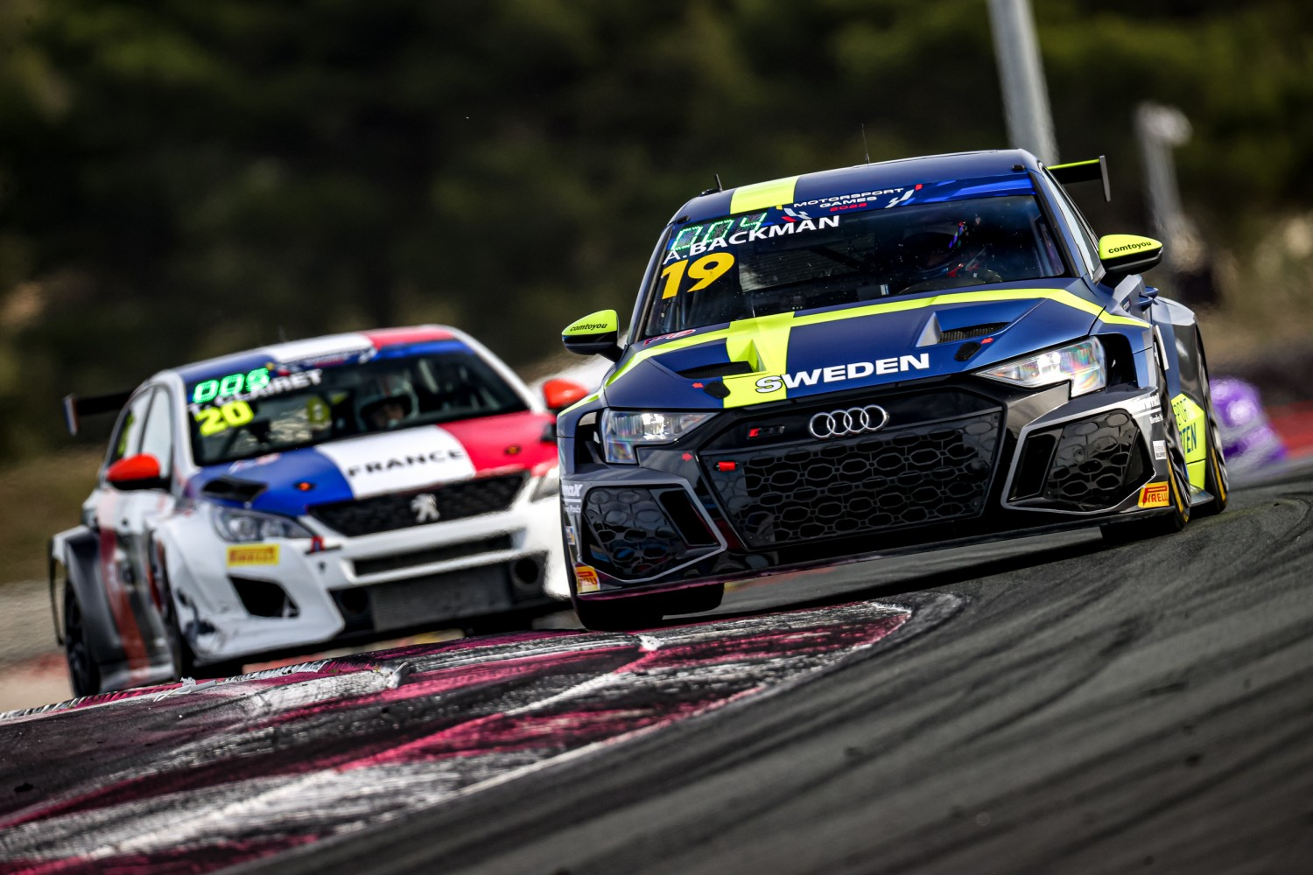Andreas Bäckman (car number 19) drove up from the last starting position to a sixth place in the Main Race.  
Photo: FIA Motorsport Games (Free rights to use the images)  
  
For the Main Race, the car was repaired, and Andreas started from the back, and had a strong drive up through the grid up to a final 6th position.

- It was nice to be able to finish of the weekend with a good race. The speed was very good, and I had the same speed as the winning driver. With that in mind, maybe the opportunities would have been there to fight for the gold medal. But I’m happy with my weekend and big thanks to team Comtoyou Racing, The Swedish Automobile Sports Federation, and the Swedish National Team for this fantastic opportunity I was given to represent Sweden, **Andreas Bäckman** says.

**Andreas’ results:**  
Free Practice 1: 8th place  
Free Practice 2: 8th place  
Qualifying: 4th place  
Qualifying Race: DNF (Retired)  
Main Race: 6th place  
  
  
**Did you miss last weekend’s FIA Motorsport Games-event? See the live-stream replays below:**  
[Click here](https://youtu.be/XeyDNEQCmQg) to see the Qualifying  
[Click here](https://youtu.be/iEe7mAg8ri8) to see the Qualifying Race  
[Click here](https://youtu.be/PVArmCWkMCA) to see the Main Race

***Free rights to use the images.***

***Download press-photos here:***[***http://bit.ly/jabaeckman-photos***](http://bit.ly/jabaeckman-photos)[***https://www.mynewsdesk.com/se/ja-backman/images***](https://www.mynewsdesk.com/se/ja-backman/images)

