Press Release: 06/06/2012
Easyart’s New Urban Art Collection
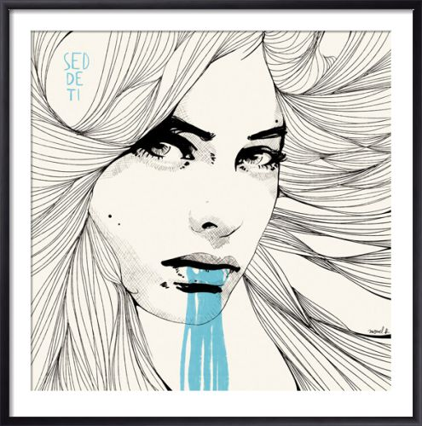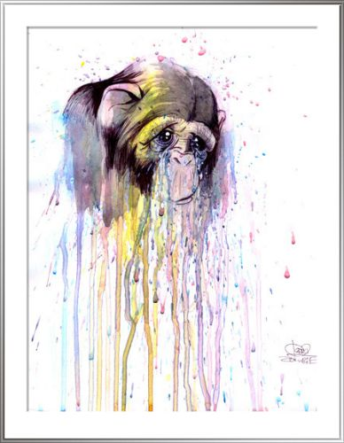
“Seddeti,” by Manuel Rebollo, from £8.94 (L). “Monkey 4,” Lora Zombie, from £11.26 (R)
Urban Art has been increasingly popular in recent years thanks to the works of artists like Banksy, and all signs show that this trend is heading higher and higher still. Recently, urban artists were shown on an episode of BBC’s Apprentice, which drove demand for these edgy works to an even larger level with more mainstream appeal.
Easyart is pleased to have an extensive Urban Art collection on the site, including new works from artists such as Benjamin Buckley, whose works are exclusively found on Easyart. Buckley’s works play off of eastern and western themes, blending them in to fantasy urban scenes.
The site is also home to the Eyes on Walls collective, a group of young, urban artists quickly catching the attention of galleries and interior designers with their imaginative, trendy imagery. Manuel Rebollo’s chic interpretations of fashion illustration have been particularly well-received; as have Lora Zombie’s mix of bright colours and dark themes.
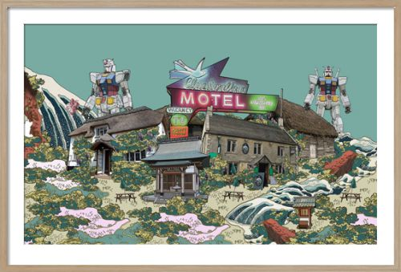
“Refridgerated Air”
Benjamin Buckley
From 30x48cm
From £33.62

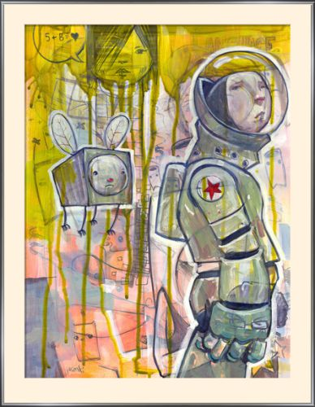
“You Always Walk Away”
Aaron Jasinski
From 39x30cm
From £11.26

Easyart.com is the simple and enjoyable way to shop the UK's best range of art prints and posters online. Founded in 1999, the site has a range of over 100,000 images covering well known artists like Picasso and Warhol and themes like photography, landscape, figurative and vintage art. Visitors can find the perfect pictures for their home or workplace and customise using sizing, framing and canvas options.
The company has worked with 1000s of interior designers, is a proud member of the BIDA and has an official partnership with the National Gallery.

