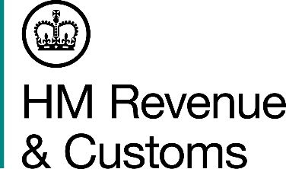
News Release

 | For the attention of News Desks |  | No of pages: 2
 | Date: | 10/12/2015 | Ref: | NAT 58

Return your Self Assessment and find your inner peace

The deadline for 2014-15 Self Assessment filing is fast approaching and HMRC is urging all customers to find their inner peace by returning theirs before the 31 January.

More than 85% of customers chose to submit their return online last year, the service is quick, easy and has a wide range of support resources available, such as web chat.

If you’re filing online for the first time, you will need to register for an activation code, which will be posted to you. This can take a few days, so you’ll need to allow time for this.

But remember – you have to file and pay any tax owed by the 31 January to avoid paying a penalty or interest on any tax paid late.

This year we are giving more than one million Self Assessment customers access to their own Digital Tax Account for the first time. This is an online service personal to each individual customer, allowing them see how their tax is calculated, update personal details and access all their tax information in one space, just like online banking.

Ruth Owen, Director General, Personal Tax, HMRC said:

“The 31 January deadline will soon be here. And while it’s tempting to put completion of your tax return to the bottom of the ‘to do’ list at this time of year, it’s not something I would recommend, if you want to avoid a last minute rush in January.

“We have improved our online services again this year to help our customers get their tax right quickly, simply and securely.”

Notes for Editors
- The deadline for Self Assessment returns is the 31 January.
- If you are filing your 2014/15 Self Assessment return online for the first time, you will need to register for SA Online. Registering for online filing is simple – visit the GOV.UK website at www.gov.uk/register-for-self-assessment.
- Help is available from the GOV.UK website at www.gov.uk/self-assessment-tax-returns or from the Self Assessment helpline on 0300 200 3310.
- Always type in the full online address (www.hmrc.gov.uk) to obtain the correct link to file your SA return online securely and free of charge.
- Follow HMRC on Twitter @HMRCgovuk
- HMRC's flickr channel www.flickr.com/hmrcgovuk

Issued by HM Revenue & Customs Press Office
Press enquiries only please contact:

Patrick O’Brien
Tel: 03000 585 024
Email: patrick.o’brien@hmrc.gsi.gov.uk

Rachel Williams
Tel: 03000 585020
Email: rachel.williams1@hmrc.gsi.gov.uk

Out of hours
Tel: 07860 359544

Website www.gov.uk/hmrc

