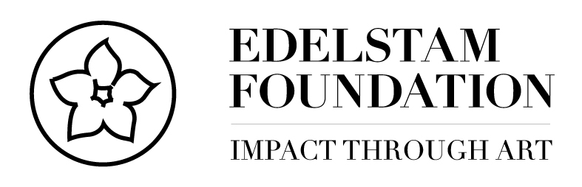

PRESS RELEASE Santiago den Chile, 03/14/2018

Inauguration of the Exhibition “Human Rights, Civic Courage, and Heroes” at Museo de la Memoria, Chile

During an inauguration ceremony on Monday, the 12th of March, at the Museo de la Memoria y los Derechos Humanos, the Edelstam Foundation presented its exhibition “Human Rights, Civic Courage, and Heroes,” which portrays each article in the United Nations Universal Declaration of Human Rights together with a hero relevant for each article, and the exhibition is staged on symbolic sites around the world. The exhibition pays tribute to the 70th Anniversary of the United Nations’ Universal Declaration of Human rights.

The exhibition is painted by the Swedish artist, Mr. Carl Adam Cronstedt, and produced in collaboration with the Edelstam Foundation. The exhibition will be presented from March 12 to April 15, 2018, at Museo de la Memoria y los Derechos Humanos, in Santiago de Chile.

Through portraying Human Rights the Edelstam Foundation aims to inform and educate about the content of United Nations’ Declaration of Human Rights (UNDHR), and the importance of each article and relate them to concrete examples through using real heroes, in order to inspire people to show civic courage.

- “Museo de la Memoria y los Derechos Humanos is a highly symbolic site, as it is dedicated to commemorate the victims of human rights violations during the civic-military regime led by Augusto Pinochet between 1973 and 1990. Through combining the Human Rights and exemplifying them with heroes who have played an essential role in relation to each article of the UNDHR, we will make the concept of Democracy and the content of UNDHR available to everyone through art,” says Caroline Edelstam, Co-Founder and President of the Edelstam Foundation.

The teaching of Human Rights consists not only of the learning of principals, but also the “practical wisdom”- the ability to conform the principals to sensitivity for the concrete circumstances without a self-interest. We need heroes to set examples.

The ambition of creating “guidelines” for Human Rights approached by Eleonor Roosevelt in 1948, in creating the United Nations’ Universal Declaration of Human Rights “as a common standard of achievement for all peoples and all nations, to the end that every individual and every organ of society, keeping this Declaration in mind, shall strive by teaching and education to promote respect for these rights and freedoms and progressive measures, national and international, to secure their universal and effective recognition and observance, both among the peoples of territories under their jurisdiction.”

The Edelstam Foundation
The Edelstam Foundation exists to encourage civic courage in Ambassador Harald Edelstam’s spirit by working with formation of opinion and advocacy, education and information, research, and observation within the Defence of Human Rights. In addition the Edelstam Foundation administrates the Edelstam Prize awarded for outstanding contributions and exceptional courage in standing up for one’s beliefs in the Defence of Human Rights.

The Edelstam Foundation and the Edelstam Prize is named after, and awarded in the memory of the Swedish diplomat and Ambassador, Harald Edelstam (1913-1989). Harald Edelstam distinguished himself as a diplomat by his professional competence, his bravery and his civic courage in the fight for Human Rights. He was an early proponent and symbol of what is today known as the “Responsibility to Protect” and his memorable acts contributed to save more than a thousand lives.
Who was Harald Edelstam?: https://www.youtube.com/watch?v=0oJFqooGWyg&t=63s

The Edelstam Foundation stands for a humanistic view, based on the values and principles that mainly are expressed in the United Nations’ Declaration on Human Rights from 1948, along with the conventions that followed and internationally accepted public law. The Foundation is a politically and religiously independent organization.

For further information, please contact:

Ms. Caroline Edelstam, Co-Founder and President of the Edelstam Foundation
Tel: +46 (0)706 98 72 23, e-mail: caroline.edelstam@edelstamprize.org

Web page: www.edelstamprize.org / www.edelstam.org

