PRESS RELEASE 2018

**BUZZ WIRELESS LAUNCHES GLOBAL 4G SOLUTION**

**Buzz Wireless introduces Hubba X4 Global**

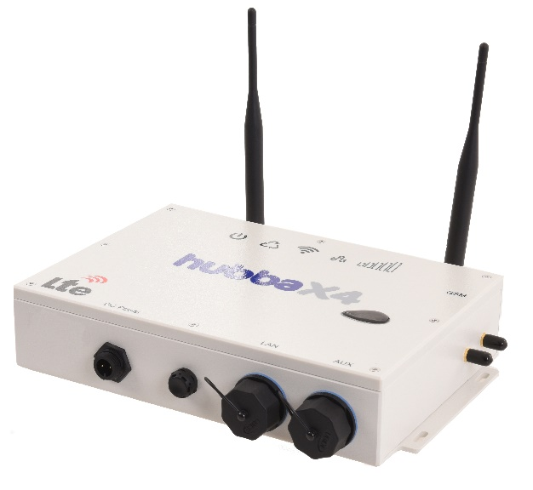Buzz Wireless is one of the leading providers of 3G and 4G mobile communications platforms for the leisure and commercial marine markets.

In a perfect world all countries would deploy a global standard protocol for cellular data, but in reality many have their own allocated frequency bands and system variants, nowhere is this more evident than the US and Canada, where systems are often incompatible with European and Asian counterparts. This has meant that for the shipping industry it has hitherto been difficult to come up with a global solution in one box.

Step forward the Hubba X4 Global, the first multiband, multi-protocol, dual SIM, LTE data router designed for the maritime sector. Ideal for operators regularly crossing borders, it also interoperates with existing VSAT systems to switch seamlessly when out of range of shore based networks.

The new Hubba X4 Global provides a cost-effective solution to help vessels stay connected across multiple networks up to 20 miles offshore in range of shore based mobile networks.

For vessels travelling further offshore, the Hubba X4 Global has an automatic switch over which automatically selects the vessel’s VSAT system when out of mobile range. As soon as a new mobile network is detected the Hubba will activate automatically, switching from VSAT to Hubba. It will allow a maximum downlink speed of 300 Mbps and a maximum uplink speed of 50 Mbps.

Hubba X4 Global is the first multiband, multi-protocol, dual SIM, LTE data router specifically designed for the maritime sector. It is ideal for commercial operators and long-distance cruising across multiple borders.

Steve Smith, Managing Director of Buzz Wireless said: “We are excited to be launching the new Hubba X4 Global. With the appropriate SIM card installed, users will be able to use this one piece of equipment to stay connected while travelling across borders. This solution works with existing VSAT systems to switch seamlessly between in-port Wi-Fi networks to VSAT when out of range of shore-based networks.”

Hubba X4 Global is an addition to the already available Hubba X4 Single and Hubba X4 Duo and is available to buy, ready to install including antenna, from £1295 +vat which makes it a highly cost effective option for any vessel operating in coastal waters with a need for reliable on-board communications.



**About Buzz Wireless**

Buzz Wireless are part of Buzz Networks, their range of marine broadband routers are sold in countries around the world.

Buzz Wireless’ 4G & 3G router solutions are a result of their knowledge and experience in the marine market. They are leaders in marine connectivity providing cost effective alternatives to marine satellite.

Their routers give owners and operators the ability to provide high speed internet access to crews and guests on board.

Buzz Wireless provides a quality connection for both fixed devices on a wired network or via Wi-Fi to the various smartphones, laptops and tablets that are all hungry for data. In such situations, the costs against VSAT are comparatively minimal and worthy of the time and effort invested by the diligent captain to provide this increasingly essential service.

Press contact

|  |  |
| --- | --- |
| Company contact:  Steve Smith  Buzz Wireless  +44 (0)203 137 1144  [stevesmith@buzznetworks.co.uk](mailto:stevesmith@buzznetworks.co.uk)  [www.buzzwireless.co.uk](http://www.buzzwireless.co.uk) | Media contact:  Kirstie Smith  Saltwater Stone  +44 (0)1202 669244  [k.smith@saltwater-stone.com](mailto:k.smith@saltwater-stone.com)  [www.saltwater-stone.com](http://www.saltwater-stone.com) |

ENDS