**FOR IMMEDIATE RELEASE**

**Contact:**

Joakim Perani

Rewine AB

Tel: +46 8 31 19 48

jp@rewine.se

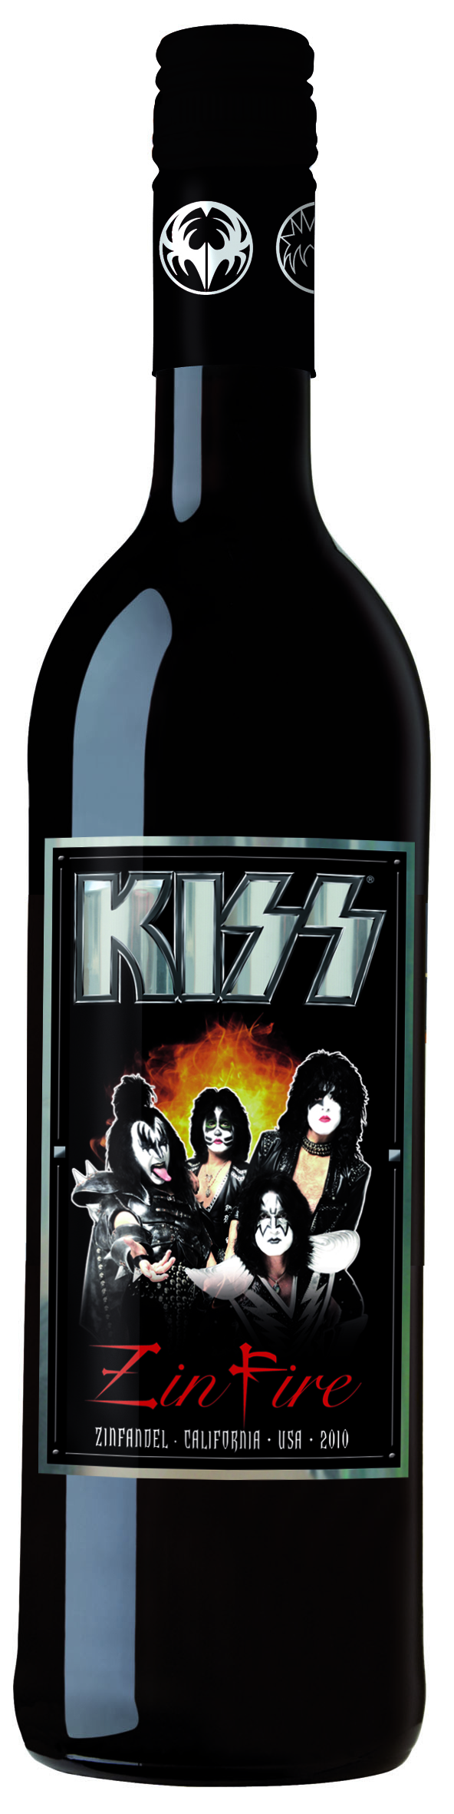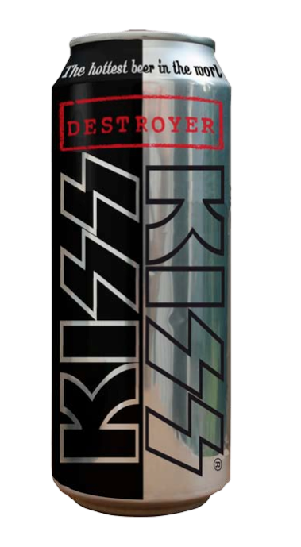

**KISS WINE AND BEER Raise A GLASS TO ROCK AND ROLL**

Rewine and **KISS** Partner to Create Zin Fire Zinfandel and Destroyer Beer

**Los Angeles, CA, USA and Stockholm, Sweden --- September 28, 2011** --- Legendary rock band **KISS** is raising a glass to celebrate its show-stopping spirit with spirits! **KISS** and wine distributor Rewine today announced the signing of a European licensing deal to create rare rock and roll vintages of **KISS**-themed Zin Fire Wine and Destroyer Beer. The private-label liquors, which feature customized **KISS** packaging, will be available in Europe this fall.

**KISS** Zin Fire is a bold and fruity 2010 California Zinfandel --- the result of a cool, long growing season that promoted fantastic flavor, acidity, and color. A brazen blend of blackberry and pepper gives the vintage a hard-rocking kick and spicy smooth finish.

**KISS** Destroyer Beer is an easy-to-drink beer in the best German tradition. A careful brewing process creates its great head of foam and a balanced flavor, like an original "Pils." The brew will come in both a 33 cl (11.2 oz) bottle and 50 cl (16.9 oz) can.

"This isn't just something we put a label on. We wanted wine and beer unique to **KISS** and we got it, said Paul Stanley of **KISS**. "This stuff will set your taste buds on fire."

"If you love beer and wine, this one is for you!" said Gene Simmons of **KISS**.

"Working with **KISS** was a fantastic experience," said Joakim Perani, managing director/partner of Rewine. "The band members were incredible partners in creating something that fans of fiery rock music, as well as great wine and beer, will enjoy."

**KISS** Zin Fire Wine and Destroyer Beer will launch in Sweden, Norway, and Finland, followed by Denmark, The Netherlands, and the UK. Wine will be available at retail stores on September 20, 2011, at a price of 11-14 euros. Beer will be released in mid-October, at a price of 1.5-2 euros. Additional distribution details are online at [www.kissrockdrinks.com](http://www.kissrockdrinks.com).

Live Nation Merchandise, **KISS'** exclusive worldwide merchandise and licensing agent, brokered the deal.

**About Rewine**

Founded in 2002, Rewine is a leading distributor that specializes in providing control- and private-label wines and wine brands for retail, on-premise, and affinity customers. The company is best known for partnering with renowned wineries and icons to create celebrity vintages for the European market. Previous releases included Elvis Presley wines, which ranked among the most successful California wines priced above 10 euros, and Christian Audigier's wine and champagne.

**About KISS**

**KISS**, the legendary American rock band, was formed in New York City in 1972. Nearly four decades later, the group's iconic style, explosive performances, and raging rock anthems have made it one of the most influential bands in the history of rock and roll.

**KISS**' staggering achievements include the release of 44 albums, sales of 100 million albums, sold-out stadium tours around the globe, and the ferocious support of nearly five million Facebook fans and generations of **KISS** Army fans. The band has been recognized with honors from MTV, VH1, the Recording Industry Association of America, the People's Choice Awards, and the Hollywood Walk of Fame. The "Hottest Band in the World" literally set the stage on fire at high-profile shows at Super Bowl XXXIII, the 2002 Winter Olympics, the Rockin' the Corps concert dedicated to our troops, and *American Idol's* 2009 finale. And the band can be seen and/or heard all night and every day in movies, television shows, and legions of fans showing off their cool **KISS** shirts and merchandise.

**KISS** continues its screaming success with a recent nomination to the Rock and Roll Hall of Fame and a #2 *Billboard 200* debut for its latest album, *Sonic Boom*.

**KISS** is currently in the studio, unleashing musical mayhem on a new album aptly titled *Monster*. *Monster* will roar into stores, along with a massive global tour, in 2012.

For all things **KISS**, visit [www.KISSonline.com](http://www.KISSonline.com).



###