Press Information
Hansgrohe Innovations Focus on the User
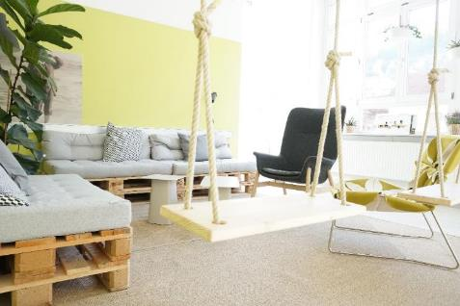
Hansgrohe-Group_Innolab.jpg
Copyright: Hansgrohe SE
The Hansgrohe Group found a new home for its Innovation Lab in the city of Schramberg – the center of the Black Forest’s ingenuity and creativity.

Schiltach, February 2019. In its 118-year history, the Hansgrohe Group has continuously proven that innovation is a key driver of the company’s success story. At the 2019 ISH, the Black Forest manufacturer of faucets, showers, and shower systems will for the first time present the results of the newly aligned Innovation Department.
Human Needs Determine Thinking and Acting
The human being, water, and sustainability – these three terms characterize the actions of the Hansgrohe Group, also in the realm of innovations. Hansgrohe summarizes its actions under the term Smart Living rather than Smart Home. “We don’t practice innovation management for its own sake, but rather to make a contribution to increasing the quality of life of each individual. For this reason, the focus of our daily work is on people and how we can improve their lives,” says Steffen Erath, Head of Innovation. In addition to innovations, excellent design and reliable quality determine the work of Hansgrohe.
Results of a Pilot Project Released at ISH
Thinking consistently from a human centric point of view also means experimenting with new pathways and structures in product development. An interdisciplinary innovation team, driven by the question of the importance of digitization for customers, develops products that fundamentally change the experience of showering. The Innovation Lab has found a new home in Schramberg: The city is considered the center of the Black Forest’s ingenuity and creativity – therefore, it was a logical move to open the laboratory there. For more than thirty years, Phoenix Design has been a strong innovation partner for Hansgrohe. With their honorary title “Red Dot: Design Team of the Year” in 2018, the creatives from Stuttgart have demonstrated that they belong to the best in their industry. At the ISH in March 2019 – the world's leading trade fair for sanitary solutions, energy, and air conditioning technology in Frankfurt – both partners will present a first milestone, which is a prime example of the ongoing transformation.
The innovation approach of the team has inspired other areas of the company: with the Hansgrohe Campus, a learning platform consisting of six faculties including strategy, innovation, and digitization, employees and executives continue to educate themselves, new digital marketing activities open up new markets, and with “talent mobility,” global cooperation becomes more effective.
From the Individual Inventor to a Comprehensive Ecosystem for Innovation
Striving for innovation is deeply rooted in Hansgrohe's DNA: Klaus Grohe, CEO until 2008, continued the company's innovation tradition with his ingenuity and hands-on mentality and became the role model for today's innovation team: courage, the right amount of risk-taking, and a good gut feeling are essential for the required creativity; user orientation and trust in the skills of the innovators are the top priority for Hansgrohe. “It’s needless to say that our current innovation management follows certain processes and structures. That is something that we have successfully worked on over the past year. A healthy level of process orientation is important, in order to provide people around the world with special water moments,” says Erath.

About the Hansgrohe Group – the Original from the Black Forest
With its brands AXOR and hansgrohe, the Hansgrohe Group, based in Schiltach/Southern Germany, enjoys a reputation as a leader in innovation, design and quality within the bath and kitchen industry. The Hansgrohe Group brings form and function to water with taps, showerheads and shower systems. The 118-year history of the company is marked by innovations such as the first hand-held shower with multiple spray types, the first pull-out kitchen tap, and the first wall bar to hold a hand-held shower. The company holds more than 15,000 active property rights. The Hansgrohe Group stands for long-lasting quality products. With 34 subsidiaries and 21 sales offices supplying products in more than 140 countries, the company is a reliable partner to its customers around the world. The Hansgrohe Group, its brands and products have won numerous awards, including more than 500 design prizes since 1974. Sustainable production of resource-conserving products is central to the company’s business activities around the globe. The products of the Hansgrohe Group are featured in projects around the world, such as the luxurious ocean liner Queen Mary 2, and the world’s tallest building, the Burj Khalifa in Dubai. The Group’s high quality standards are ensured by five wholly-owned production facilities: two in Germany, one each in France, the United States and China. In 2017, the Hansgrohe Group generated a turnover of EUR 1.077 billion. It employs about 5,000 people worldwide, about 60 percent of whom work in Germany.

Find out more about the Hansgrohe Group and its brands
AXOR and hansgrohe on:
www.facebook.com/axor.design
www.facebook.com/hansgrohe
www.twitter.com/Hansgrohe_PR
www.instagram.com/axordesign
www.instagram.com/hansgrohe
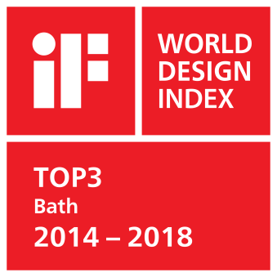
Top Rankings within the iF WORLD DESIGN INDEX

The Hansgrohe Group has achieved top rankings within the iF WORLD DESIGN INDEX 2014 – 2018 of the International Forum Design (iF).

The Black Forest-based showers and fixtures specialist is ranked among the Top 3 listed companies within the iF category INDUSTRY: Bath.

Among the 1.365 German companies, the Hansgrohe Group is ranked among the Top 10 within the iF category COUNTRIES: Germany; globally, the Hansgrohe Group is ranked in the Top 25 among 4.000 companies within the iF category: COMPANIES.

At the iF DESIGN AWARDS 2018 nine AXOR and hansgrohe branded products received an iF DESIGN AWARD 2018.

For further information on our design awards, please visit www.hansgrohe.com/design.

Further Information: | Hansgrohe SE  - Public Relations -  Astrid Bachmann  P +49 78 36 51 1297  E-Mail: public.relations@hansgrohe.com  www.hansgrohe-group.com  www.axor-design.com  www.hansgrohe-int.com

Image Overview
Copyright of all images: Hansgrohe SE
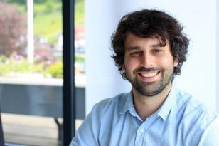
Steffen_Erath.jpg
“We don’t practice innovation management for its own sake, but rather to make a contribution to increasing the quality of life of each individual. For this reason, the focus of our daily work is on people and how we can improve their lives,” so Steffen Erath, Head of Innovation.
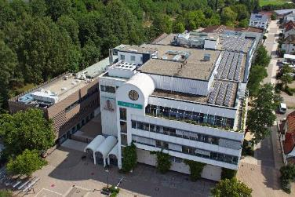
Hansgrohe_SE_WSA_002.jpg
In its 118-year history, the Hansgrohe Group has continuously proven that innovation is a key driver of the company’s success story.
Images Link: https://www.mynewsdesk.com/se/hansgrohe
Copyright: We must draw your attention to the fact that we have only limited usage rights for the images provided; extended image rights, however, belong to the respective photographers. The images with a Hansgrohe SE copyright may therefore only be published free of charge if they clearly and expressly serve to portray or advertise the performances, products or projects of Hansgrohe SE and/or its brands (AXOR, hansgrohe). All other images shall only be used in connection with the corresponding press release. Any other form of publication requires the approval of the respective copyright owner and remuneration must be made in agreement with said copyright owner.

