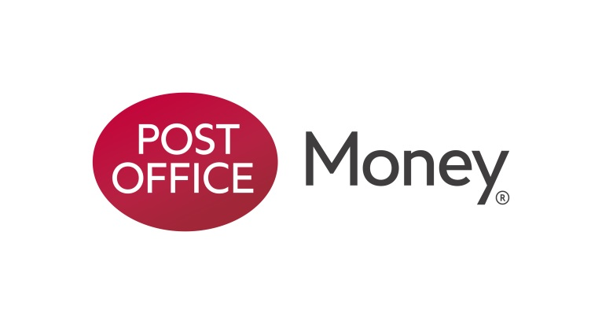

**For immediate release: Tuesday 27th September**

**Post Office Money shakes up the mortgage market with a seven-year fixed deal**

* New seven-year fee free fixed rate, 75% LTV at 2.59%
* Market leading new rates at 90% and 85% LTV
* New rates feature cashback for first-time buyers and reduced Help to Buy and Buy to Let rates

Post Office Money Mortgages has today launched a new range of competitive mortgages, including their first ever seven-year fixed rate. The move follows demand from customers who want longer term value without committing to a 10 year deal.

The new seven-year fixed rate at 75% LTV has a rate of 2.59% with early repayment charges of just 4% until 30/11/2020, 3% until 30/11/2022 and 2% until 30/11/2023.

**Market leading rates**

Also included in the new range are market-leading fixed rates across several 90% and 85% LTV deals.

Market-leading rates include:

* 90% LTV five-year fixed rate at 3.28% (£750 cashback on completion, free valuation)
* 85% LTV three-year fixed rate at 2.16%
* 85% LTV five-year fixed rate at 2.49%

**Cashback deals**

The new range also introduces reduced Help to Buy rates, and new deals for Buy to Let customers. The new rates also feature cashback offers for first-time buyers [full range in Notes to Eds].

**John Willcock, Head of Post Office Money Mortgages, said:** “We are continuing to improve our mortgage offering across the board and adding a seven-year fixed rate for the first time allows us to give customers a wider range of choice and allowing them to take advantage of historic low interest rates.

“As strong supporters of the Help to Buy scheme we are also pleased to be able to cut rates for those striving to get onto the property ladder. From our own research we understand the difficulty first-time buyers are facing, with 40 per cent (8.5 million) of those currently renting not believing they will ever be able to buy their own property we are keen to provide support where we can.”

Customers can pick up information about the new mortgage range and rates online at postoffice.co.uk/mortgages or from one of over 11,500 Post Office branches across the UK. Customers can also arrange a call-back from a mortgage adviser at the call centre, via all branches, or call the Post Office directly on 0800 077 8033. Terms and condition can be found at postoffice.co.uk

**Ends**

**For more information, please contact:**

Carmel McCarthy

Post Office Money Press Office

0207 250 2268

[Carmel.mccarthy@postoffice.co.uk](mailto:Carmel.mccarthy@postoffice.co.uk)

[www.postoffice.co.uk](http://www.postoffice.co.uk/)

**Notes to editor:**

Cashback for first-time buyers:

* 90% LTV two-year fixed rate at 2.69% (£500 cashback on completion, free valuation)
* 90% LTV three-year fixed rate at 2.84% (£500 cashback on completion, free valuation)
* 90% LTV five-year fixed rate at 3.28% (£750 cashback on completion, free valuation)

New Buy to Let rates:

* 60% LTV two-year fixed rate at 1.99%
* 60% LTV two-year fixed rate at 2.45% (free valuation, standard legal fees paid)
* 60% LTV five-year fixed rate at 2.84%
* 60% LTV five-year fixed rate at 3.19% (free valuation, standard legal fees paid)
* 70% LTV two-year fixed rate at 2.27%
* 70% LTV two-year fixed rate at 2.75% (free valuation, standard legal fees paid)
* 70% LTV five-year fixed rate at 2.99%
* 70% LTV five-year fixed rate at 3.39% (free valuation, standard legal fees paid)

New Help to Buy rates:

* 95% LTV two-year fixed rate at 3.89% (£500 cashback on completion, free valuation)
* 95% LTV three-year fixed rate at 4.15% (£500 cashback on completion, free valuation)
* 95% LTV five-year fixed rate at 4.28% (£500 cashback on completion, free valuation)

**FULL DETAILS OF MORTGAGE RATES AVAILABLE:**

















**About Post Office Money**

Post Office Money, launched in January 2015, brings together all of Post Office’s multi-award winning financial products under one umbrella as it seeks to become one of the leading financial services providers by 2020. Post Office Money will be available at thousands of branches within Post Office’s network, as well as over the phone or online.

Bank of Ireland has supported customers in the UK for many decades and is the exclusive financial services partner to the Post Office.  Bank of Ireland primarily operates in the UK through its wholly owned and separately incorporated subsidiary Bank of Ireland (UK) plc, which is authorised and regulated by the Financial Conduct Authority and the Prudential Regulation Authority.  Activities related to the Post Office partnership are conducted within this entity and as such, all retail deposits up to £75,000 with the Post Office are protected under the UK’s Financial Services Compensation Scheme.  At 31 December 2014, Bank of Ireland (UK) plc had a loan to deposit ratio of 91% with customer deposits of c. £20 billion utilised to fund customer lending of c. £18 billion (primarily comprising c. £14 billion of UK residential mortgages).

**About the Post Office**

The Post Office (Post Office Limited) has an unrivalled national network of over 11,500 branches across the UK, more than all the high street banks combined, and sits at the heart of communities in Northern Ireland, Scotland, Wales and England. The Post Office has made a commitment to maintaining its network of branches at its current size and reach.

The Post Office serves over 17 million customers a week and a third of small businesses. Some 99.7% of the total population live within three miles of a post office and over 97% live with one mile of a post office. For many rural communities, the post office is the only retail outlet. Post Offices branches remain highly valued and trusted, and are the focal point of many communities. For more information, visit [www.postoffice.co.uk](http://www.postoffice.co.uk).