Strong season ending for the Bäckman’s after a tough year
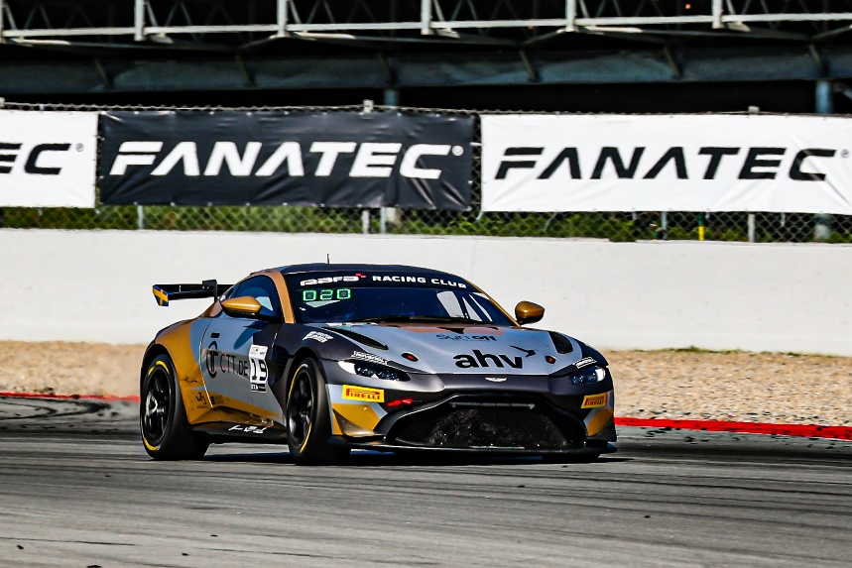
Andreas and Jessica Bäckman competed last weekend on the classic Formula 1 track Circuit de Barcelona-Catalunya in Barcelona, Spain at the season finale of the GT4 European Series.
Photo: GT4 European Series (Free rights to use the image)
Last weekend, September 29th - October 1st, Andreas and Jessica Bäckman competed at the Spanish Barcelona circuit at the sixth and final round of the GT4 European Series in an Aston Martin Vantage GT4 car. After a tough year with a lot of setbacks, the siblings together with the team made progress this weekend.
- We got the car better this weekend, so we were more competitive both in qualifying and the race. Nice to end the season with great progress and our best race weekend, Andreas Bäckman says.

The previous weekend, September 29th – October 1st, the Bäckman siblings competed in the GT4 European Series at the Formula 1 track Circuit de Barcelona-Catalunya, located approximately 20 kilometers from the city of Barcelona in Spain. On the starting line, Bäckman faced 44 of the best GT4 drivers/cars in the world.
It has been a tough season for the siblings, who this year switched from TCR to GT4 racing. The siblings started the season strong but after that the speed and results haven't quite been there and they have been involved in quite a few incidents out on the track.
Before the end of the season, the siblings were hungry for revenge after a tough year. They were looking forward to competing on the Barcelona track, which Andreas has fond memories of before with his wins in 2019 and 2020 in TCR.
Quick lap times in the practice and qualifying sessions
Right away in the practice sessions, the speed was much better and in the Thursday test session, the siblings were among the top placed cars. During Friday's free practice, work continued on improving the speed and balance of the car ahead of Saturday's and Sunday's Qualifying’s and Race’s.
- We had a good feeling in the car quite early on the weekend. Together with the team, we worked during practice on fine-tuning the car especially for the Qualifying, which is always extremely important in this tight championship, Andreas Bäckman says.
In the Qualifying on Saturday morning, Andreas drove in Qualifying 1 (Q1) and Jessica in Qualifying 2 (Q2). Andreas posted early in Q1 a good time, but unfortunately the time was deleted due to a "track limit" in the penultimate corner. On the following lap, he was on his way to another good time that would have matched the first lap but was then blocked three corners from the finish line, losing four tenths of a second. In the end it was a final 12th place in the class, but which could potentially have been a 7th or 8th place in the class.
Jessica also had a very strong Qualifying and quite early in Q2 set a time that was enough for 10th place in the class, despite having to overtake several cars during her fastest laps. This meant that they had two good positions with starting positions for both races.
Eventful racing with lots of overtaking
The first race on Saturday afternoon got off to an eventful start when Andreas ended up in the gravel trap in turn 2 and lost a few places unfortunately. Then there were further incidents during the lap which luckily, he was able to get through without any damage to the car. After that he had difficulty moving up the field with overheated brakes and tires. Halfway into the race it was time for a pit stop and the siblings made a good stop. Jessica then put in a strong finish, despite coming onto the track in a very difficult position and powering her way up through the field to an eventual 14th place finish in class.
- We went into the pits quite late, so I got out on the track when most of the cars had already been in the pits, so then it was important to be there and fight straight away. But I kept calm and moved forward step-by-step, even though the car was difficult to drive with overheated brakes and tires, Jessica Bäckman says.
For Sunday's race, the siblings together with the team made some fine-tuning adjustments to the car based on the information they gathered from the first race. The changes to the car turned out to work well.
Jessica made it through the first lap despite being three-wide on several occasions through the first corners and close to being sandwiched between the cars. Unfortunately, she lost a few positions like Andreas in Race 1, but then had a good feeling in the car and advanced a few positions before it was time for the driver change. Once again, the siblings had a quick driver change and Andreas took to the track and was able to immediately start attacking forward. It turned out to be a tough battle between 6-7 cars in the last 20 minutes of the race, but the car proved to hold up well and Andreas was able to work his way up to a final 11th place in the Silver class.
- It was probably the most enjoyable race of the year, very good battles throughout the race and tough racing but still fair. It was very difficult to overtake as we lacked some top speed on the straights compared to most of the others, so I had to plan the overtakes carefully. Nice to end the season with a positive race, Andreas Bäckman says.
- Fun to end the season with a positive weekend with good speed in both the Qualifying’s and the Race’s after a challenging year. The balance in the car was the best I've experienced all season, especially in the Qualifying, and then it's extra fun to drive. Many thanks to our team racing one, our sponsors and everyone who has supported us this season, Jessica Bäckman says.
Andreas and Jessica’s results (Silver class):
Official test: 8th place
Free practice 1: 13th place
Free practice 2: 14th place
Qualifying 1 (Q1): 12th place
Qualifying 2 (Q2): 10th place
Race 1: 14th place
Race 2: 11th place
TV links in case you missed last weekend’s qualifying and races:
Click to watch Qualifying 1 & 2
Click to watch Race 1
Click to watch Race 2

Free rights to use images.
Download press pictures here:
http://bit.ly/jabaeckman-photos
https://www.mynewsdesk.com/se/ja-backman/images

