Capture One Launches Editorial Color Grading Styles
Bringing the coveted styles of top photographers & retouchers
exclusively to Capture One
COPENHAGEN, February 7, 2019: Capture One, the world’s premier name in image processing software, has released the Editorial Color Grading Style Pack. The Style Pack brings within reach of any user, for the first time, the editorial aesthetic of 3 acclaimed photographers and retouchers whose work can be found in Vogue, Harper’s Bazaar, and Cosmopolitan among others.
Michael Woloszynowicz, Marie Bärsch, and Pratik Naik are all celebrated photographers and retouchers with hundreds of thousands of dedicated followers, and years of published work to their names. Their approach is at once contemporary and timeless, and they have chosen to work specifically with Capture One to create 7 Styles each that reflect their individual aesthetic.
Capture One Styles are precisely-designed presets that adjust the overall look and feel of an image with one click yet allow the image to be fully tuned and refined to suit individual taste. With the option to add each Style as a layer and control its intensity, and use multiple layers and Styles per image, Capture One Styles can serve as either a starting point or finishing touch or to give a specific nuanced flair.
The Editorial Color Grading Pack includes 3 sets of 7 Styles made by Michael, Marie, and Pratik, giving a total of 21 unique Styles to choose from. The wide variation of Styles provides countless possibilities to create professional and distinguished editorial images, be it fashion, street, travel, wedding, portraiture, and any other genre of your editorial work.

Pricing and Availability
The Editorial Color Grading Style Pack is available now at the Capture One e-store: get.phaseone.com/editorial-color-grading
The Styles can be purchased per pack or as an Editorial Color Grading Styles Kit where all 3 packs are added for the cost of 2.
Price per Style Pack:
EUR: 39. USD: 34. GBP: 34.
Price for Editorial Color Grading Styles Kit:
EUR: 78. USD: 68. GBP: 68.
Note to editors:
Please find Before/After example imagery below, and annexed documentation for links to video instruction and demonstration together with more information from the artists.
Contact: Global Public Relations Manager, Nadia Julie Froberg: njf@phaseone.com
Michael Woloszynowicz

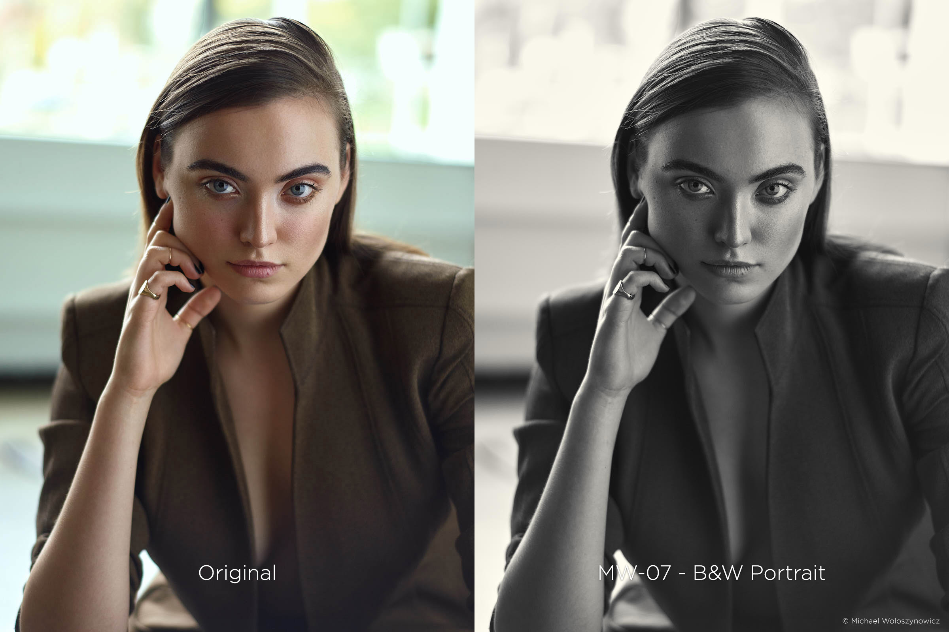
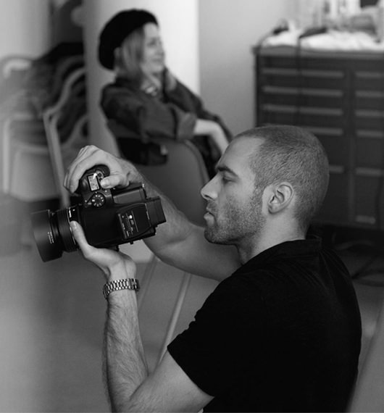

Michael Woloszynowicz:
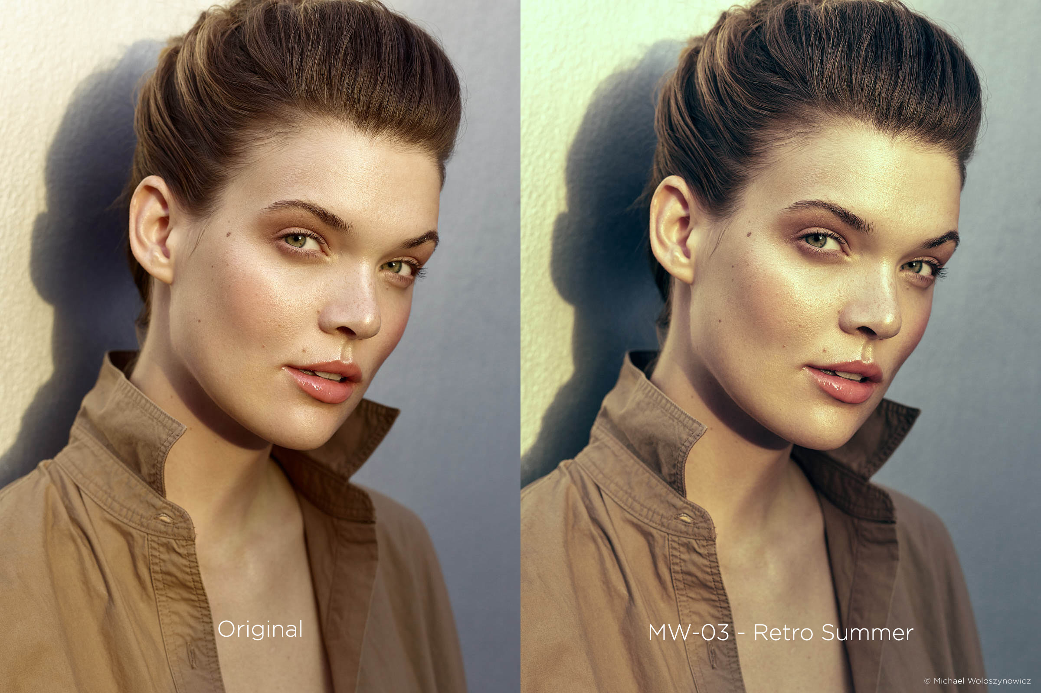
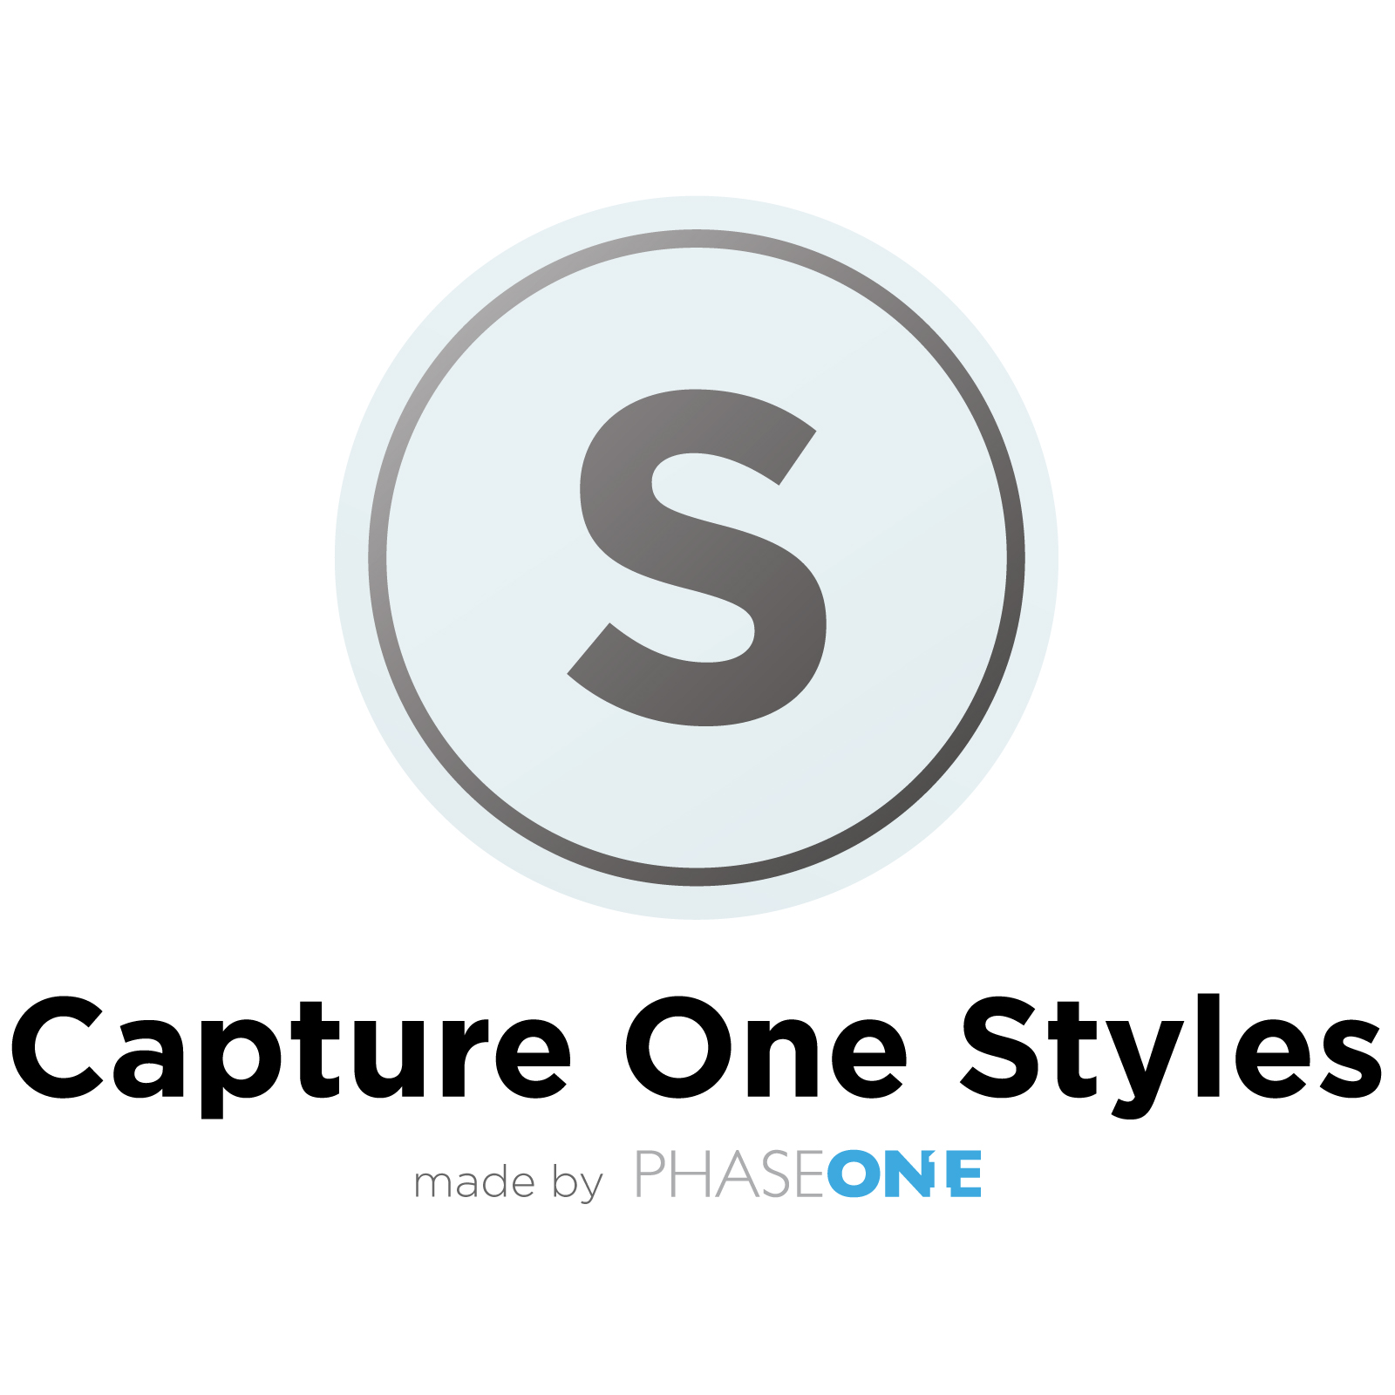
Michael is a fashion, beauty and portrait photographer and retoucher. His photographic style can best be described as minimal, elegant and timeless
www.vibrantshot.com

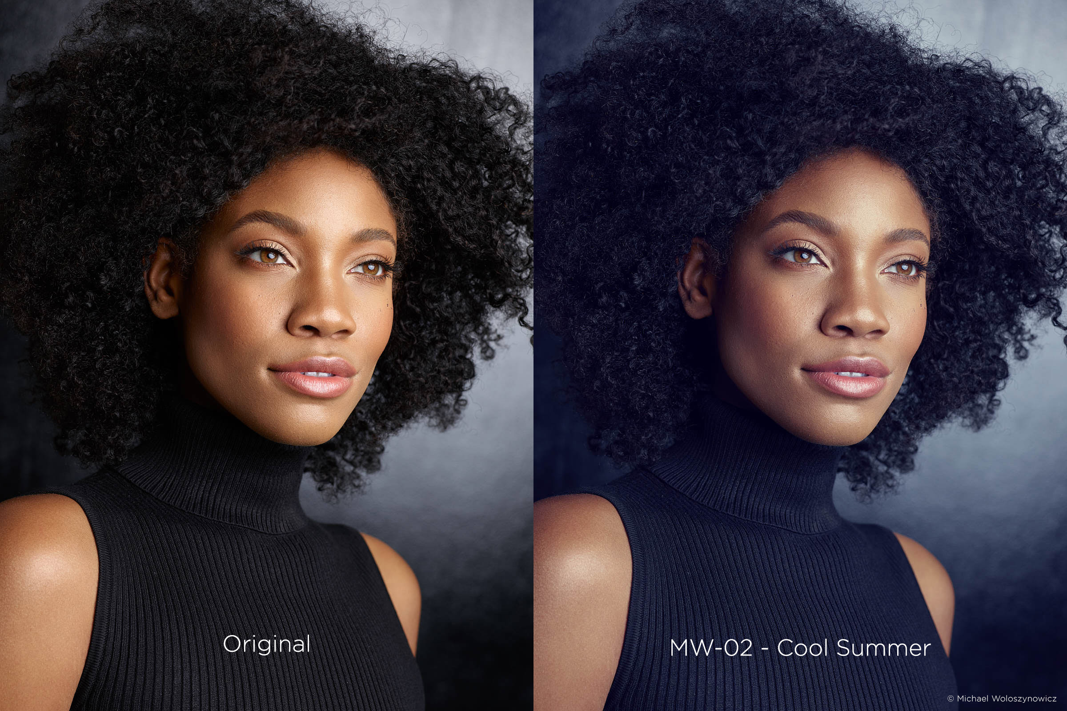

Marie Bärsch

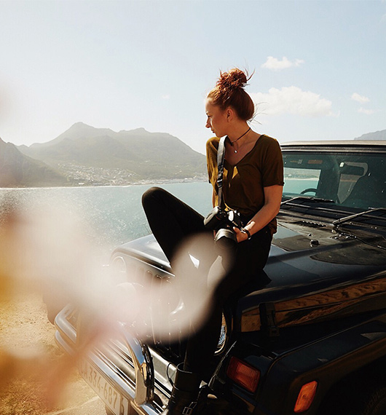

Marie Bärsch:
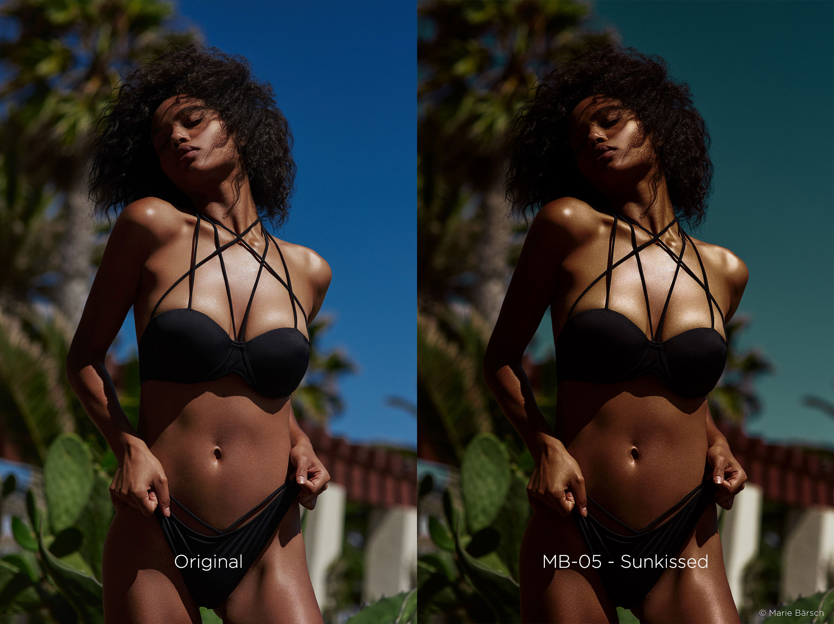
Marie is a high-end fashion and beauty photographer. Her unique style blends exotic locations with stylized aesthetics of beautiful female models
www.mariebaersch.com

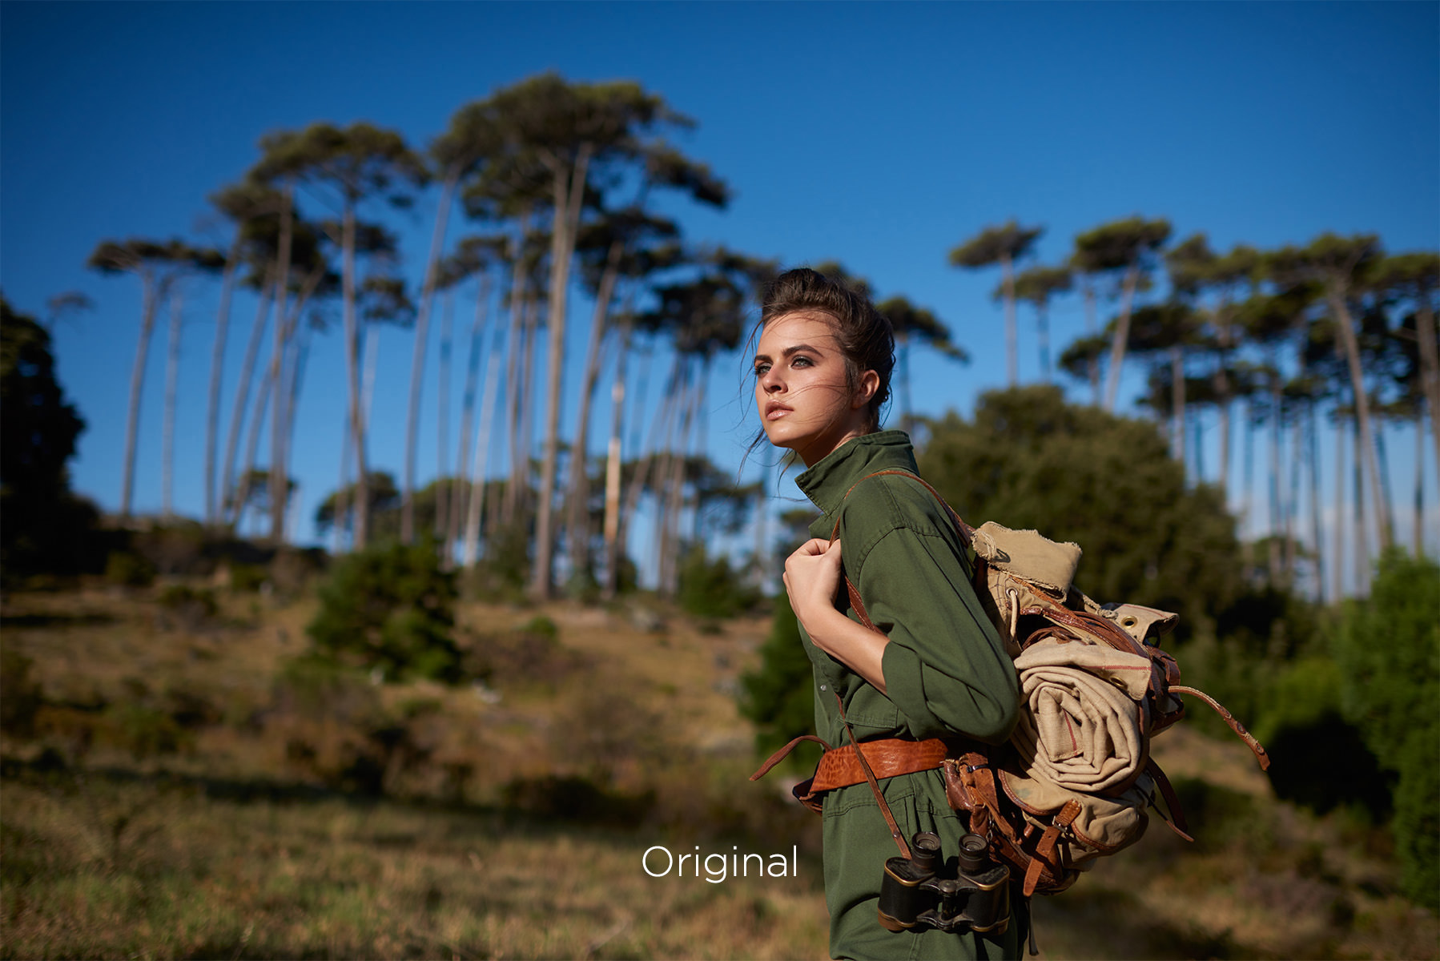
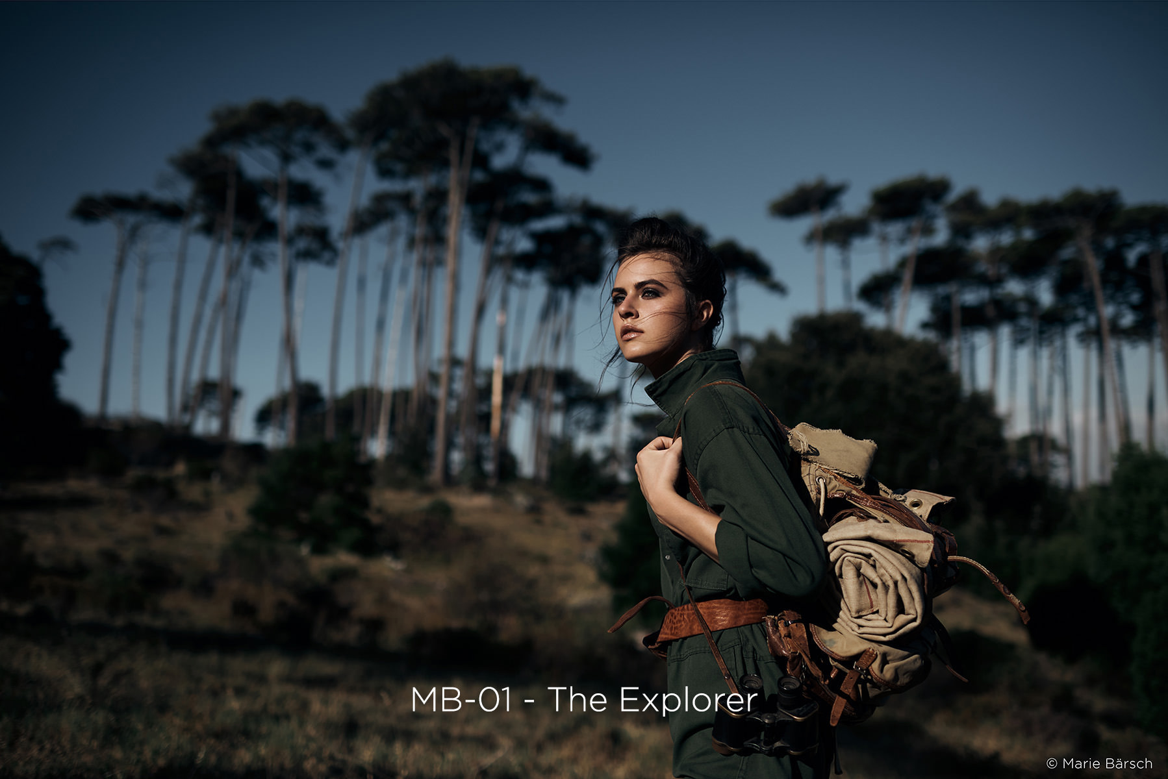
Pratik Naik

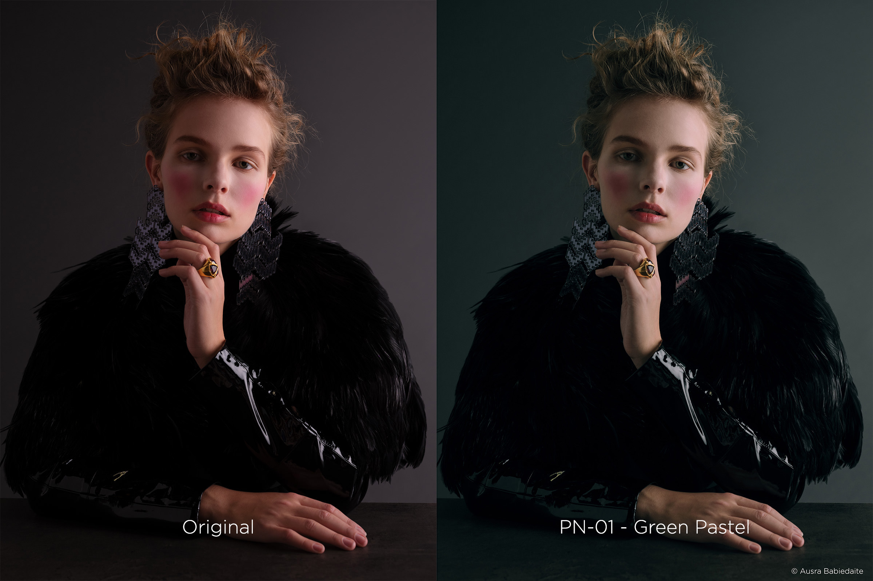

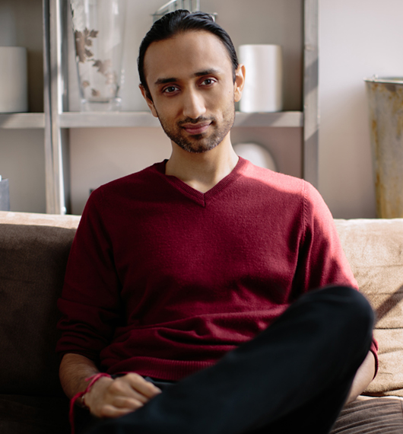

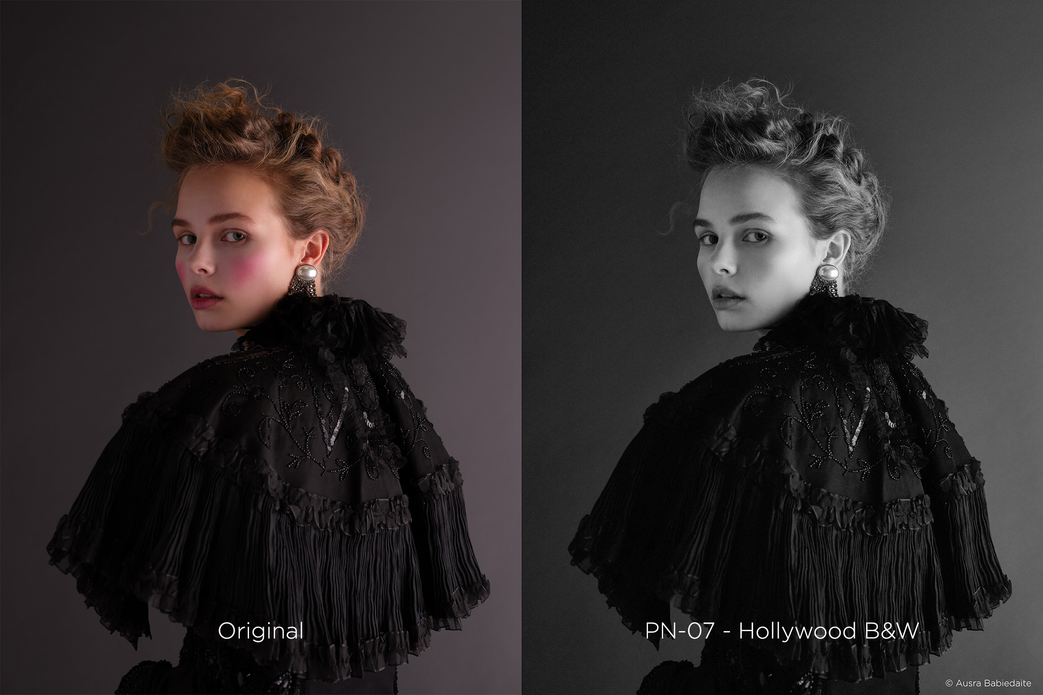
Pratik Naik:
Pratik is a commercial and editorial high-end retoucher with a passion for pixels. Being able to harness the potential of RAW files and see it through to fruition gives him a lot of joy
www.solsticeretouch.com

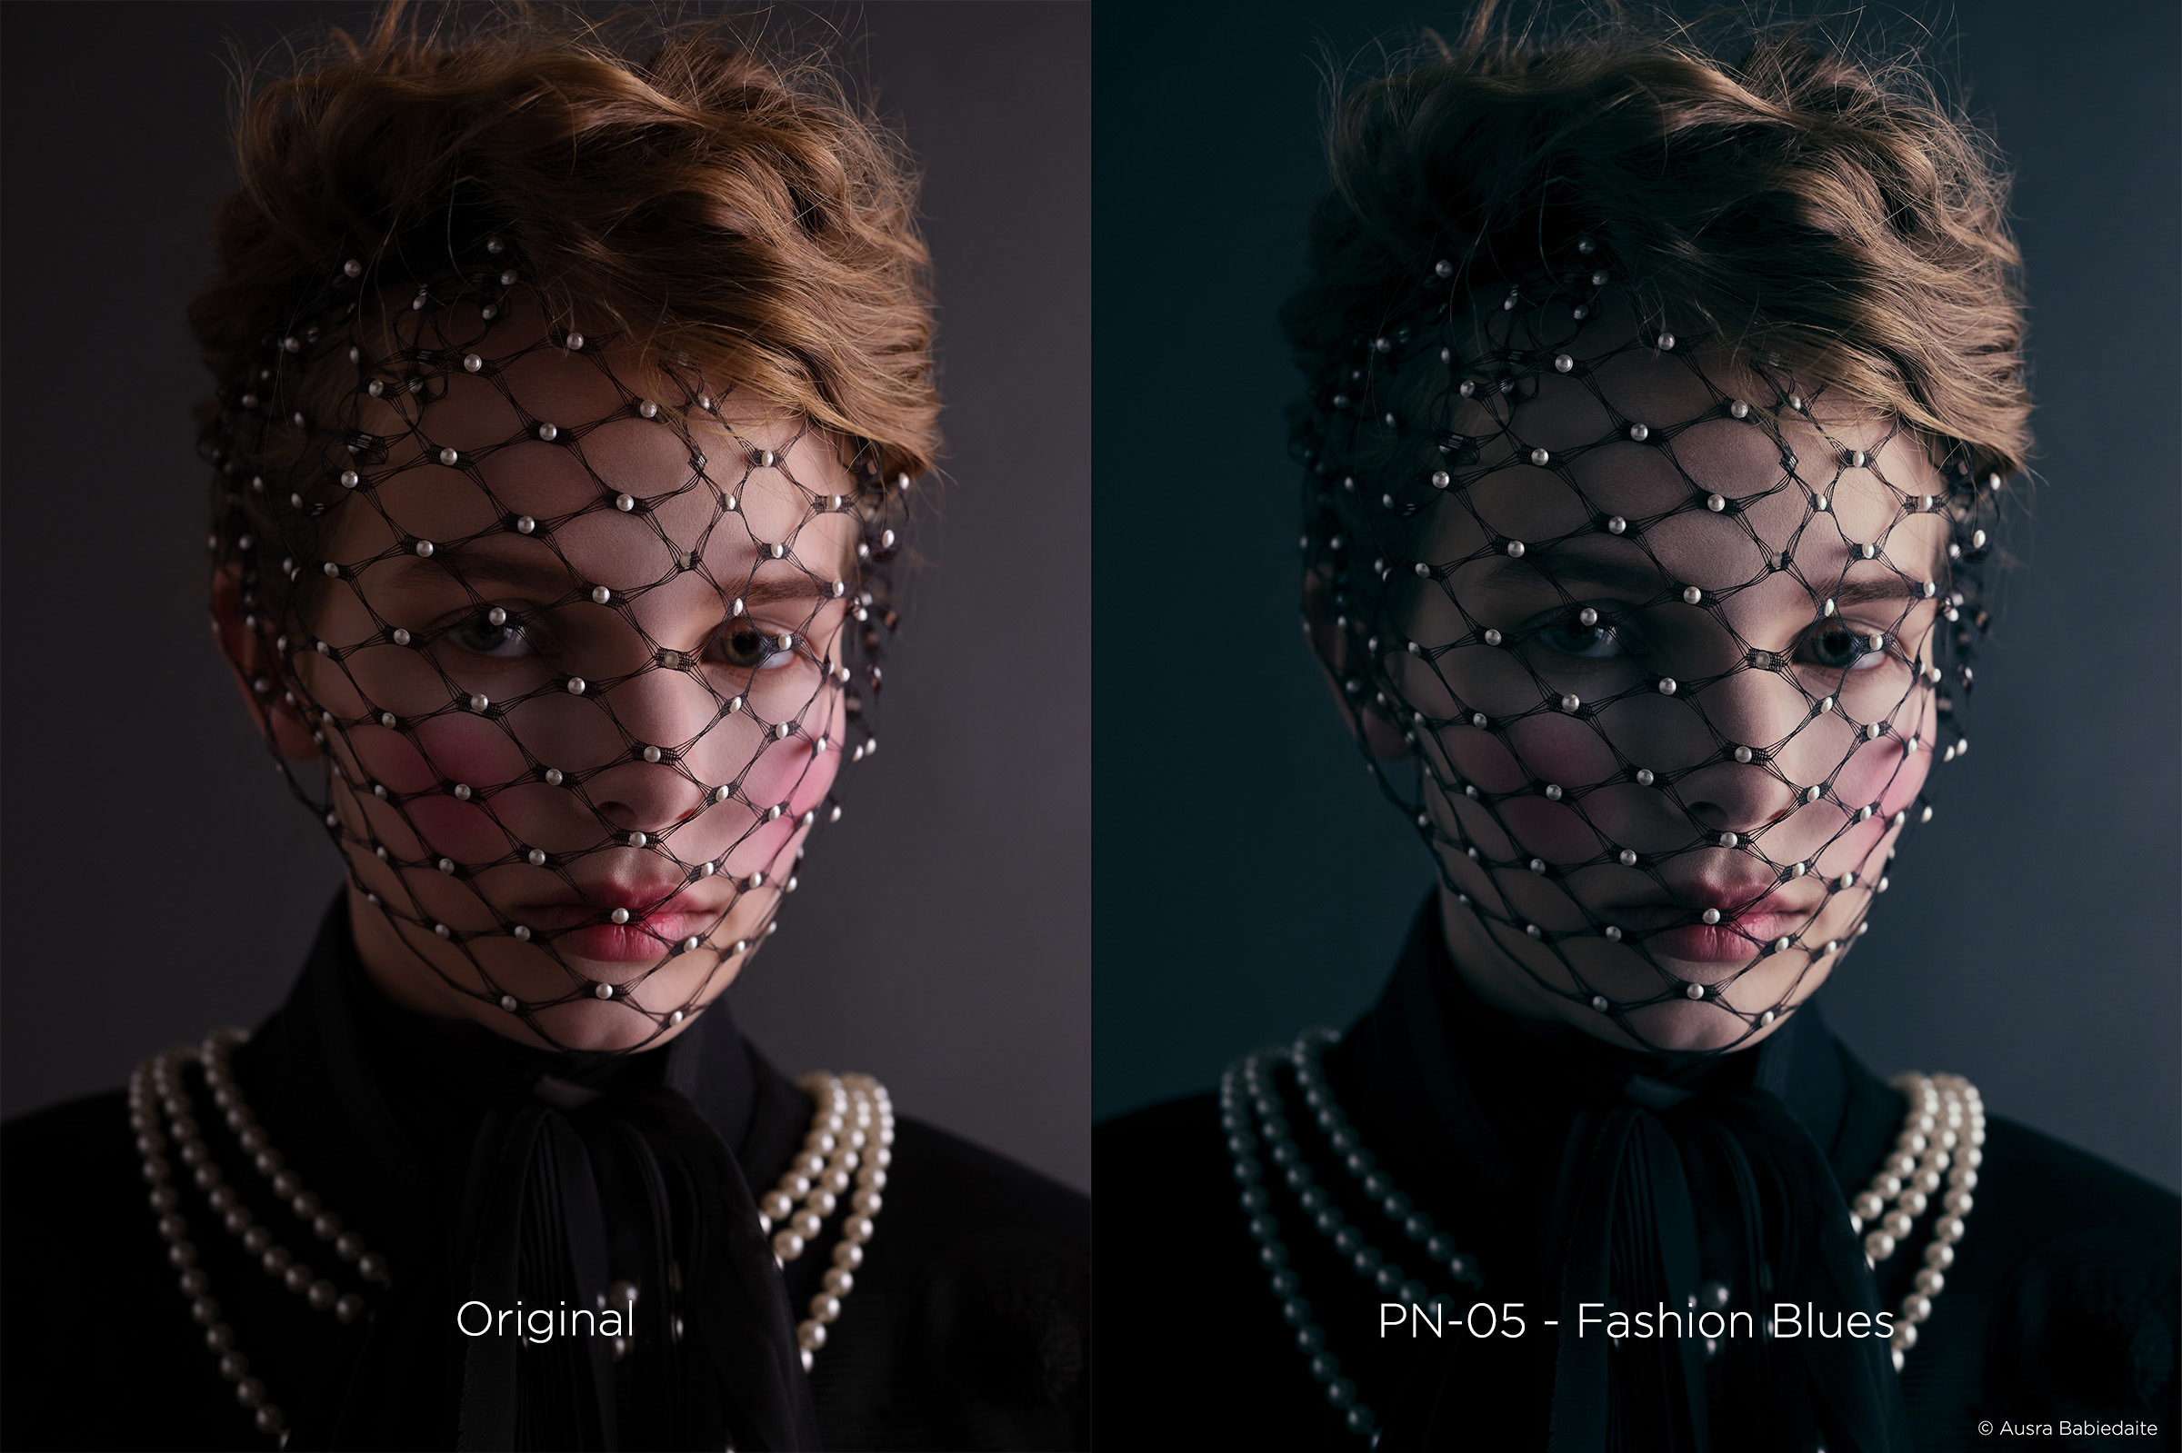

About Phase One and Capture One
Capture One is the award-winning professional choice in image editing software. With native support for more than 500 camera models, Capture One software offers fast and powerful RAW conversion, image editing and asset management. Capture One features a highly responsive processing engine, unmatched color handling, precision-editing tools, and seamless tethered support.
Capture One is developed by Phase One A/S, the world’s leading manufacturer of medium format digital photography systems and imaging solutions for professional photographers, and cultural heritage and industrial solutions. Established in 1993, Phase One has pioneered the field of digital camera systems and imaging software, including multiple breakthroughs – from the world’s first 100MP camera systems to advanced imaging workflows in Capture One.
By controlling all aspects of the medium format camera system supply chain, Phase One is uniquely positioned to help photographers and imaging experts everywhere stand out from the competition and realize their creative visions without compromise.
Based in Copenhagen, Denmark, and with offices in New York, Tokyo, Cologne, Shanghai and Tel Aviv, Phase One is committed to delivering an unmatched level of service and support to every customer through this expert team of global partners.
Phase One and Capture One are registered trademarks of Phase One A/S. All other brand or product names are trademarks or registered trademarks of their respective holders.
Learn more here:
Capture One at: www.captureone.com
Phase One at: www.phaseone.com
Facebook at: www.facebook.com/CaptureOnePro
Instagram at: www.instagram.com/CaptureOnePro
YouTube at: www.youtube.com/CaptureOneProDK

