WHAT MAKES THE PHANTOM 4 RTK THE IDEAL HIGH-PRECISION AERIAL SURVEY TOOL?

Industry Demands:
- High accuracy and precisely executed flights
- Highly accurate and precise data output

Features and Benefits Guide:

Accurate and precise | Accuracy refers to how close the measured value is to the standard or known reference value.  Precision is when the measurement is taken multiple times and the same value is attained each time.  The Phantom 4 RTK generates data that is very precise and accurate.  In fact the mapping accuracy of Phantom 4 RTK meets the Class III requirements for Digital Orthophotos of the American Society for Photogrammetry and Remote Sensing. | 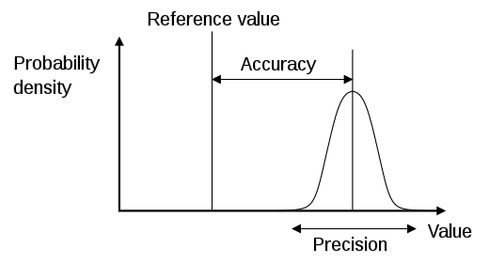
Integrated Real-Time Kinematics module (RTK) | The Phantom 4 RTK has an integrated RTK module which enhances the accuracy of position data obtained from satellite-based positioning systems; i.e., GNSS.  RTK is a technology that automatically corrects the positioning information data. | 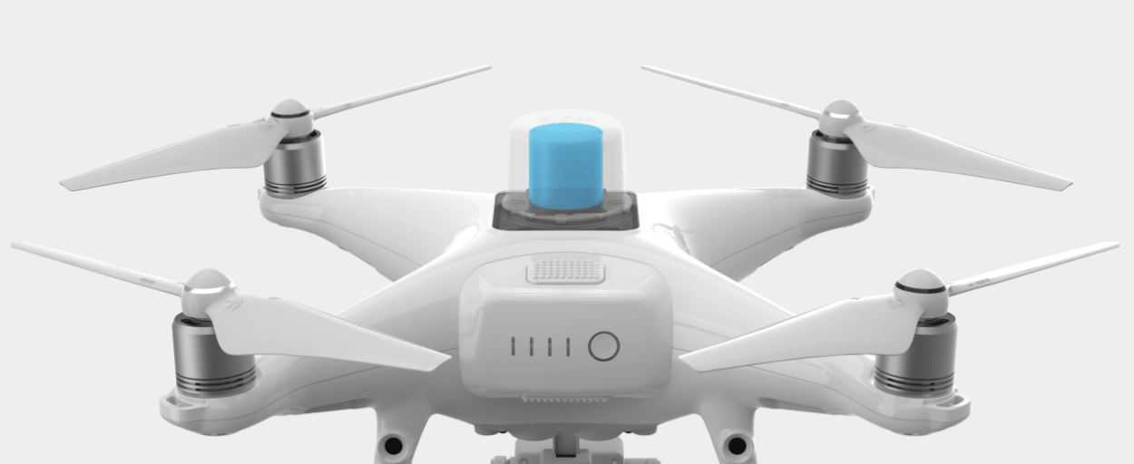  http://bit.ly/2QX6fDG
Time efficient – Saves at least 75% on-site surveying time by replacing common ground control points | Due to the built-in RTK module, it is possible to conduct surveying operations with fewer ground control points (GCPs). This is highly beneficial as it allows surveyors to save a lot of time. Placing these GCPs can take many hours depending the size of the area.
Supports Post Processed Kinematic (PPK) | GNSS data stored on the drone´s SD-card can improve  accuracy when being post processed with specific 3rd party software. The original captured satellite observation data as well as the ephemeris data are processed after the flight.
2 x Redundant Global Navigation Satellite System (GNSS) | GNSS is a satellite navigation system that receives signals from different satellites: GPS, GLONAS, BeiDou. Having access to multiple satellites allows for better accuracy and redundancy because it is able to receive the best signal.
Mechanical Shutter | In aerial surveying, multiple images are are being processed to receive a pointcloud. The mechanical shutter on Phantom 4 RTK’s camera reduces blur effects when flying at high speeds to keep the images sharp. The drone does not need to be stopped to take pictures. | 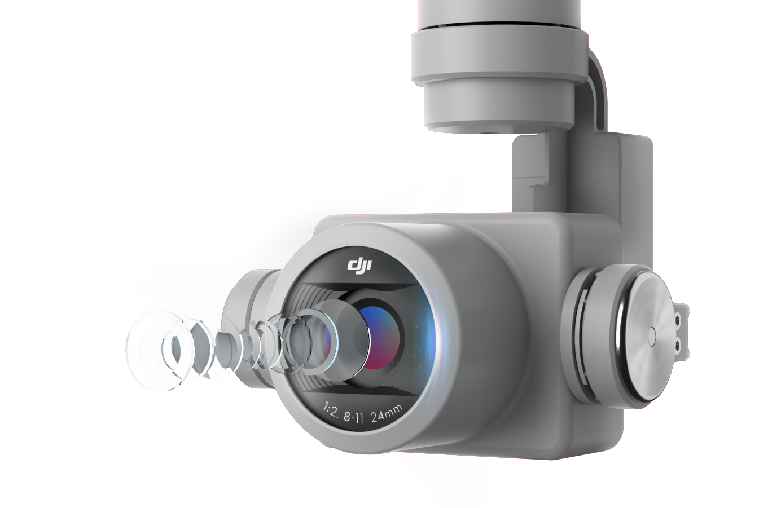  http://bit.ly/2AhqfeV
Disable Automatic Distortion Correction | Some surveyors prefer to disable ‘distortion correction’ to achieve better results during the distortion parameters when uploaded into third-party post processing software.
Timesync – Aligns flight controller and RTK module automatically | Aligning the flight controller, RTK module and camera on a millisecond level ensures that each photo captured by the Phantom 4 RTK has the most accurate positioning data.  It matches the positioning data to the center of the camera’s CMOS sensor and therefore optimises the results from photogrammetric methods. | 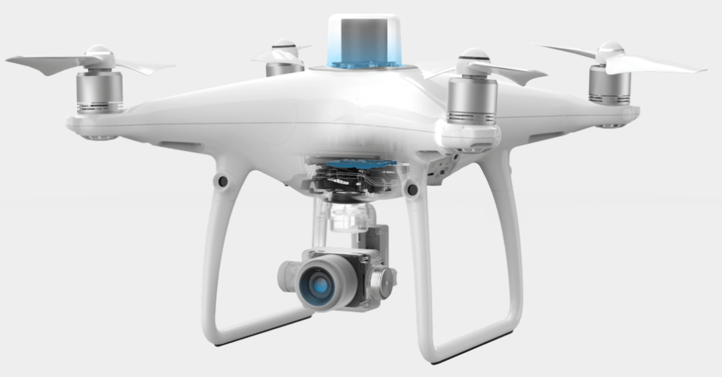  http://bit.ly/2CSfm5H
D-RTK 2 Mobile Station | The D-RTK 2 Mobile Station improves overall positioning reliability.  Connected with DJI’s data link, Ocusync, it helps to achieve accurate results in areas with low mobile network coverage. | 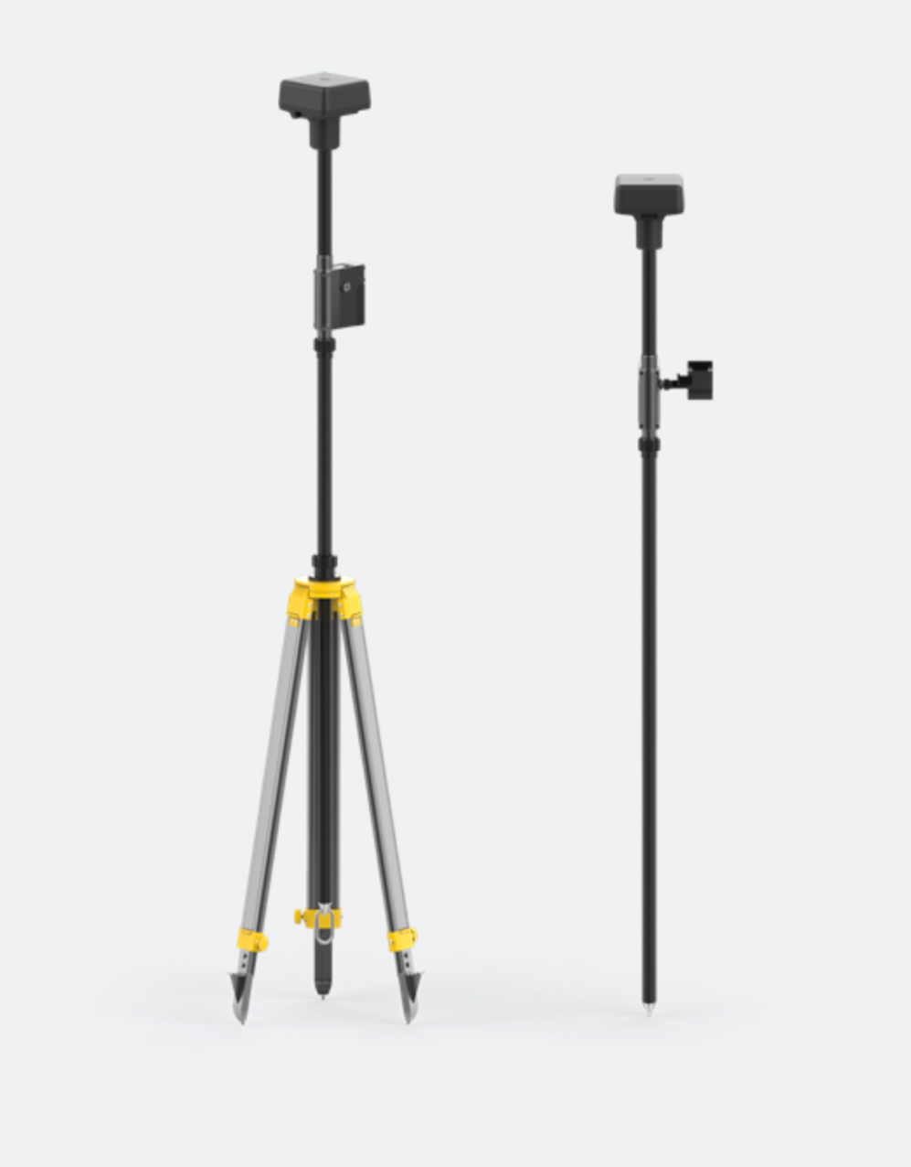  http://bit.ly/2NLYXR9
Operation Resumption Function | Mapping of large areas may require the battery to be replaced.  The Phantom 4 RTK automatically resumes the mapping back at the position where it left off and continues completing the mission.
OcuSync Transmission System | Enables reliable stable connection between the drone and its remote control with live HD video and control transmission to the controller’s screen at distances up to 7km.

