**Nightmare weekend sums up Bäckman's ADAC GT4 Germany debut**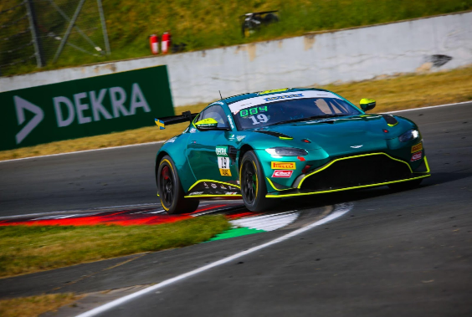Andreas and Jessica Bäckman had a tough start to the German GT4 championship.  
Photo: Axel Weichert (Free rights to use the image)

**Last weekend, May 26-28th, siblings Andreas and Jessica Bäckman made their GT4 debut in ADAC GT4 Germany at the Oschersleben circuit in Germany. The weekend started well with good speed in practice, but then the bad luck started. Technical problems after technical problems led to a tough weekend with two retired races.**

**- It was a very tough weekend for us, we never got to show what we were capable of this weekend, which is sad, but this can happen in motorsport. We have to look ahead to the next race, Jessica Bäckman says.**

The previous weekend, May 26-28, the Bäckman siblings made their debut race in ADAC GT4 Germany. On the starting line, Bäckman faced 27 of the best GT4 drivers/cars in the world. The weekend started positively with fourth best time in the first practice and seventh best in the second practice.

- We had good speed right from the start of practice sessions, so we felt ready and confident for the qualifyings and advance to give us good starting positions for the races, **Andreas Bäckman** says.

**Tough weekend for the siblings**In the first qualifying on Friday evening, it was Andreas who qualified. The pace was looking promising after the practice sessions but he was then unfortunately blocked on his fastest laps by drivers coming out of the pits in front of him. The qualifying result was a final 12th place.

- It was frustrating as I felt that I had more speed and could have qualified at the top, **Andreas Bäckman** says.

For the first race that was run on Saturday morning, it was Andreas who started the race from 12th position. The start of the race he was hanging on just fine but with the tight Oschersleben track, which is known for being difficult to overtake on, it was difficult to move up in the field. Then it was time for the driver change and Jessica's turn to drive. She continued to chase ahead in the field but with a few laps to go she had to retire from the race with technical problems.

- It was disappointing to have to retire the car with only a few laps left, especially when there are problems with the car that you, as the driver, cannot influence, **Jessica Bäckman** says.

For Sunday's qualifying, it was Jessica's turn to qualify. Unfortunately, she was also hit by traffic on her fastest laps and didn't get the chance to set the lap times she felt she and the car were capable of. She qualified in 17th place, which then became a 15th starting position after two drivers were penalized.

In the race, Jessica started the race and had a good start and was on her way to the front of the field, but after four laps she again suffered with technical problems and was forced to stop the race in the pits.

- It was a very tough weekend for us, we never got to show what we could do this weekend, which is sad, but this can happen in motorsport, so we have to look ahead to the next race, **Jessica Bäckman** says.

**Andreas and Jessicas results:**Free practice 1: 4th place  
Free practice 2: 7th place  
Q1: 12th place  
Q2: 17th place  
Race 1: DNF  
Race 2: DNF

**TV links in case you missed the races:**[Click to watch Q2](https://www.youtube.com/live/-3Gjbitsw5k?feature=shareature=share)[Click to watch Race 1](https://www.youtube.com/live/kmLbRG97jLk?feature=shareature=share)[Click to watch Race 2](https://www.youtube.com/live/cA3qshoihlM?feature=shareure=share)

**ADAC GT4 Germany Calendar 2023:**May 26-28th - Oschersleben, Germany  
June 23-25th - Zandvoort, Netherlands  
August 4-6th - Nürburgring, Germany  
August 18-20th - Lausitzring, Germany  
September 8-10th - Sachsenring, Germany  
October 20-22nd - Hockenheim, Germany

***Free rights to use images***

Download press pictures here:  
[http://bit.ly/jabaeckman-photos](http://postman.mynewsdesk.com/ls/click?upn=4mSYdFH0I-2BnSctn7rnXbif8-2FRfm6fHVIS6FXq16TURLmrFdqRw6dteDZaOJjr-2FMyMv-C_ZtyLTlYa78bQffWNrIlGC89uBpjFc4wPoL31whaXJXqA-2BRsUrcXzNWFVj0soHGyX26TNNKzSJG8P29CGUwlZk8wMQScmiadZYmHpC5iaM8tEj74cd2-2Bshm3O-2FicQq1rN-2B0J0spS3qWh-2BTd-2BFOtBEGa0hOPevvcT2ZyNuHn4H24lKD8TOMITvV1ITcL4U3LzSFx4eOoVK5r4xBL0-2BnU3AkA5GnTB1N-2FfgzX5T-2FCyjfX8QYE-2B1bRomuvp1CRJ9jo6VHV7zdrYo8QRpmhYze5b1YEUC-2FpQPaNS-2BzMu0kM7NT7Yj7NRMRxsnQvHEYLLpOvzAprZR9xDIqp0dZewR1BOC3zAHf53kx-2FmuoA3Hk-2BNR0k1GbIbiJM8AVhlcZn785MT2KNYO7jZK3B-2Btt9-2B05D3EU9yXtL1yaNt074kK1qPv7UA-3D)[https://www.mynewsdesk.com/se/ja-backman/images](http://postman.mynewsdesk.com/ls/click?upn=WoIcRi1A806qLxoNW47-2ByDMK-2FB9-2BYkCh6O459BWDJ545aOroHSZTzKtBcMykYW8eQ6ERGgPGp-2FcoK9cMyYIVnA-3D-3D9B3L_ZtyLTlYa78bQffWNrIlGC89uBpjFc4wPoL31whaXJXqA-2BRsUrcXzNWFVj0soHGyX26TNNKzSJG8P29CGUwlZk8wMQScmiadZYmHpC5iaM8tEj74cd2-2Bshm3O-2FicQq1rN-2B0J0spS3qWh-2BTd-2BFOtBEGa0hOPevvcT2ZyNuHn4H24lKD8TOMITvV1ITcL4U3LzSFx4eOoVK5r4xBL0-2BnU3AkH-2FkBB-2Fy-2BZ-2FJS-2Bo4uhkD6tP2ZO42tgESlOtnQ-2FJzqTvHzSuvUBXoWvWlpWT3ykHsq37UjtrEBmbC4dNCOeD0zEK7OxzrMO3WGfBVeo2bEXTCg7wK3CBUoYPKnYb-2FitNVPaMjt-2BjF-2BhA5xQzTnF-2BLcTU3m0CGdhkEXaQWnN8EoYJIsF-2FE9yWeYWT1x8pPJqLs1djRjvnKGJE249ArqbthAmg-3D)

