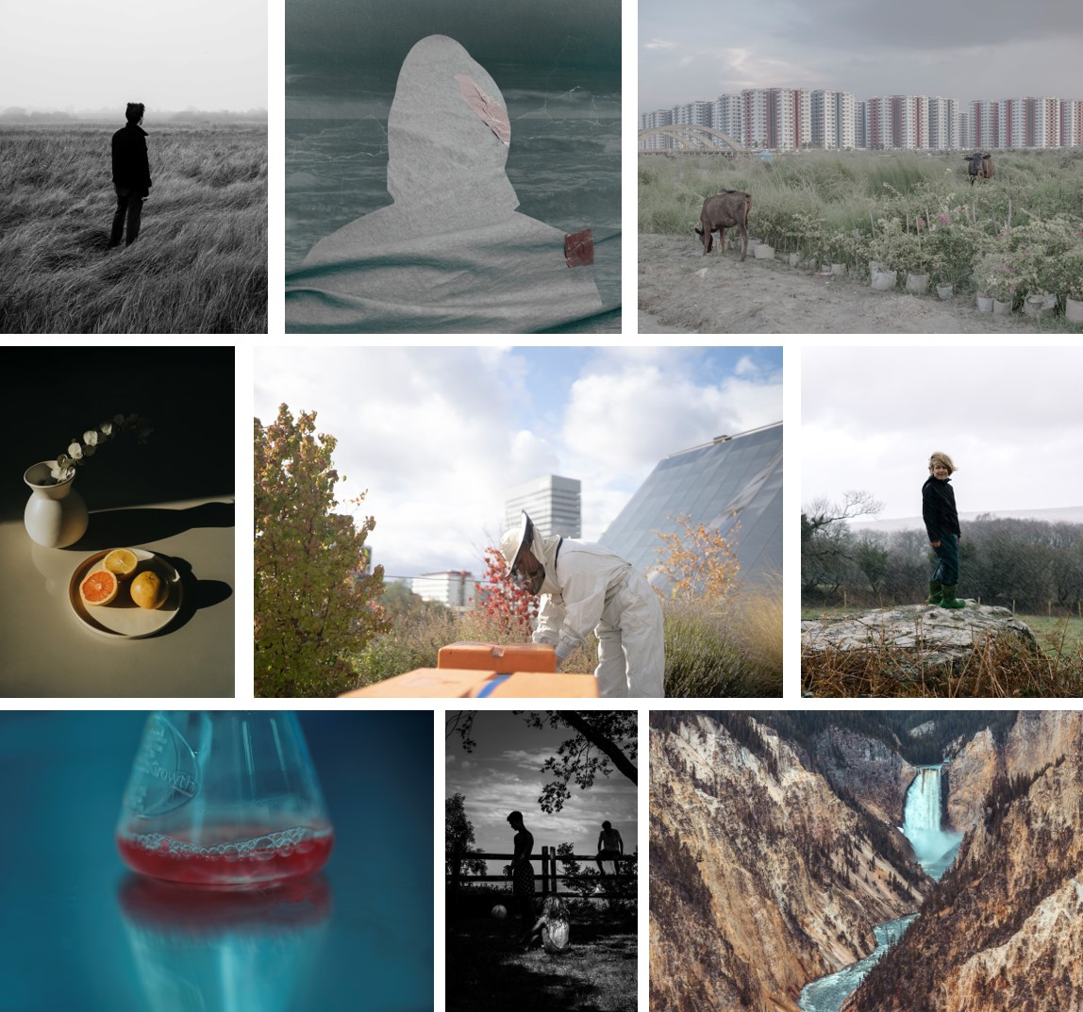

The World Photography Organisation announces today the shortlisted photographers in the Student competition and new information about photographic projects by Sony Student Grant 2019 recipients. Also included are details of photographers shortlisted in the Youth competition. Works by Student and Youth shortlists and Student Grant recipients will go on display as part of the Sony World Photography Awards 2020 exhibition at Somerset House this April.

STUDENT COMPETITION SHORTLIST

The Student shortlist features bodies of work by ten students at leading higher education institutions from across the world. Students were challenged to submit a series of five to ten images responding to two different briefs. All ten shortlisted photographers have won Sony digital imaging equipment to help complete their project with the Student Photographer of the Year winner due to receive €30,000 worth of Sony photography equipment for their institution.
The first brief Invisible Lines asked students to engage with the stories of people trying to break invisible barriers and structures whether natural, social or intellectual. Reyad Abedin’s (Bangladesh, Counter Foto - A Center for Visual Arts), The Name of My City is Dust and Smoke and Life features images of his native city Dhaka in which rapid infrastructure development and the eroded boundaries between nature and manmade constructions has had a devastating effect on the ecological balance of the environment in and around the city. For her project The Truth is in The Soil, Ioanna Sakellaraki (Greece, Royal College of Art) dwelled with the traditional communities of female professional mourners, or moirologists, inhabiting the Mani peninsula in Greece. Responding to personal grief and loss, Sakellaraki’s images depict the silhouettes of the mourning women projected against abstract backdrops which convey our relationship to and acceptance of death.

The second brief, Sustainability Now, tasked students with producing a body of work connected to environmental sustainability. Highlights include Guardians by Fangbin Chen (China Mainland, Qilu University of Technology), which records efforts by the photographer’s local community to contain the spread of coronavirus. Referencing the predation of wild animals as the likely source of the epidemic, Chen’s photographs urge people to reconsider their relationship to the natural world. In Roots of Cause, Arantza Sánchez Reyes (Mexico, LCI Monterrey) reflects on the efforts of individuals living in Monterrey, Mexico, known as one of the most polluted cities in Latin America, to strike a renewed balance with nature by practicing a more sustainable lifestyle.

Other featured students include: Micaela del Sol Angulo (Peru, Centro de la Imagen), Robin Ansart (France, Ecole Nationale Supérieure Louis-Lumière), Amy Davis (South Africa, CityVarsity Cape Town), Ashley Tofa (New Zealand, The University of Auckland), Tobia Faverio (Italy, Nuova Accademia di Belle Arti) and Chip Skingley (UK, University of the West of England – Bristol).

This year’s Student shortlist was judged by Tim Clark, curator, writer and Editor in Chief 1000 Words.

SONY STUDENT GRANT 2019

Chosen from the Student competition shortlist of the Sony World Photography Awards 2019 the latest Sony Student Grant recipients are Joel Davies (UK), Sam Delaware (USA) and Tobias Kobborg Kristensen (Denmark). Each photographer was given $3,500 (USD) and asked to use their Sony cameras to produce a project in response to the brief of Changing Cities, an exploration of green initiatives across different cities.

The resulting projects will be exhibited at the Sony World Photography Awards 2020 exhibition and include:
We Reap What We Sow by Joel Davies depicts at the work of the Freightliners Farm, a charity operating in the borough of Islington, London – the most densely populated district in the UK. Davies’ images document the volunteers and visitors for which the farm acts as a much needed green space and communal support. Cellular Culture by Sam Delaware features innovative research undertaken by JUST Inc. a food manufacturing company based in San Francisco, looking to turn to lab grown meat to mitigate societies’ impact on earth’s natural resources. Green Copenhagen by Tobias Kobborg Kristensen features the efforts and initiatives by the city’s officials and residents towards reaching their goal of becoming the first carbon neutral capital by 2025.

YOUTH COMPETITION SHORTLIST

This year, the World Photography Organisation introduced a new format for the Youth competition 2020, which aimed to give more opportunities to young photographers and resulted in more than a 50% increase in entries. Running from June to December 2019, entrants were asked to submit up to three images relating to a specific theme each month. Themes included Landscape, Travel, Portraiture and Street Photography. Each month a new category winner was announced and added to the shortlist for the Youth Photographer of the Year 2020 award.

Youth competition shortlist 2020 includes:

Jason Chen’s (USA, 17yrs, Landscape, June 2019) photograph features a majestic scene of the river and waterfall known as the Grand Canyon of Yellowstone. Through his image Dita Suci Putri Rahmawati (Indonesia, 18yrs, Environment, July 2019) wishes to raise awareness about the polluted and dangerous living conditions in TPST Piyungan in the Bantul Regency of Yogyakarta. Bruce Bai (China Mainland, 17yrs Nature & Wildlife, August 2019) presents a black & white picture of the tranquil surface of Qinghai Lake in China. Ram Kaushalyan’s (India, 17yrs, Travel, September 2019) image depicts the face of a young woman preparing for the Maha Shivaratri Festival in Kaveripattinam, an annual celebration in honour of the Lord Shiva. For her shortlisted portrait Kolton Almany (USA, 16yrs, Portraiture, October 2019) decided to photograph her model in a library setting to represent the various chapters and stories in people’s lives. Hsien-Pang Hsieh (Taiwan Region, 19yrs, Street Photography, November 2019) uses his image, of a man seemingly walking hurriedly but in fact standing still, to comment on the intensive pace of life and encourage others to slow down from time to time. Liam Moynihan’s (USA, 17yrs, Open Call, December 2019) high contrast black & white photograph features the dark outlines of three boys playing ‘roofball’ at a summer camp, Worton, Maryland.

Youth Photographer of the Year is chaired by Gisela Kayser, Managing Director and Artistic Director, Freundeskreis Willy-Brandt-Haus e.V., Berlin. Alongside worldwide exposure with today’s leading image-makers, the winner will receive a range of Sony digital imaging equipment to nurture their vision.

STUDENT COMPETITION 2020 SHORTLIST

Reyad Abedin, Bangladesh
Counter Foto – A Center for Visual Art

Robin Ansart, France
Ecole Nationale Supérieure Louis-Lumière

Micaela Del Sol Angulo, Peru
Centro de la Imagen

Fangbin Chen, China Mainland
Qilu University of Technology

Amy Davis, South Africa
CityVarsity Cape Town

Tobia Faverio, Italy
NABA Nuova Accademia di Belle Arti

Ioanna Sakellaraki, Greece
Royal College of Art UK

Arantza Sánchez Reyes, Mexico
LCI Monterrey

Chip Skingley, UK
University of the West of England

Ashley Tofa, New Zealand
The University of Aukland

YOUTH COMPETITION 2020 SHORTLIST

LANDSCAPE: Jason Chen, USA

ENVIRONMENT: Dita Suci Putri Rahmawati, Indonesia

NATURE & WILDLIFE: Bruce Bai, China Mainland

TRAVEL: Ram Kaushalyan, India

PORTRAITURE: Kolton Almany, USA

STREET PHOTOGRAPHY: Hsien-Pang Hsieh, Taiwan Region

OPEN CALL: Liam Moynihan, USA

IMAGES AVAILABLE AT WORLDPHOTO.ORG/PRESS

PRESS CONTACTS
FOR FURTHER INFORMATION, PLEASE CONTACT:
Inbal Mizrahi on press@worldphoto.org / +44 (0) 20 7886 3018
NOTES TO EDITORS

ABOUT SONY WORLD PHOTOGRAPHY AWARDS
Produced by the World Photography Organisation, the internationally acclaimed Sony World Photography Awards is one of the most important fixtures in the global photographic calendar. Now in its 13th year, the free-to-enter Awards are a global voice for photography and provide a vital insight into contemporary photography today. For both established and emerging artists, the Awards offer world-class opportunities for exposure of their work. The Awards additionally recognise the world’s most influential artists working in the medium through the Outstanding Contribution to Photography Awards; previous recipients include Martin Parr, William Eggleston and Nadav Kander. The Awards showcase the works of winning and shortlisted photographers at a prestigious annual exhibition at Somerset House, London. To book tickets please visit worldphoto.org/sony-world-photography-awards-exhibition
ABOUT SONY GRANT
Furthering Sony’s commitment to supporting contemporary photographers and contributing to the continued development of photographic culture worldwide, the Sony Grants program was introduced in 2016 and is organised by the World Photography Organisation. It provides winning and shortlisted photographers of the Sony World Photography Awards with additional opportunities to cultivate and establish an ongoing relationship with Sony after the Awards. The recipients are chosen by Sony from the Awards’ Professional and Student competitions.

ABOUT WORLD PHOTOGRAPHY ORGANISATION
The World Photography Organisation is a global platform for photography initiatives. Working across up to 180 countries, our aim is to raise the level of conversation around photography by celebrating the best imagery and photographers on the planet. We pride ourselves on building lasting relationships with both individual photographers as well as our industry-leading partners around the world. The World Photography Organisation hosts a year-round portfolio of events including the Sony World Photography Awards, one of the world’s leading photography competitions, and PHOTOFAIRS, leading international art fairs dedicated to photography. For more details see worldphoto.org. Follow the World Photography Organisation on Instagram (@worldphotoorg), Twitter (@WorldPhotoOrg) and LinkedIn/Facebook (World Photography Organisation). Our hashtags to follow are #sonyworldphotographyawards #swpa.

ABOUT SONY CORPORATION
Sony Corporation is a creative entertainment company with a solid foundation of technology. From game and network services to music, pictures, electronics, semiconductors and financial services - Sony's purpose is to fill the world with emotion through the power of creativity and technology. For more information, visit sony.net

SONY IMAGING PRODUCTS & SOLUTIONS INC.
is a wholly-owned subsidiary of Sony Corporation that is responsible for its imaging products and solutions businesses, from consumer camera, solutions with a focus on broadcast- and professional-use products, to medical business.

VISITOR & LISTING INFORMATION
TITLE: Sony World Photography Awards 2020
VENUE: Somerset House, London, WC2R 1LA
DATES: 17 April – 4 May, 2020
OPENING TIMES: Monday - Friday, 10am-9pm / Saturday - Sunday, 10am-8pm
TICKETS: Available to buy on 5 March, 2020 (£9-14). Find out more at worldphoto.org/exhibition

IMAGE CREDITS

LEFT TO RIGHT BY ROW:
© Chip Skingley, United Kingdom, Student Shortlist, 2020 Sony World Photography Awards
© Ioanna Sakellaraki, United Kingdom, Student Shortlist, 2020 Sony World Photography Awards
© Reyad Abedin, Bangladesh, Student Shortlist, 2020 Sony World Photography Awards
© Arantza Sánchez Reyes, Mexico, Student Shortlist, 2020 Sony World Photography Awards
© Chip Skingley, United Kingdom, Student Shortlist, 2020 Sony World Photography Awards
© Sam Delaware, United States, Sony Professional Grant, 2020 Sony World Photography Awards
© William Moynihan, United States, Category Winner, Youth competition, Open call, 2020 Sony World Photography Awards
© Jason Chen, United States, Category Winner, Youth competition, Landscape, 2020 Sony World Photography Awards

