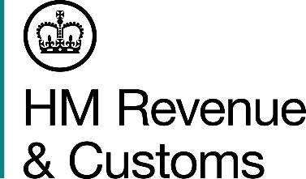
News Release

 | For the attention of News Desks |  | No of pages: 2
 | Date: | 5 January 2018 | Ref: | LON 01/18

Food for thought as delivery boss sentenced

A company director who used his food delivery business to make £227,000 in false tax claims over ten years has been sentenced.

Billa Dhand, 56, from Southall, West London, was the director of Dysan Fresh Ltd, which delivered fruit and vegetables to be processed for the UK’s big supermarket chains.

Investigators from HM Revenue and Customs (HMRC) found Dhand had charged his customers VAT but failed to pass it on to HMRC. He created hundreds of false invoices between 2006 and 2016 to hide VAT receipts and reclaim VAT repayments totalling £227,764.84.

Mark Cox, Assistant Director, Fraud Investigation Service, HMRC said:

“Dhand thought he was above the law and could get away with cheating the system. He was wrong and is now paying the price for his greed.

“Tax cheats take money from the public services we all rely on. Anyone with information about tax fraud can contact our hotline on 0800 788 887.”

Dhand pleaded guilty to four counts of fraud. He was given a seven-year jail sentence, suspended for two years, at Southwark Crown Court on 4 January 2018.

On sentencing Dhand, Her Honour Judge Korner said: “This was an extremely serious offence. HMRC has to operate on trust that people will comply with the law and pay the tax owing. You failed to do so. It was a carefully planned and deliberate fraud.”

HMRC is seeking to recover Dhand’s criminal proceeds.

Notes to Editors

- Billa Dhand, DOB 07/01/61, a company director, of Hartington Road, Southall, London, UB2, was found guilty at Southwark Crown court on 4 January, 2018 of four counts of fraud and was sentenced to seven years of jail, suspended for two years. He was also ordered to do 250 hours of unpaid work.
- Follow HMRC Press Office on Twitter @HMRCpressoffice.
- HMRC's Flickr channel: www.flickr.com/hmrcgovuk.

Issued by HM Revenue & Customs Press Office

Press enquiries only please contact:

Roger Kasper
Tel: 03000 525110 / 07388 955843
Email: roger.kasper@hmrc.gsi.gov.uk

Or

Helen Danson
Tel: 03000 541066 / 07730 812571
Email: helen.danson@hmrc.gsi.gov.uk

Out of hours
Tel: 07860 359544

Website www.gov.uk/hmrc

