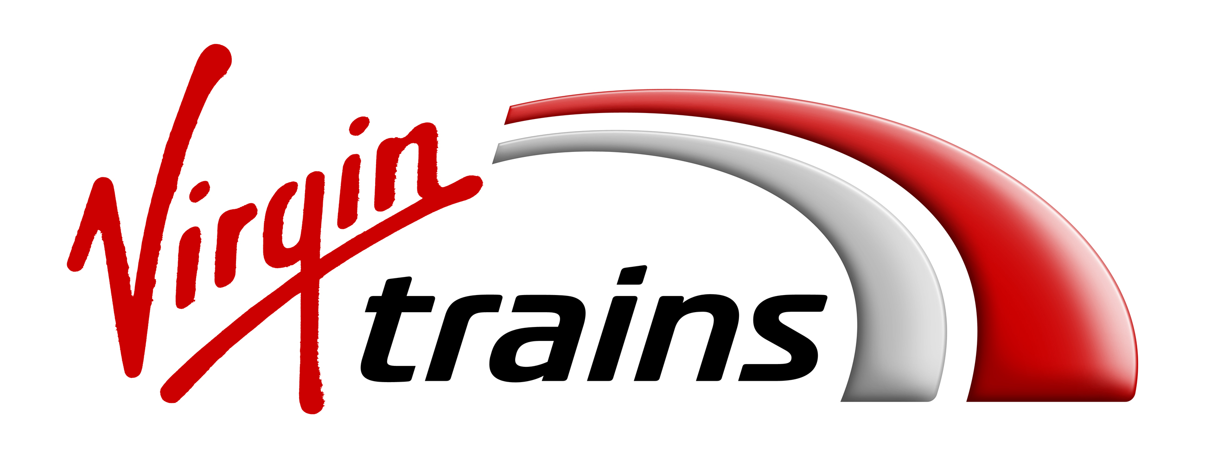

**Press Release**

**GRAB A BLACK FRIDAY FESTIVE BARGAIN WITH A QUARTER OF A MILLION DISCOUNTED TICKETS ON VIRGIN TRAINS**

* Up to 52% off selected First and Standard advance fares, including the London to Manchester Standard ticket
* Tickets starting from only £5 in the five-day seat sale from Thursday 23rd November

Virgin Trains Winter Seat Sale is set to spread festive cheer up and down the country this November with tickets starting from just £5.

A quarter of a million First Class and Standard ticket prices will be slashed over five days with Virgin Trains on the West Coast from Thursday 23rd November to Monday 27th November. Visiting family and friends this winter has never been easier, with many destinations along the route available for half the usual price.

Whether sipping delicious mulled wine at the Birmingham Christmas market, ice skating outside the iconic Natural History Museum in London, enjoying the magical Manchester panto Dick Whittington or celebrating with loved ones, Virgin Trains customers will see their money travel further without compromising on style and comfort beyond the festive period and into mid-January.

Customers can travel between Monday 18th December 2017 to Sunday 14th January 2018 and even treat themselves to a First Class experience.

Discounted fares are available on First and Standard Class Advanced tickets, and include:

* London to Manchester Standard Class: originally £23, now £11
* London to Glasgow Standard Class: originally £30, now £18
* London to Birmingham Standard Class, originally £8, now £5
* London to Manchester First Class: originally £45, now £30
* London to Glasgow First Class: originally £60, now £37
* London to Birmingham First Class: originally £27, now £17

Sarah Copley, Executive Director Commercial, for Virgin Trains on the West Coast, said: “Virgin Trains is about connecting with friends and family, and that’s at the heart of what we do. With our seat sale this winter, our customers can easily make those important journeys and maybe even treat themselves with a First Class experience. We get you there quicker than the car, and with our industry firsts - such as mobile ticketing, automatic compensation for delays and our free on-demand entertainment app beam – your journey should be smoother and more enjoyable too. With 250,000 discounted First Class and Standard tickets, our passengers can look forward to their journeys even more this winter.”

Discounted tickets on Virgin Trains West Coast will be available to book from 00:01 on Thursday 23rd November exclusively at [www.virgintrains.com](http://www.virgintrains.com) and Trainline.

ENDS

For more information, please contact Lily Marriott at Kaper,

020 3301 2261 / [lily@kaper.uk.com](mailto:lily@kaper.uk.com)

**Terms & Conditions**

Terms and Conditions apply, see [www.virgintrains.com/sale](http://www.virgintrains.com/sale)

**Notes to Editors**

The blackout dates pre-Christmas would be Friday 22nd and Saturday 23rd December. Wednesday 27th December will be excluded is it’s a key travel date and has major engineering works.

**About Virgin Trains**

Stagecoach and Virgin are working in partnership to operate the East Coast and West Coast inter-city routes under the Virgin Trains brand. Together, they are on track to revolutionise rail travel across the UK.

The combined network connects some of the nation’s most iconic destinations including Glasgow, Liverpool, Birmingham, Manchester, Edinburgh, Newcastle, Leeds, York and London.

Virgin Trains is committed to delivering a high speed, high frequency service, offering shorter journey times, more comfortable travel and excellent customer service. Customers consistently rate Virgin Trains as one of the top long-distance rail franchise operators in the National Rail Passenger Survey (NRPS) commissioned by industry watchdog, Transport Focus.

On the East Coast route, £140m is being invested to create a more personalised travel experience. We have already invested £21m to completely revamp our existing fleet and customers can now benefit from 42 additional services (22,000 extra seats) per week between Edinburgh and London. 2018 will see the introduction of completely new Azuma trains being built in the UK by Hitachi.

The West Coast route has a proud record of challenging the status quo - from introducing tilting Pendolino trains, to a pioneering automated delay repay scheme and becoming the first franchised rail operator to offer m-Tickets for all ticket types.

Visit the Virgin Trains Media Room - [http://mediaroom.virgintrains.co.uk](http://mediaroom.virgintrains.co.uk/) - for the latest news, images and videos. Subscribe [here](http://www.mynewsdesk.com/follow/47939) for regular news from Virgin Trains.

Press Office: 0845 000 3333. Company website: www.virgintrains.co.uk.