FOR IMMEDIATE RELEASE Stockholm, Nov. 20, 2020
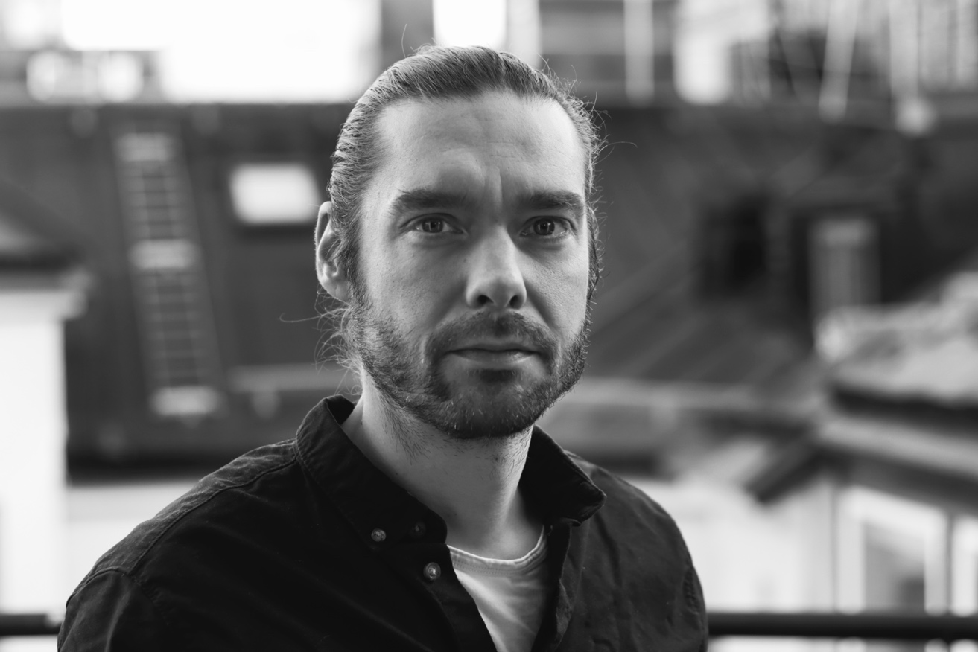
We are delighted that Daniel Enervald, an expert in filmmaking, 3D motion graphics,
AR and VR has joined the Open team to support our growing international client roster.
New digital storytelling star
to add magic for Open clients
STOCKHOLM, Nov. 20 – Open Communications, the Stockholm-based international brand communications agency, is strengthening its digital, film and social media offering with the addition of Daniel Enervald, an experienced digital storyteller with deep knowledge and craftsmanship in 3D film and motion graphics. The move is part of Open’s strategy to help its clients create brand experiences that move people and get results in an increasingly digital world.
“We’ve known Daniel for years and used his unique talents on multiple projects to add that extra sparkle, so we know what he can do,” says Open CEO, Brand Strategy Director and Co-owner Gunilla Lundström. “When he was looking for a new challenge, we jumped at the opportunity.”
New York digital experience
Daniel’s work was recently featured in Forbes Magazine for a virtual concept store he helped to designed with Valtech in New York for Estée Lauder’s MAC cosmetics brand. The store, which was cited as “The Next Step in Virtual Reality,” allowed customers to customize their own palettes, personalize product packaging, and virtually try on makeup shades or even entire looks created by MAC makeup artists. Most recently, Daniel worked at Frank, a digital agency focused on brand experiences, and earlier at Valtech (IT consulting), Crosby (visual storytelling) and C2 (creative production).
Guided by curiosity
“I was attracted by the opportunity to be involved in the entire creative process with global brands and to work with Open’s experienced international team, whom I’ve teamed up with previously,” says Daniel Enervald. “By nature, I’m a curious person and love to push the boundaries of storytelling in motion and design new, immersive experiences that strengthen the brand.”
Some tips and advice
Asked whether he has any advice for clients, Daniel cites three things:
1. Don’t get hung up on tools and effects – Always start with the story you want to convey and to whom. Be clear about the end result you want. Effects are only a means to an end.
2. Make sure everything reflects the brand tonality – For example, a premium brand should have high-quality imagery and graphics that reflects this.
3. Think about engaging all the senses – Everything from the music, voice and motion are increasingly important ingredients in creating an emotional connection with a brand.
“Daniel is a unique talent who can add that creative magic to everything from social media posts to film and virtual exhibitions or streaming projects,” says David Gray, Open Founder and Copy Chief.
All in all, the move further strengthens Open’s in-house capabilities to offer to its clients quick, relevant, high-quality creative work for cross-border brand-building.

- ENDS –
For more information:
Gunilla Lundström, CEO Open
Tel: + 46 70 292 71 14
Email: gunilla@open.se
About Open Communications
Open is an independent brand communications agency that focuses on complex international projects and works primarily in English. We combine insightful strategic thinking, Scandinavian design and emotional storytelling to activate brand experiences across a range of channels. Clients include Sandvik, Getinge, Iggesund, Sulzer, Andritz, Sedana Medical, Xylem, Ovako, Mycronic, Enequi, CAP, Thermo Fisher and others. www.open.se

