Epson launches brilliant HDR-Compatible home theatre projector with 4K enhancement technology
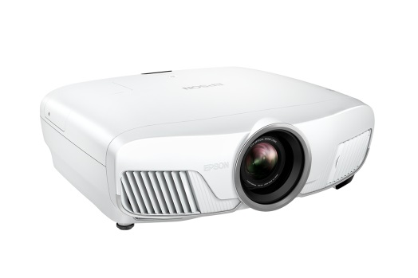

EH-TW8300 Home Theatre Projector

Kuala Lumpur, 28 November 2016 – Epson will be launching the EH-TW8300 series home projector with new 4K enhancement technology, delivering brilliant high-definition images with exceptional colour performance, sharpness and clarity for an immersive home cinema experience.

The EH-TW8300 projector is compatible with High Dynamic Range content, delivering clear, detailed and realistic images with enhanced details, sense of depth and 3D effects. The projector delivers 2,500 lumens of colour brightness and white brightness, and is ideal for a variety of room settings in both bright and dark settings.

Its 4K enhancement technology processes and reproduces the details of standard 1080p videos to appear as filmed or captured in 4K resolution. The results are extremely detailed images that are virtually indistinguishable from native 4K contents. With a contrast ratio of 1,000,000:1, the EH-TW8300 ensures rich details in both bright and dark scenes.

A new feature to the EH-TW8300 series are its motorized lenses that enable users to easily adjust zoom, focus and lens position according to their preference, and allows for preset of up to 10 positions for both standard projections and wide cinema ratios. Users can easily change the aspect ratio settings via remote control for the optimal viewing experience.

“The EH-TW8300 delivers premium value to the sophisticated home theater enthusiasts for its exceptional performance for an immersive experience. Combining the high contrast ratio of 1,000,000:1 together with 4K enhancement technology, users can enjoy the cinema experience in the comfort of their own home,” said Danny Lee, General Manager, Sales & Marketing, Epson Malaysia.

The EH-TW8300 projector comes with wireless HD transmitter with 4K compatibility. The wireless HD transmitter allows users to play a variety of entertainment contents wirelessly and conveniently from mobile devices.

***

About Epson
Epson is a global technology leader dedicated to connecting people, things and information with its original efficient, compact and precision technologies. With a lineup that ranges from inkjet printers and digital printing systems to 3LCD projectors, smart glasses, sensing systems and industrial robots, the company is focused on driving innovations and exceeding customer expectations in inkjet, visual communications, wearables and robotics.
Led by the Japan-based Seiko Epson Corporation, the Epson Group comprises more than 73,000 employees in 91 companies around the world, and is proud of its contributions to the communities in which it operates and its ongoing efforts to reduce environmental impacts.
http://global.epson.com/

About Epson Southeast Asia
Since 1982, Epson has developed a strong presence across major markets in Southeast Asia. Led by the regional headquarters, Epson Singapore Pte Ltd., Epson Southeast Asia spans an extensive network of 10 countries, and is responsible for delivering and supporting Epson’s cutting-edge consumer and business digital imaging products to the customers of these markets through its comprehensive infrastructure of over 360 service outlets, 10 Epson solution centres and 8 manufacturing facilities. http://www.epson.com.sg

About Epson <ESC information>

Media Enquiries:
Epson Malaysia Sdn Bhd  Chua Li Tinn  Manager – Marketing Communications  Tel: (03) 5628 8288 Ext 274  Email: ltchua@emsb.epson.com.my | SWOT Communications  Edina Manuel  Tel: 012 2500142  Email: edina@swotcommunications.com

