PRISREGN Over lg g5 på MWC
– LGs nyeste smartphone tog al opmærksomheden til mobilbranchens pendant til Oscar-uddelingen

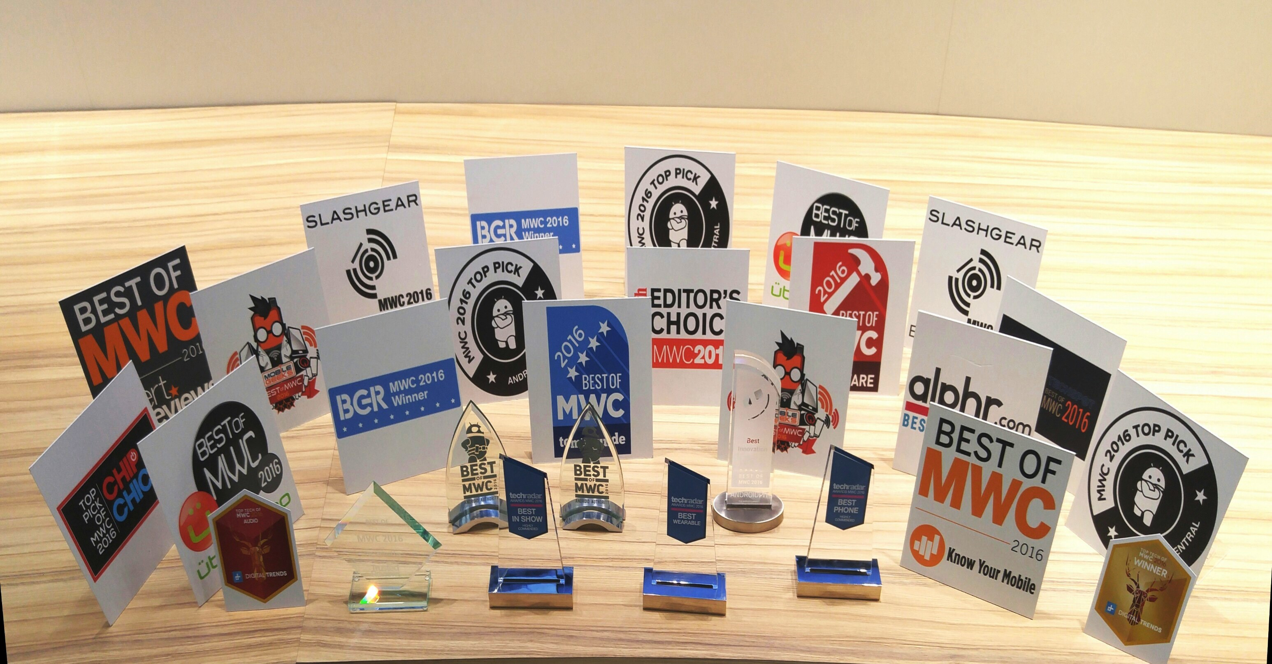
København, 26. februar, 2016 – LG Electronics tog ikke mindre end 33 forskellige priser med hjem ved dette års Mobile World Congress (MWC). LGs nyeste flagskib, LG G5, med sit modulære design og tilbehør tog den prestigefyldte top pris hjem, Best Mobile Handsets & Devices Award hvilket viser, at LG fører an på mobilområdet. LG G5 modtog også den højeste hædersbevisninger blandt Android Authority, Digital Trends og Ubergizmo.

For yderligere information om LG G5, besøg LG Electronics danske presseside.

Læs mere om prisregnen over LG Electronics og LG G5 med tillbehør ved Mobile World Congress 2016 i den engelske pressmeddelse nedenfor:

LG G5 & FRIENDS WIN AT MOBILE WORLD CONGRESS

LG’s Newest Smartphone Sweeps the Competition at the Mobile Industry ‘Oscars’

BARCELONA, Feb. 25, 2016 ― LG Electronics amassed a total of 33 awards at Mobile World Congress (MWC) 2016 including the event’s top honor, Best Mobile Handsets & Devices Award, securing status as the most honored company at the show. The wins highlighted the Modular Type innovation behind LG’s latest flagship smartphone, the LG G5 and Friends, demonstrating that the company is at the forefront of mobile communications. LG G5 and Friends earned top honors from Android Authority, Digital Trends, Trusted Reviews and Ubergizmo, among others.

“The initial response to our new LG G5 has been phenomenal and rewards the effort our experts have made to create something genuinely innovative and unique in the smartphone space,” said Juno Cho, president and CEO of LG Electronics Mobile Communications Company. “The G5 and its Friends modules are aimed at giving consumers a more playful smartphone experience and these awards suggest that we have offered something truly different in the market.”

LG unveiled the G5 to a 2,000 strong crowd prior to the main MWC event to high acclaim. The flagship smartphone is a brand new design with a sleek, metal uni-body featuring a Slide-out Battery and a Modular Type design that gives a greater smartphone experience. Complete with LG Friends, a collection of companion devices, the G5 can be transformed into a digital camera, Hi-Fi player and more.

With an estimated 100,000 attendees, MWC 2016 is the mobile industry’s keynote event. Awards won by LG at MWC 2016 include:
GSM Association (GSMA)
Best Mobile Handsets & Devices - LG G5

4gnews
Major Revelação - LG G5

Alphr
Best Smartphone - LG G5

Android Authority
Best of MWC 2016 - LG G5 / LG Friends

Android Central
MWC Top Pick - LG G5 / LG Rolling Bot / LG 360 VR

Android Pit
Best Innovation - LG G5

BGR
MWC 2016 Winner - LG G5 / LG Rolling Bot

Chip Chick
Most Innovative - Rolling Bot

Digital Trends
Top Tech of 2016 Winner - LG G5
Top Tech of 2016 Audio - LG Hi-Fi Plus

Expert Reviews
Best of Innovation - LG G5
Best Smartphone - LG G5

Know Your Mobile
Best of Innovation - LG G5
Best Smartphone - LG G5

Men’s Health
Editor’s Choice - LG G5

MobileGeeks
Best Smartphone - LG G5
Most Innovative Company - LG Electronics

Slashgear
Best Smartphone - LG G5
Best Accessory - LG Rolling Bot

Techradar
Best in Show - LG G5 & Rolling Bot
Best Phone - LG G5
Best Wearable - LG 360 VR

Techspot
Best of MWC - LG G5

Tom’s Guide
Best of MWC - LG G5

Tom’s Hardware
Best of MWC - LG G5

Trusted Reviews
Best of MWC 2016 - LG G5 / Rolling Bot

Ubergizmo
Best of MWC – LG G5 / LG Friends

For more information about LG's products at MWC 2016, please visit www.LGnewsroom.com/MWC2016.

Om LG Electronics
LG Electronics, Inc. (KSE: 066570.KS) er en af verdens største leverandører og en innovator inden for forbrugerelektronik, husholdningsapparater og mobilkommunikation med 83 000 ansatte fordelt på 119 kontorer i verden. LG opnåede en global omsætning på 55,91 milliarder USD i 2014. LG består af fire hovedområder – Home Entertainment, Mobile Communications, Home Appliance & Air Solution og Vehicle Components – og er en af verdens største producenter af fladskærms tv, mobiltelefoner, luftvarmepumper, vaskemaskiner og køleskabe. Siden oktober 1999 er LG Electronics kommet til Norden. Den nordiske omsætning var i 2014 omkring 2,2 milliarder SEK. For mere information, besøg www.lg.com.

Om LG Electronics Mobile Communications
LG Electronics Mobile Communications Company er et globalt ledende foretagende inden for mobil kommunikation. Gennem avanceret teknik og innovativ design, skaber virksomheden produkter, der skaber en bedre livsstil for forbrugere over hele verden gennem en komplet smartphone oplevelse. Som et ledende foretagende inden for 4G Long Term Evolution (LTE), fortsætter LG forpligtelsen for, at skabe banebrydende LTE-teknologi og opfylde forbrugerens behov gennem differentierede LTE-produkter af højeste kvalitet, baseret på selskabets store beholdninger af LTE patenter og tekniske viden.

For mere information kontakt:
LG-One Hill+Knowlton (LG’s PR-bureau)  Tel: +45 33 13 14 33  E-post: lg-oneDenmark@lg-one.com | Thomas Wering  Nordic Marketing Manager MC  LG Electronics Nordic AB  Box 83, 164 94 Kista  Mobil: +46 (0)735 234 026  E-post: thomas.wering@lge.com

