PRESS RELEASE Sochi, Russia 2014-02-11

**International Anti-Doping Warrior and Chairman of the IOC’s Medical Commission Received Top Honors in Sochi**

**The Foundation for Global Sports Development (GSD) is putting drug-free competition in the spotlight by honoring Professor Arne Ljungqvist – Chairman of the International Olympic Committee’s (IOC) Medical Commission, former Vice Chairman of the World Anti-Doping Agency (WADA) and– with their prestigious Humanitarian Award.**

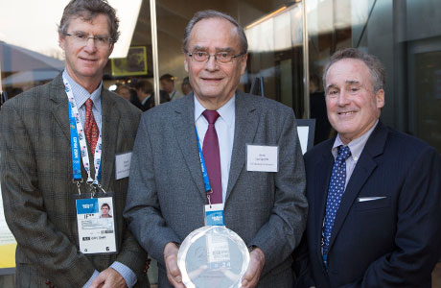

*David Ulich, executive board member of GSD, Professor Ljungqvist and  Dr Dr. Steven Ungerleider,  founding trustee of GSD. Photo: IOC/Greg Martin*

This year’s ceremony was held at the USA House in the Sochi Olympic Park on February 8, and featured an influential lineup of guests and speakers that includes IOC Vice President and WADA President Sir Craig Reedie and IOC member Dr. Ugur Erdener, at the ceremony representing IOC President Thomas Bach. In addition to the distinguished award, GSD presented Professor Ljungqvist with a $100,000 grant for his own foundation – Professor Arne Ljungqvist Anti-Doping Foundation – to use toward advancing the foundation’s work for clean sport and healthy life style.

GSD’s Humanitarian Award was created in 2010 in an effort to honor and recognize individuals and organizations that work to preserve the values of fair play, sportsmanship and drug-free competition in the world of sports.

“I think this award is hugely important. I think it is impossible to believe that this award could have ever been given to anybody who is more deserving.“

*Sir Craig Reedie, Vice President of IOC and President of WADA*

“This award was conceived to celebrate individuals that have stepped up to champion equality and integrity in sport and I can’t think of anyone who’s done more for the well-being of the global athletic community and the modern Olympics movement than Professor Arne Ljungqvist.”

*Dr. Steven Ungerleider, anti-doping expert and founding trustee of GSD*

“Given that it’s an Olympic year, Professor Ljungvist was a natural pick for our Humanitarian Award. Arne has been on the frontlines of the international clean sports movement since the early ‘70s and continues to be a thought leader in creating positive change, regardless of financial or scientific limitations.”

*David Ulich, executive board member of GSD*

Previous Humanitarian Award winners include former Olympian Richard W. Pound (2010) whom many have credited with saving the Olympic Movement; and President of the International Paralympic Committee, Sir Philip Craven (2012).

<http://globalsportsdevelopment.org/arne-ljungqvist-humanitarian-award/>

- - - - - - - - - - - - - - - - - - - - - - - - -

**SPEECHES:**

Introduction speech by David Ulich (GSD)  
<http://www.youtube.com/watch?v=2oO7cDPzfL8>

Speech by Sir Craig Reedie (IOC and WADA)  
<http://www.youtube.com/watch?v=9zpfY2_RCJ0>

Speech by Dr Ugur Erdener (Representing the IOC President Thomas Bach)  
<http://www.youtube.com/watch?v=2DqvJrXdkMA>

Speech by Dr Steven Ungerleider (GSD)

<http://www.youtube.com/watch?v=Rz6_DNBzJZI>

Thank you speech by Professor Arne Ljungqvist (PALJF)  
<http://www.youtube.com/watch?v=xJxywKkQ8vs>

- - - - - - - - - - - - - - - - - - - - - - - - -

**MORE INFO/CONTACT**

MyNewsdesk  
<http://www.mynewsdesk.com/pressroom/professor-arne-ljungqvist-anti-doping-foundation/news/view/professor-arne-ljungqvist-anti-doping-foundation-awarded-100-000-usd-by-the-foundation-for-global-sports-development-gsd-77114>

**Global Sports Development:**

Dr Steven Ungerleider: [drsteven@stevenungerleider.com](mailto:drsteven@stevenungerleider.com)

**Professor Ljungqvist Anti-Doping Foundation**

Kristina Wiberg, PA to Professor Ljungqvist: [Kristina.Wiberg@paljf.com](mailto:Kristina.Wiberg@paljf.com)  
  
Contact at site ­in Sochi:  
Bjorn Bertoft: [bertoft@paljf.com](mailto:bertoft@paljf.com)  
+7 938 439 9661