Upgrade Your Business, Get a CRM Implemented!
Efficiency in processes while achieving higher customer satisfaction rate is desired by all businesses. SenServe Limited’s CRM implementation will deliver you what you have dreamt of. It will help you effectively market, sell your products and so much more.
Introduction
In the current era of technology driven society it has become an utmost need to adopt IT at business. The dynamic environment of market is constantly putting businesses out of competition. To stay in operations it is necessary that a system is put in place like CRM (Customer Relationship Management) software to cope with the rising problems.
SenServe Limited has been excelling in providing tailor-made CRM solutions to its customers. These allow better interaction prospects with customers. Customised CRM ensures that it fits your business needs exactly. It will help you resolve problems and increase efficiency.
CRM implementation solution by SenServe enables businesses to achieve improved capabilities, significant reduction in operational costs and profitability.
Customer Relationship Management (CRM)
Customer loyalties are worth everything nowadays in market. Businesses would try to explore new extremes in order to achieve customer satisfaction. Such importance only makes us to think of ways of how to earn customers. Better delivery of services is what attracts customers.
What is CRM?
CRM Software looks after your Marketing, Sales, Orders and Support Campaigns. It delivers you with solutions to make your processes effective to convert more leads into loyal customers.

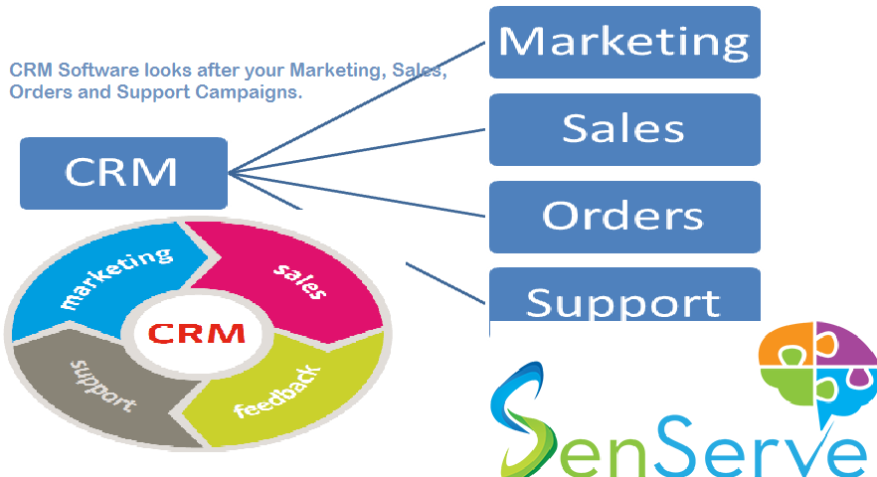
Marketing
CRM will help your marketing campaigns in an effective manner getting you more leads and forming a database of the contacts.
Through a CRM you will be able to launch email marketing campaigns. These will be customised according to customer preferences in the past to be more effective. CRM insights would give you the information in relation to the leads. These will then be added to the main database for follow up procedure by the Sales team. The main database will hold the data of all prospective clients and the campaigns will then be customised for them.
Sales
After the database is made of the leads, Sales team will then assign individual or group of leads to Sales Reps. These reps would then be responsible to help them convert to customers.
In the assigning process the relevant sales representative will give feedback about which leads qualified. These qualified leads will be entered into the database automatically.
Successful conversion of leads into customers will make CRM to put them in a database of customers. New products will then be marketed to them and any new opportunity will be tracked for future.
Orders
The ordering team will generally include those who are responsible for delivery of services. CRM will generate automatic tickets in respect of those in charge of service delivery.
After successful delivery the CRM will generate invoices to be sent to the customer in respect of the services delivered. These invoices will be computer generated and will be sent off to the customers for payment.
Support
CRM will assist the support team by managing the cases of different customers who might have to supply some feedback. This feedback would be forwarded to the relevant person.
Training schedules are also made by CRM for the support staff. After-Sales services are also put in the calendar for customers who require it. Through the queries and its answers a knowledge base is created to facilitate future users. These will be provided to customers so that they are aware of the usual stuff that they will encounter during their CRM usage.
CRM Classification
CRM can be broadly categorised into:
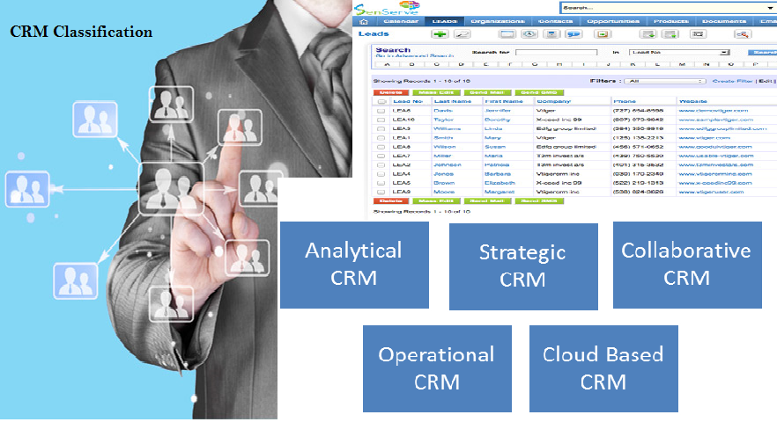
Analytical CRM
Purpose of an analytical CRM is to get you software which ensures timely delivery with complete effectiveness. These are based upon analytics obtained through an understanding of Customers. These offer businesses high-end methods to sales programs and more active customer conversion methods. This results in the higher customer retention ratios.
The prospects gained through this CRM can be used to assess different approaches that can be utilised for different customers.
Strategic CRM
These are CRMs which are mainly focused and force the whole of the system to run after a single focus. The whole strategy is made to revolve around a pivotal point which is regarded as the most crucial point when it comes to sales. These can be categorised in three main points namely Product, Production and Sales Oriented.
Product Orientation means that the business would believe that Product Quality is what makes the customers to buy their product. CRM will be focusing more on the quality of the products and the timely delivery too. It will ensure that the quality is maintained through putting up high standards and not compromising any defect when it comes to the overall build of the product.
Production Oriented focuses more on how the production takes place. In Services this would mean how they service is actually delivered. In this the End-Product is not the focus of business rather that of how it is delivered. These are of those businesses where customers give high regard to friendly environment and an easy way to get things done.
Sales Oriented Businesses are those which are focused purely on their relationship with the customers. These are businesses where the Quality of the Service along with how it is delivered is important. CRM will ensure that both of these things are maintained and customers get a high quality end-product on a timely basis.
Collaborative CRM
These are based upon Collaborative work of different entities which come together for synergy purposes. Together the customers are increased for the complementary products which each of the business might be providing. CRM would be taking input from all the businesses in collaboration to give outcomes benefitting all the businesses.
Such a CRM is mainly complex enough to address the needs of different businesses. Its infrastructure however can be different for business which have differing needs.
Operational CRM
Customer Services and Support is automated by the operational CRM. Applications that are put in the CRM are focused on enabling automation and integration of the whole sales process. The automation of processes at different stages allows users to get interactive ways of completing tasks.
Marketing is done in such a way that customer groups are made to facilitate the customisation of the campaign. These customer groups then are marketed the products which they might be interested in by carefully overviewing their past records.
Sales processes are also automated to deliver best results. Leads are managed to increase customer conversion rates. Customers are managed by the CRM for effective decision making for the future. The projects are managed by the CRM including the deadline and the tasks assignment to different individuals.
Services are also automated for better communications management. Services offered by different individuals are assigned by the CRM. The queries of customers are answered are dealt with by assisting the CRM.
Cloud Based CRM
CRM on cloud is mainly for those who like to do work over the go. SenServe CRM also runs on mobile and other devices so you are always connected with it. Being over the cloud helps it keep secure and out of the reach of any malicious on-lookers of data.
Access to the database can also be done from remote places where it is not possible to keep the entire system. Cloud storage also helps keep the data of customer safe complying with Data Protection rules. It also allows the users to work for home which enhances productivity and ensures work-life balance.
The communication channels are also made secure and all of the working is done over the server. The tunnels through which data passes are encrypted for secure correspondence between customers and the sales team.
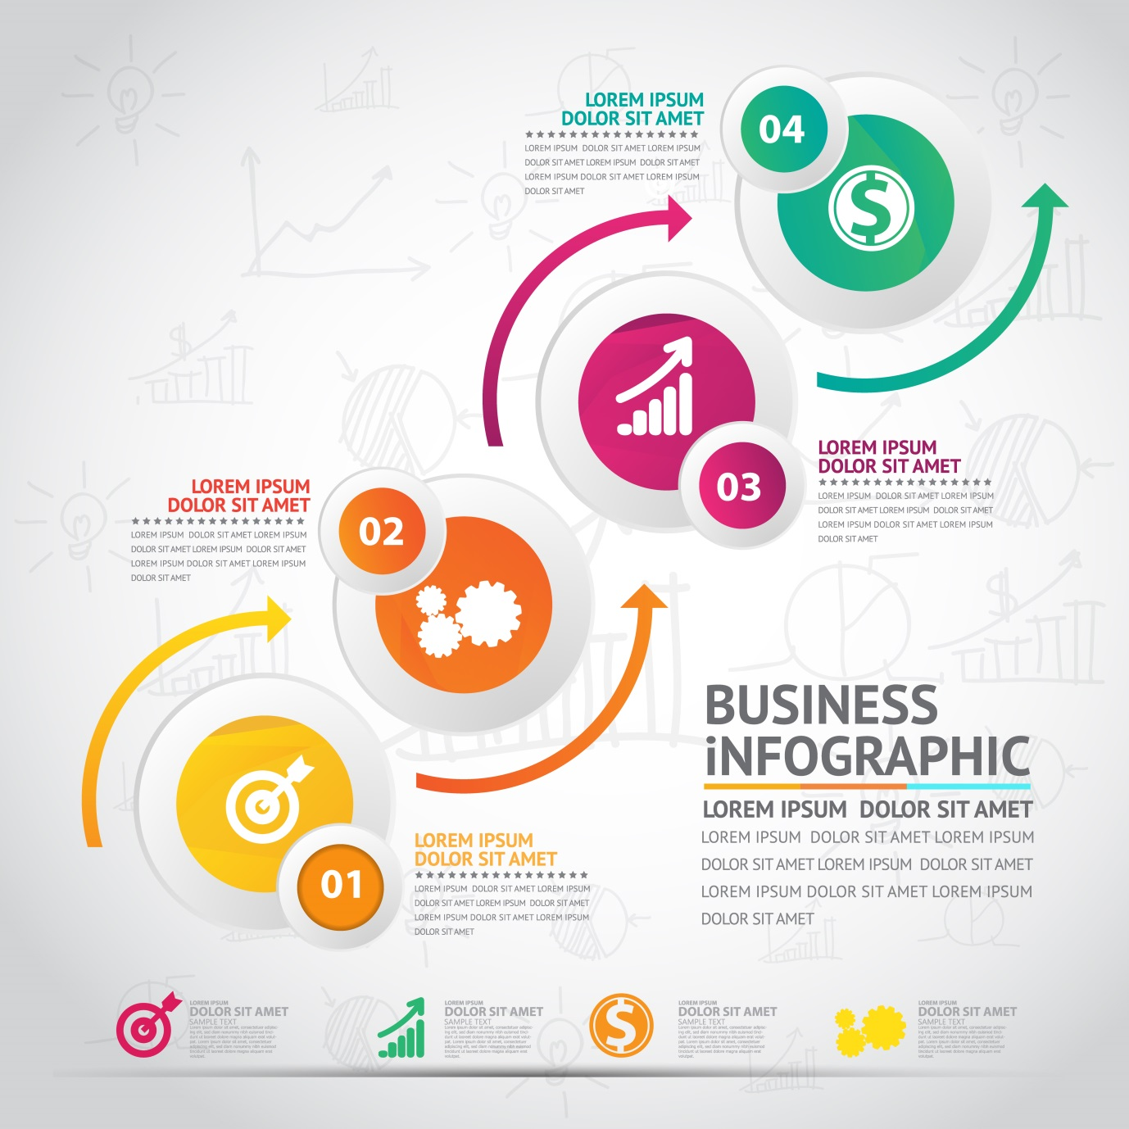
CRM Implementation
An implementation of CRM that involves the processes of the business including Marketing, sales and services would require changes at businesses. These would need to be made in order for a successful implementation. Processes upgrading, training people and an enhancement of technology would need to be made. In order for this all to be done SenServe will devise a strategy that would be followed to implement CRM at business.
After the strategy is made a foundation needs to be establishing which would set out the parameters for the CRM. After this the Needs must be determined of the users and customers. After the requirements are completed the partner is determined accordingly which can deliver the required product. CRM will then be implemented which would involve taking all of the hardware and software at business to embed CRM Software in it. After successful implementation the Evaluation is performed to help determine the issues and to resolve these.
Features that SenServe CRM will have on offer include:
Customer Database Management
In this the customer’s data will be stored in a secure fashion. This data would be utilised in many different ways including customisation of email marketing campaigns and devising follow up plans for individual customers.
Sales Analysis
A dashboard would be made for the customer where he would be able to see the results of the sales. The information will be provided in easy-to-understand manner to assist your decision making process. Tools will help you determine future sales level so you can plan out accordingly. Report generation would allow you to present the figures with anyone in the business.
Sales Channel Management
This feature of CRM would enable the users to make specific forms and searches to get you the exact data you need. It will also help determine the buying patterns of the customers. Future decisions about marketing campaigns will also be made keeping in view this information.
Customer Support
SenServe CRM will give customers a call centre support feature that will cater the complaints and queries section. The issues will also be racked in order to build a FAQ (frequently asked questions) section. This section would be available to all customers to be aware of usual issues that they need to be aware of. Accounting packages to create invoices, bills and quotes through online channels. Email campaigns to market products to customers according to their preferences.
CRM Platform
There are many platforms that can be used by businesses for implementation. Many are available on market with basic features that are free and advanced ones which are based on monthly subscriptions per user. The features vary and a business should first determine which platform is suitable to cater their needs in an effective manner. It is best advised to ask some professional expert before choosing on which CRM platform to use at your business. SenServe can also help you choose the right platform which fits your business needs.
SenServe provides CRM solutions that are made for your business and to match the dynamic needs of the market. Your business will get a competitive edge over others and with efficient means help you earn customers. You can obtain all of these services in cost-effective packages that will help you remain in budget while pushing up efficiency.

