Kongsberg Digital delivers first K-Sim Fast Craft simulators to Singapore Police Coast Guard’s Training Centre
High-speed boat operations training solution unveiled at official opening in Singapore
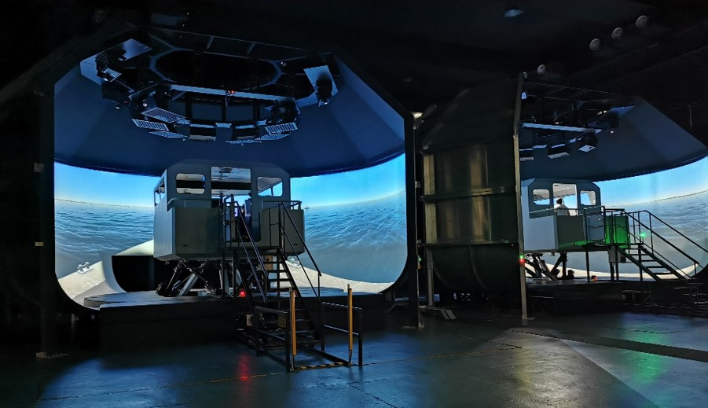
The simulator delivery to the Singapore Police Coast Guard includes four high-speed craft simulators replicating different boat types, all of which will be integrated with weapon capabilities for full-scale tactical training

Asker, Norway, June 15th, 2020 – Kongsberg Digital (KDI) is pleased to announce the delivery of its first K-Sim Fast Craft simulators to the Singapore Police Coast Guard (SPCG) Training Centre in Singapore.
Unveiled at an official opening at the centre previously this year, the four installed simulators reproduce a variety of high-speed vessel types and are supplied under the terms of a landmark contract with the Singapore Ministry of Home Affairs.
The simulator is first of its kind in enabling highly realistic vessel simulation at speeds exceeding 50 knots and integrates with an advanced eye-tracking system in addition to weapons capabilities. It will be put to work straight away to provide new recruits with the most, lifelike high-speed tactical and rapid interception training program possible. The simulator training will enable exercises to be carried out and professionally assessed in controlled conditions of complete safety, avoiding risk to personnel and removing the prospect of equipment damage. In addition, the exercises are repeatable, so trainees can undertake them as many times as is necessary in order to achieve the required high standard of competence.
The highly adaptable K-Sim Fast Craft simulator uses an advanced physics engine and customizable hydrodynamic modelling, derived from and validated against recorded vessel performance data, to duplicate the ways in which high-speed vessels behave in the real world when affected by factors such as wave movements or impacts with other crafts and floating objects, in a range of sea states and at different speeds.
Along with the authenticity provided by the full motion platform, the simulator’s 270° HFOV (horizontal field of view), low-radius, cylindrical visual projection system also provides a large vertical field of view with extension panels for floor projection covering the hull sides, while the integrated physical bridge layout can accommodate genuine control and display apparatus such as navigation systems, engine start/stop switches and communications equipment to heighten the sensation of working in a complex onboard operating environment.
As well as enhancing the trainees’ tactical decision-making capabilities by exposing them to a comprehensive range of complex scenarios, the simulator also supports all-important training in advanced boat handling, navigation and interception techniques, escalation of force and weapons engagement, including mission planning, rehearsals and full-scale debriefing/after action reviews. Its cutting-edge instructor, monitoring and assessment system means that trainees receive the highest standard of invaluable and easy-to-understand feedback.
“The delivery of our first K-Sim Fast Craft simulator marks the beginning of a transformative new era for the personnel engaged in such vital and potentially hazardous work,” says Tone-Merete Hansen, Senior Vice President, Maritime Simulation, Kongsberg Digital. “The long-term value of providing full scale training for these highly skilled duties in conditions of absolute safety is incalculable. Our cost-effective simulators obviously save substantial sums of money, but of prime importance is the fact that they also literally save lives.”
Ends
For further information, please contact:

Anne Voith
Maritime Simulation
Kongsberg Digital
Tel: +47 4567 8255
anne.voith@kdi.kongsberg.com

David Pugh
Saltwater Stone
Tel: +44 (0)1202 669244
d.pugh@saltwater-stone.com

About Kongsberg Digital
Kongsberg Digital is a provider of next-generation software and digital solutions to customers within maritime, oil and gas, and renewables and utilities. The company consists of more than 500 software experts with leading competence within the internet of things, smart data, artificial intelligence, maritime simulation, automation and autonomous operations.
Kongsberg Digital is subsidiary of KONGSBERG (OSE-ticker: KOG), an international, knowledge-based group delivering high-technology systems and solutions to clients within the oil and gas industry, subsea, merchant marine, defence and aerospace. KONGSBERG has 11.000 employees located in more than 40 countries.
Web: Kongsberg Gruppen | Kongsberg Digital
Social media: LinkedIn | Twitter | Facebook

