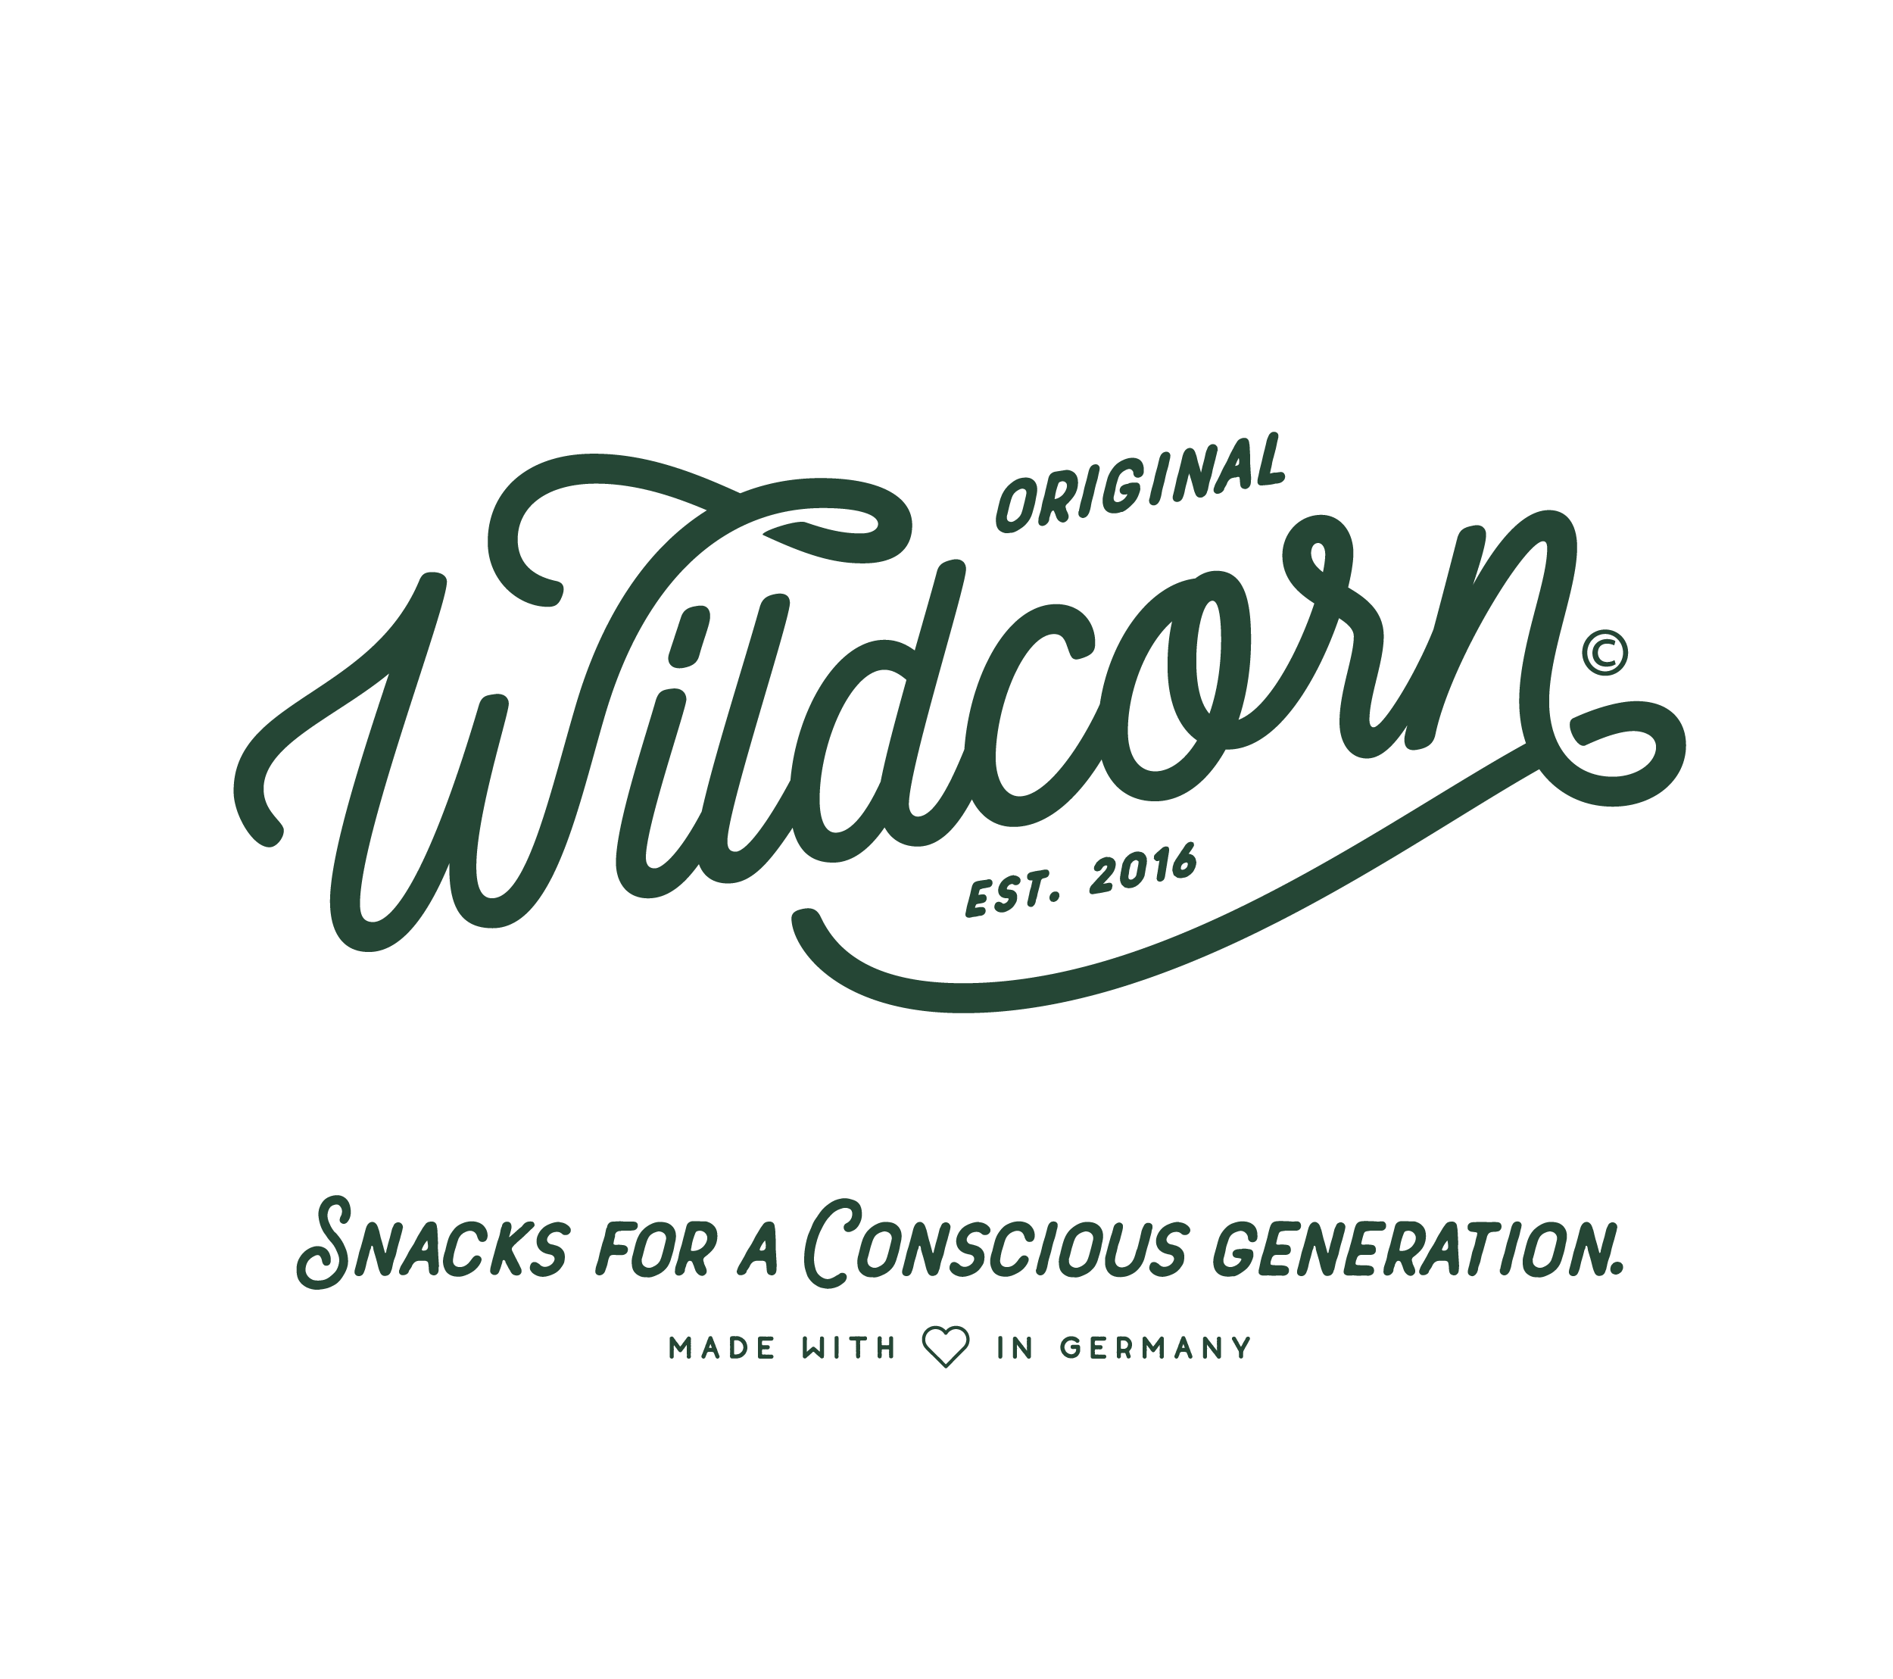 | Contact:  Rejne Rittel  Wildcorn GmbH  Paul-Lincke-Ufer 41  10999 Berlin  Germany  Tel: +49 176 2447 4906  press@wildcorn.de

FOR IMMEDIATE RELEASE Berlin - August 17, 2018

Wildcorn Fact Sheet
Company name: Wildcorn GmbH
Brand name: Wildcorn
URL: www.wildcorn.de, www.wildcorn.com
Other profiles online: www.facebook.com/originalwildcorn
www.instagram.com/originalwildcorn
Founded: September 2016
Employees: 9
Headquarter: Paul-Lincke-Ufer 41
10999 Berlin
Germany
Founder: Rejne Rittel, MD, Marketing
Max Lion Scherer, MD, Sales & Finance
Tobias Enge, Production & Product Development
Business concept
Wildcorn was founded in September 2016 by Rejne Rittel, Max Lion Scherer and Tobias Enge. Wildcorn's 100 % natural ingredients do not only refer to new taste experiences. During production, the company neither adds preservatives, nor sugar or flavor enhancer.
Target group
All snack fans, chips lovers and pretzel crunchers who like to snack with full taste but as little fat as possible. Because compared to potato chips, the most popular savoury snack alternative, Wildcorn popcorn contains fewer calories per bag.
Wildcorn initiative for the protection of honeybees and biodiversity
Wildcorn makes up for its corn consumption at a ratio of 1:1 – for every kilo of corn harvested, Wildcorn takes care of providing a blossoming flower strip on a correspondingly large area of arable land. Wildcorn not only tastes good, but at the same time does a good deed.
Wildcorn worldwide and in the air
Since August 1st, 2018 Wildcorn popcorn can not only be found in the shelves of selected food retailers or online at www.wildcorn.de, but also on board of every Eurowings flight. Wildcorn’s Mid Sommar popcorn is available in snack-sized bags (15 g) with only 66 kcal per bag and takes nibbling at lofty heights to a completely new level, offering a perfectly light snack for in between.
For further information visit
www.wildcorn.de

# # #

