Tough weekend for the Bäckman’s in Misano
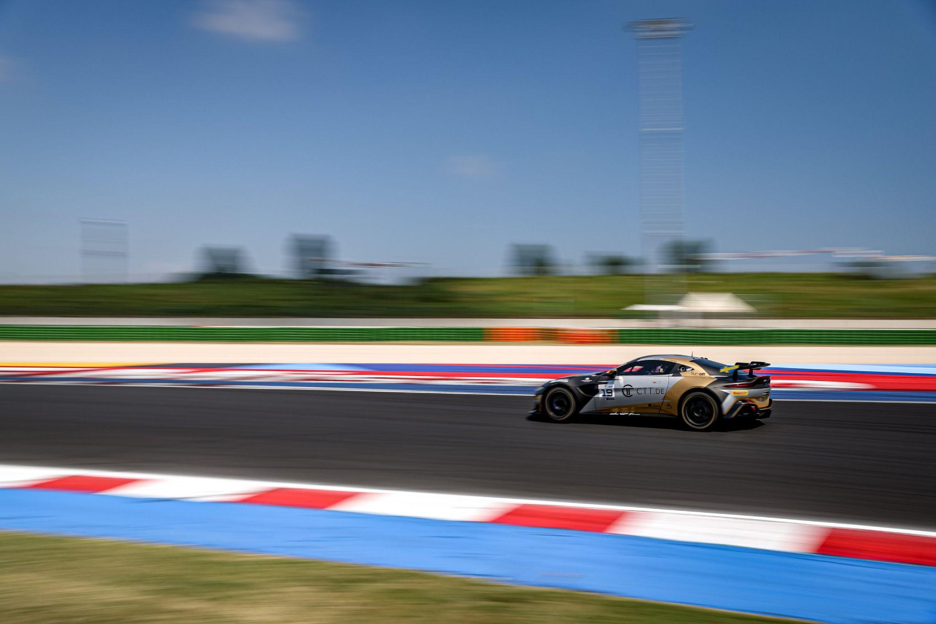
Andreas and Jessica Bäckman had a tough weekend of mixed results at the Misano World Circuit at the fourth round of the GT4 European Series.
Photo: GT4 European Series (Free rights to use the image)
Last weekend, July 14th-16th, Andreas and Jessica Bäckman competed at the Italian Misano-track at the foruth round of the GT4 European Series in an Aston Martin Vantage GT4 car. It was a weekend with mixed results but also some positive things to take away from the weekend.
- It was a tough start to the weekend in the Qualifying, where we didn't really have the speed. After that, it was difficult to advance in the two race’s in the extreme heat, Andreas Bäckman says.

The previous weekend, July 14th-16th, the Bäckman siblings competed in the European GT4 Championship at the Italian Misano World Circuit, located approximately 150 km from Bologna in Italy. On the starting line, Bäckman faced 48 of the best GT4 drivers/cars in the world.
Tough starting positions after the Qualifying
The race weekend started with test/free practice sessions on Thursday and Friday. It was the first time that Jessica and Andreas competed on the Italian track and they immediately liked the track, as it was technically challenging. Unfortunately, the speed in the car was not there during practice and together with the team, the siblings worked to find the speed to be able to challenge at the top. Small progress was made over the weekend but they were still far behind and in positions that are far from where both the siblings and the team want to be. In qualifying, the siblings qualified in 20th and 23rd place in the Silver class, which was a tough starting position to have before the two races.
- Unfortunately, this was a race where the Qualifying was hugely important, as both the engine and brakes overheat in the race almost straight from the first lap when you are close to other cars, Andreas Bäckman says.

For the first race, Andreas started the race in 23rd place in the Silver class and managed to move up some places in the first half of the race until the pit stop, even though it was difficult to overtake the cars in the extreme heat. There the driver change was made and Jessica took over for the second half of the race. Unfortunately, she had to retire from the race.
In Race 2 on Sunday, the heat in both the air and the track had risen further as Jessica started the race in 21st place in the Silver class. She had better speed than the cars in front and managed to drive up through the field. They then had a good pit stop and Andreas took over for the second half of the race. They managed to advance to a final 18th place.
- The extreme heat causes you to lose engine power and braking efficiency, and thus it is very difficult to advance in the race. Both Andreas and I did our best from the tough starting position. We worked on trying to get the car better over the weekend and took small steps forward. So there were still small positive steps forward even if it is far from what we know that both we and the team are capable of, Jessica Bäckman says.
- Now we recharge for the next competition after the summer break in six weeks in Hockenheim in Germany. It's a track we like and have done well on, hopefully we can turn around the last few tough race weekends and do well there, Andreas Bäckman says.

Andreas and Jessica’s results (Silver class):
Free practice 1: 20th place
Free practice 2: 23rd place
Qualifying 1 (Q1): 23rd place
Qualifying 2 (Q2): 21st place
Race 1: DNF (Retired)
Race 2: 18th place

TV links in case you missed last weekend’s qualifying and races:
Click to watch Qualifying 1 & 2
Click to watch Race 1
Click to watch Race 2

Next up for the siblings is the fifth round of the GT4 European Series in six weeks, September 1st-3rd, at the Hockenheimring, located near Frankfurt, Germany.

GT4 Europe Calendar 2023:
April 21st-23rd - Monza, Italy
June 2nd-4th - Paul Ricard, France
June 29th - July 2nd - Spa-Francorchamps, Belgium
July 14th-16th - Misano, Italy
September 1st-3rd - Hockenheim, Germany
September 29th - October 1st - Barcelona, Spain

Free rights to use images
Download press pictures here:
http://bit.ly/jabaeckman-photos
https://www.mynewsdesk.com/se/ja-backman/images

