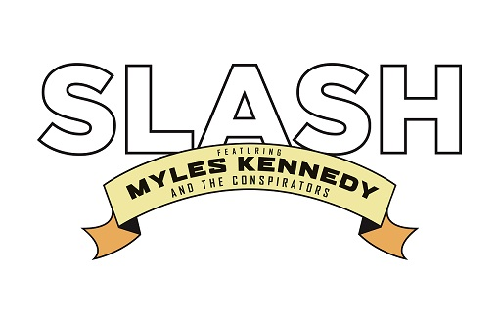
SLASH FT. MYLES KENNEDY & THE CONSPIRATORS
NEW ALBUM
‘LIVING THE DREAM’
DUE OUT 21st SEPTEMBER 2018 THROUGH SNAKEPIT/ROADRUNNER RECORDS
PRE-ORDER AVAILABLE TODAY, 25th JULY WITH EXCLUSIVE BUNDLES HERE

ALBUM COVER ART FROM RENOWNED VISUAL ARTIST RON ENGLISH UNVEILED TODAY

FIRST SINGLE
“DRIVING RAIN”
Listen to the song HERE
Watch the trailer HERE

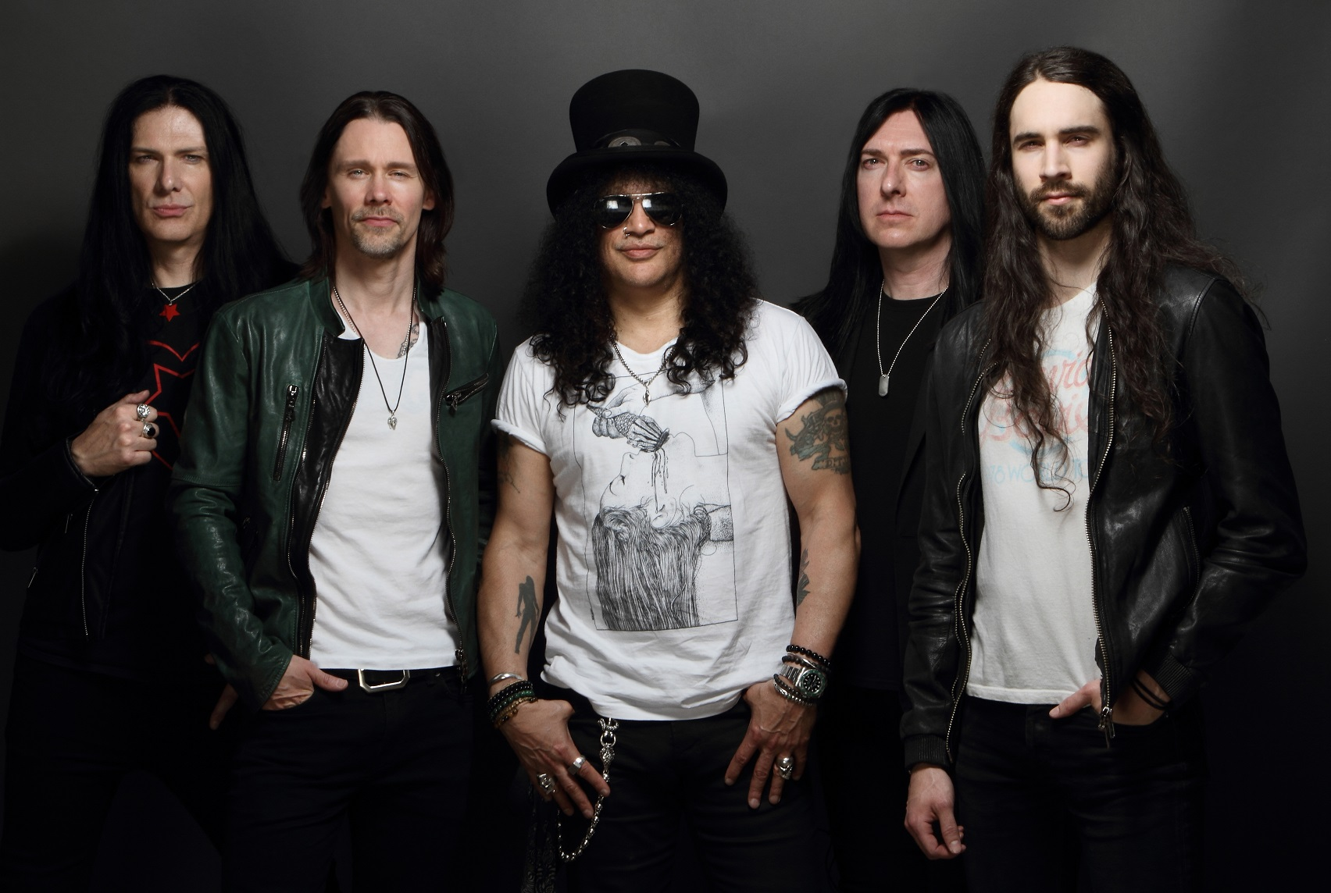
SLASH FT. MYLES KENNEDY & THE CONSPIRATORS (L-R): TODD KERNS (bass & vocals), MYLES KENNEDY (vocals), SLASH (guitar), BRENT FITZ (drums) and FRANK SIDORIS (guitar & vocals)
Photo and logo download (here).

SLASH FT. MYLES KENNEDY & THE CONSPIRATORS will release their new album titled LIVING THE DREAM on 21st September 2018 via SLASH’s own label Snakepit Records, in partnership with Roadrunner Records. The group unleashed “Driving Rain”--the first single off LIVING THE DREAM—today, to radio. Listen to “Driving Rain” HERE and watch the trailer featuring the new song HERE.
SLASH describes the creation of “Driving Rain,” “This is a riff I specifically remember playing with the guys for the first time at a venue in New Hampshire on the World on Fire tour,” explains SLASH. “It’s a cool guitar part we ran though, and from that point forward the rest of the song started to come together in my mind while on the road. We put it all together this year and Myles came up with a great melody for it.” MYLES KENNEDY adds, “The riff is very reminiscent of vintage Aerosmith. It’s got a certain funk to it that’s compelling. Lyrically, it’s a story about somebody who works on the road--it could be a musician, and it could be a traveling salesman. What makes it interesting is this guy has an addict girlfriend or spouse who continues to relapse, and she ends up getting him to come home. She’s miserable and falls back into bad old habits, and that compels him to head back to her to save the day.”

LIVING THE DREAM, is SLASH’s fourth solo album, and third with SLASH and his bandmates MYLES KENNEDY (Vocals), BRENT FITZ (Drums), TODD KERNS (Bass & Vocals) and FRANK SIDORIS (Guitar & Vocals). Today, Wednesday, 25th July the band has launched a physical pre-order for LIVING THE DREAM including CD, Heavyweight vinyl and a limited edition Deluxe Premium Set consisting of 2LP Yellow Vinyl within a Premium “Living The Dream” Vinyl-size 20 page Hardback Book, an exclusive one- sided 7” single of “Driving Rain” featuring an etching on the B-side with a special set of SLASH plectrums, Standard Physical CD album and poster. All formats are available to order along with a limited-edition T-shirt and Hoodie. To view a variety of the LIVING THE DREAM CD/merchandise bundles available now: http://www.slashonline.com.
The band has also unveiled the album cover art and tracklisting for LIVING THE DREAM. The artwork was created by renowned visual artist Ron English. View the cover art and tracklisting below.
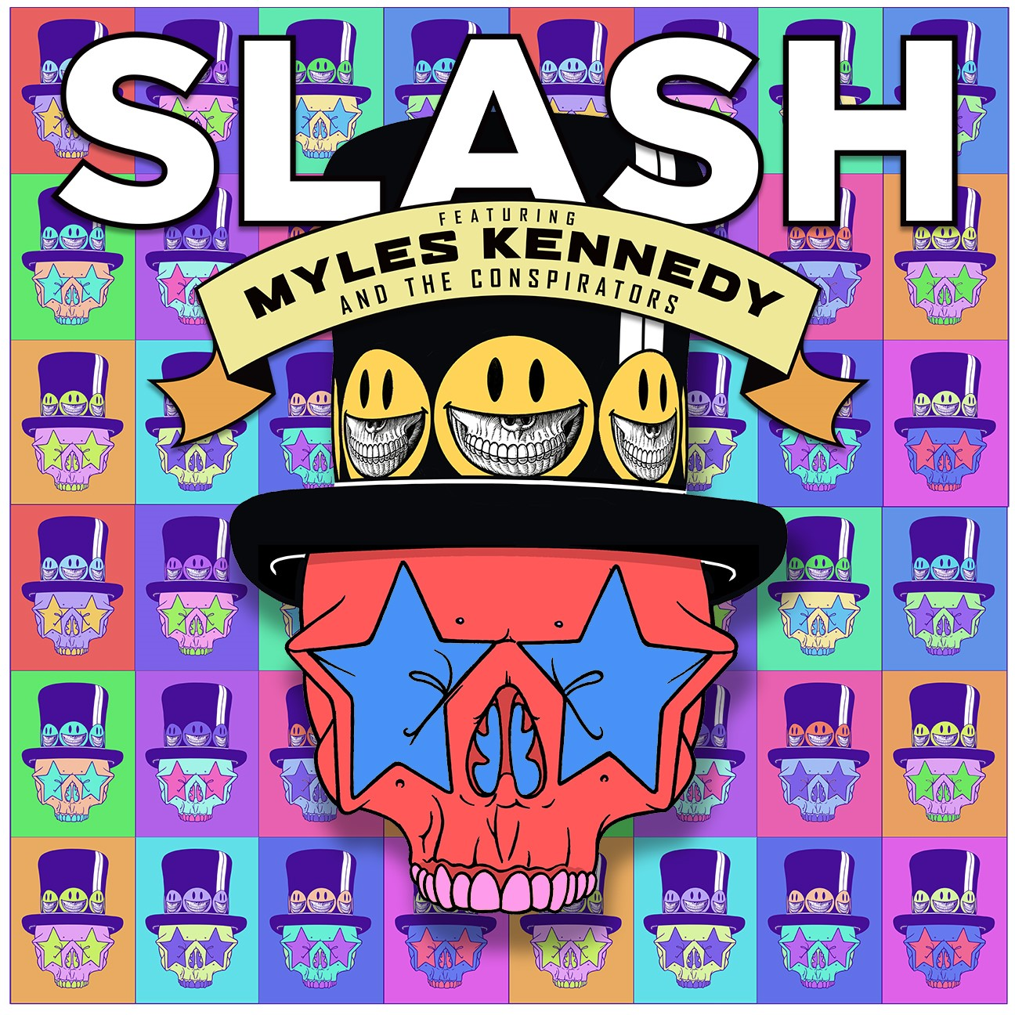
LIVING THE DREAM cover art created by artist Ron English. Download (here).

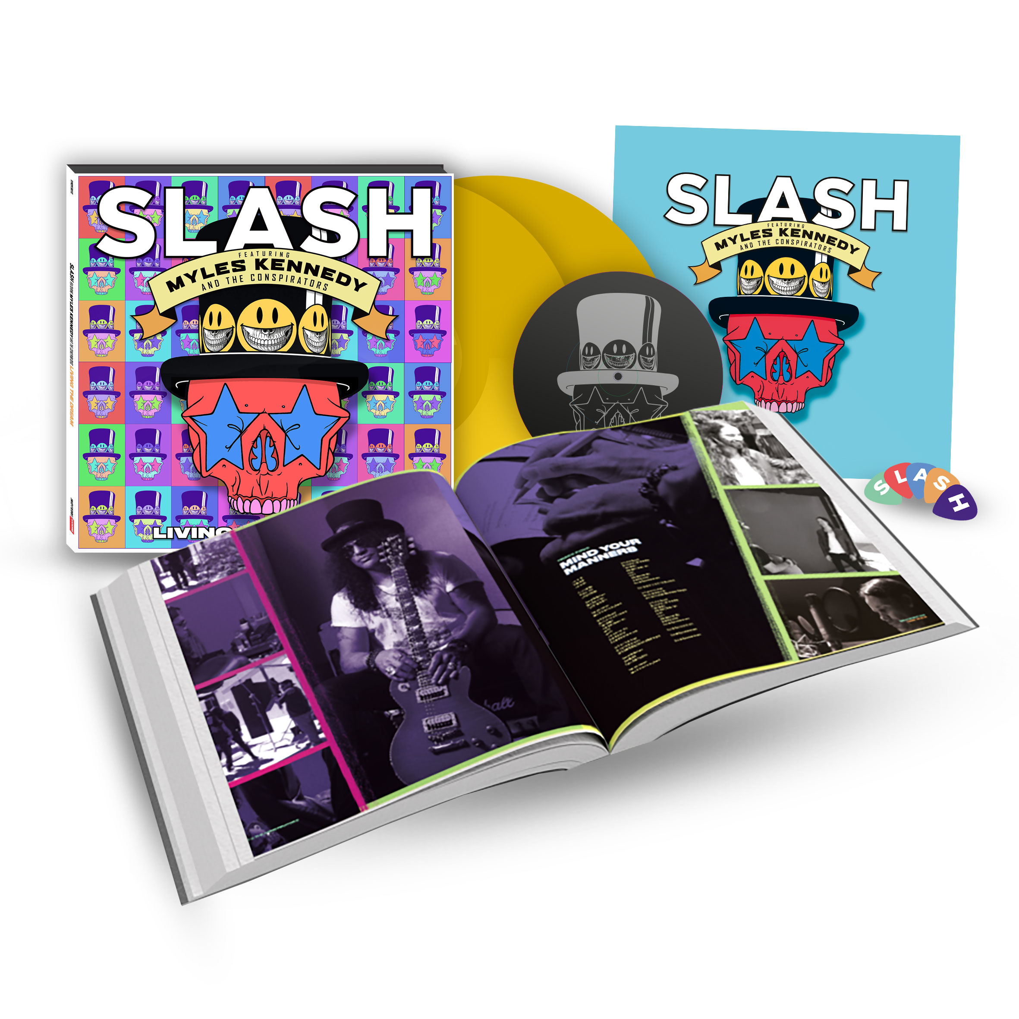
LIVING THE DREAM Deluxe Premium package.

Following is the tracklisting for LIVING THE DREAM:

1. Call of the Wild
2. Serve You Right
3. My Antidote
4. Mind Your Manners
5. Lost Inside the Girl
6. Read Between the Lines
7. Slow Grind
8. The One You Loved Is Gone
9. Driving Rain
10. Sugar Cane
11. The Great Pretender
12. Boulevard of Broken Hearts
For LIVING THE DREAM, SLASH and his band re-teamed with producer Michael “Elvis” Baskette (Alter Bridge, Iggy Pop, Incubus) on the powerful 12 song collection. The band’s previous albums World On Fire and Apocalyptic Love, debuted in the Top Ten on 12 charts globally, spawned three #1 hit singles at U.S. Rock Radio and earned worldwide praise garnering SLASH some of the best critical acclaim of his career. World On Fire was tagged in the USA by Guitar World as “another bold and unapologetically riffy statement” and “a varied, immersive and incredibly hard rocking effort” (December 2014). Rolling Stone described Apocalyptic Love--the band’s debut album--as “filled with head bangers and plenty of fancy fretwork” and Revolver declared it “a collection of lean, high-octane rock-and-roll tunes built to be blasted out of open-top sports cars, or more suitably, open-air stadiums” (May 2012).
The group’s North American headlining tour begins 13th September 2018 in Los Angeles visiting 20 major cities including New York, Denver, Philadelphia, Boston, Washington, DC (Silver Spring, MD), Chicago (New Buffalo, MI), Dallas (Thackerville, OK), Austin, Houston, and more before ending 14th October in Sacramento (all dates below). Tickets for the tour are available at: http://www.slashonline.com.
DATE | CITY | VENUE | TICKETS
Thu-Sep-13-18 | Los Angeles, CA | Whisky A Go Go | 9/13 Tickets
Sat-Sep-15-18 | Phoenix, AZ | The Van Buren | 9/15 Tickets
Sun-Sep-16-18 | Del Mar, CA | KAABOO Music Festival | 9/16 Tickets
Tue-Sep-18-18 | Salt Lake City, UT | The Depot | 9/18 Tickets
Wed-Sep-19-18 | Denver, CO | Fillmore Auditorium | 9/19 Tickets
Fri-Sep-21-18 | Tulsa, OK | Paradise Cove Margaritaville | 9/21 Tickets
Sat-Sep-22-18 | Thackerville, OK (Dallas) | WinStar World Casino | 9/22 Tickets
Mon-Sep-24-18 | Austin, TX | Stubb’s Waller Creek Amphitheater | 9/24 Tickets
Wed-Sep-26-18 | Houston, TX | House of Blues | 9/26 Tickets
Fri-Sep-28-18 | Louisville, KY | Louder Than Life Festival | 9/28 Tickets
Sat-Sep-29-18 | New Buffalo, MI | Four Winds Casino Resort | 9/29 Tickets
Mon-Oct-01-18 | Montclair, NJ | Wellmont Theater | 10/1 Tickets
Tue-Oct-02-18 | Silver Spring, MD | The Fillmore Silver Spring | 10/2 Tickets
Thu-Oct-04-18 | Rama, ON | Casino Rama | 10/4 Tickets
Fri-Oct-05-18 | New York, NY | Pier 17 @ South Street Seaport | 10/5 Tickets
Sat-Oct-06-18 | Uncasville, CT | Mohegan Sun - Wolf's Den | 10/6 Tickets
Tue-Oct-09-18 | Huntington, NY | The Paramount | 10/9 Tickets
Wed-Oct-10-18 | Philadelphia, PA | Electric Factory | 10/10 Tickets
Thu-Oct-11-18 | Boston, MA | House of Blues | 10/11 Tickets
Sun-Oct-14-18 | Sacramento, CA | Aftershock Festival | 10/14 Tickets

For more information on SLASH FT. MYLES KENNEDY & THE CONSPIRATORS, visit:
WEBSITE | FACEBOOK | TWITTER | SPOTIFY | INSTAGRAM | YOUTUBE

About Slash Ft. Myles Kennedy & The Conspirators:
SLASH--the iconic, GRAMMY-winning, American rock guitarist, songwriter and film producer--has amassed album sales of over 100 million copies, garnered a GRAMMY Award and seven GRAMMY nominations and was inducted into the Rock and Roll Hall of Fame. SLASH landed on the top of the charts with his first solo album, Slash (2010) which featured Ozzy Osbourne, Fergie, Myles Kennedy and more. Shortly after, he formed his current band SLASH FT. MYLES KENNEDY & THE CONSPIRATORS--which features MYLES KENNEDY (lead vocals), BRENT FITZ (drums), TODD KERNS (bass/vocals) and FRANK SIDORIS (rhythm guitar)--who’ve been touring worldwide and making music for over four years. SLASH FT. MYLES KENNEDY & THE CONSPIRATORS released the critically acclaimed Apocalyptic Love (2012) which stormed the Billboard Top 200 Albums Chart debuting at #4 as the top rock album. Apocalyptic Love has the added distinction of spawning SLASH’s first-ever #1 rock radio solo hits: “You’re A Lie” and “Standing In The Sun.” SLASH released Nothing Left To Fear (2013) the first-ever motion picture he co-produced from SLASHfiction, his film/TV production company specializing in the horror genre. He is currently working on a new film project. SLASH FT. MYLES KENNEDY & THE CONSPIRATORS unleashed their second album World On Fire to worldwide praise garnering SLASH some of the best critical acclaim of his career. SLASH’s third straight solo album to debut in the Top Ten, World On Fire achieved over 12, Top Ten chart debuts around the world. The album’s title track, first single “World On Fire” ascended to #1 at U.S. Rock Radio. In 2016, Guns N’ Roses re-united and SLASH joined Axl Rose and Duff McKagan for the ongoing “Not In This Lifetime Tour” which Billboard now ranks as the fourth-highest grossing tour of all time.

###

