CERONAV invests in high-performance DP simulators from Kongsberg Digital
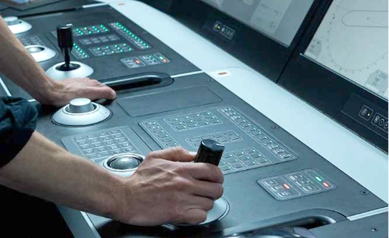
K-Sim DP Maneuvering simulators, as will be delivered to CERONAV, comprise a dual redundant
K-Pos DP operator station, a DP controller and an independent joystick system
Kongsberg, Norway, June 10th, 2020 – Kongsberg Digital has signed a contract with Navtron for delivery of a K-Sim Dynamic Positioning simulator system to the maritime training center CERONAV (Romanian Center for Training and Development of Naval Transport Personnel) in Constanta, Romania.
CERONAV is investing in KONGSBERG’s K-Sim Dynamic Positioning simulators, which integrate with KONGSBERG’s well-reputed K-Pos Dynamic Positioning (DP) system. Forming a totally unique training system, simulating vessel behavior, environmental conditions, thruster performance, position-reference system and sensors. It enables a realistic learning experience for students and supports DP training on all levels, including operator training according to Nautical Institute’s latest standards.
The delivery to CERONAV will comprise a K-Sim DP Maneuvering (Class A) simulator to support advanced training and the DP Offshore training scheme, plus a further eight KONGSBERG K-Pos DP Basic (Class C) desktop simulators for basic DP training, including instructor stations to manage the exercises.
With the new suite of DP simulators, CERONAV will prepare for accreditation of its training center and DP courses by the Nautical Institute. Ovidiu Sorin Cupsa, Associate Professor and General Manager, CERONAV, said: “Currently, our teaching activity is based on rules and regulations issued by the Romanian Ministry of Transport, and on documents developed within our Integrated Management System. However, in recent years our training programs have undergone an extensive review to enhance their content
and to conform with conditions set by the Romanian Naval Authority, OPITO and – more recently – the Nautical Institute. KONGSBERG’s K-Sim DP simulators are already compliant with these requirements, and will greatly facilitate our ability to deliver first-class training to our students, most of whom are crew with long experience as DP Operators at sea, with a need for retraining and internationally-approved certificates.”
Tone-Merete Hansen, Senior Vice President, Kongsberg Digital, said: “The K-Sim DP platform is a powerful tool enabling the user to interface with the same information and settings as found on board a K-Pos equipped vessel. Common DP operations such as offshore loading, tug assistance, offshore supply and construction, subsea and dive support, drilling vessel station keeping and emergency maneuvering can all be simulated, making onshore training a comprehensive, immersive and accurate learning experience. We are delighted that CERONAV has chosen K-Sim to help them deliver world-class training to their students.”
Due for delivery to CERONAV on 25th August 2020, the simulator will initially be installed at the Center’s existing premises before being relocated to a new, dedicated Offshore Marine Simulation facility on the shores of Lake Mamaia, when complete.
Ends

For further information, please contact:

Anne Voith
Marketing Manager, Maritime Simulation
Kongsberg Digital
Tel: +47 4567 8255
anne.voith@kdi.kongsberg.com

David Pugh
Saltwater Stone
Tel: +44 (0)1202 669244
d.pugh@saltwater-stone.com

About Kongsberg Digital
Kongsberg Digital is a provider of next-generation software and digital solutions to customers within maritime, oil and gas, and renewables and utilities. The company consists of more than 500 software experts with leading competence within the internet of things, smart data, artificial intelligence, maritime simulation, automation and autonomous operations.
Kongsberg Digital is subsidiary of KONGSBERG (OSE-ticker: KOG), an international, knowledge-based group delivering high-technology systems and solutions to clients within the oil and gas industry, subsea, merchant marine, defence and aerospace. KONGSBERG has 11,000 employees located in more than 40 countries.
Web: Kongsberg Gruppen | Kongsberg Digital
Social media: LinkedIn | Twitter | Facebook

