***PRESS RELEASE 2017-10-05***

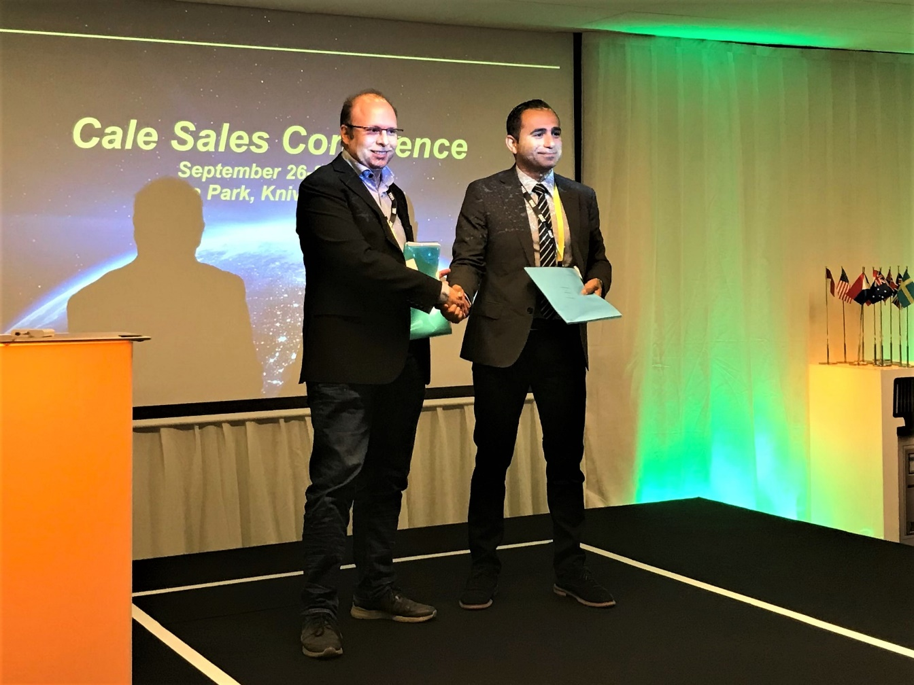**CALE Access AB entered into a worldwide distribution agreement for electric vehicle charging solutions with Chargestorm AB.**

**CALE is a worldwide leading supplier of parking and unattended payment solutions and related services. Chargestorm is the leading supplier of smart charge stations and infrastructure solutions for electric vehicles in the Nordic countries. The e-mobility market is showing a tremendous growth in many countries and the demand for integrated parking and charging solutions for all plug-in hybrids and electrical vehicles is rapidly growing. By entering this agreement, CALE will be able to offer an integrated park and charge solution in the more than 30 countries. CALE will deliver its extensive range of leading parking management solutions, including solar powered payment terminals and the WayToPark App fully integrated with Chargestorm smart AC charge stations.**

**“This agreement is in line with our strategy to offer solutions and helping cities around the world to become more sustainable and eco-friendly using connected and smart solutions” says Anton Kaya, CEO of CALE.**

**Chargestorm’s range of smart charging solutions, including NanoGrid™ for local load balancing to optimize the existing electrical infrastructure, is rapidly becoming a necessity for achieving cost-efficient scalability of existing parking areas. “We are proud and excited to work closely with CALE for this purpose” says Patrik Lindergren, CEO and founder of Chargestorm.**

**About CALE:  
Cale offers innovative and efficient parking solutions. Cale has since 1955 a leading global brand in the parking technology with offices all around the world. With the help of a professional distribution network and partners, we have global coverage and serve several thousands of clients worldwide. Cale is certified according to the latest EMV, PCI, ISO 9001 and ISO 14001 standards. Visit** [**www.calegroup.se**](http://www.calegroup.se) **to read more about the products and services**

**For further information, please contact:  
Martin Frid, Sales Director CALE Access AB,  
Tel: +46 8 799 37 43, email:** [**martin.frid@cale.se**](mailto:martin.frid@cale.se)