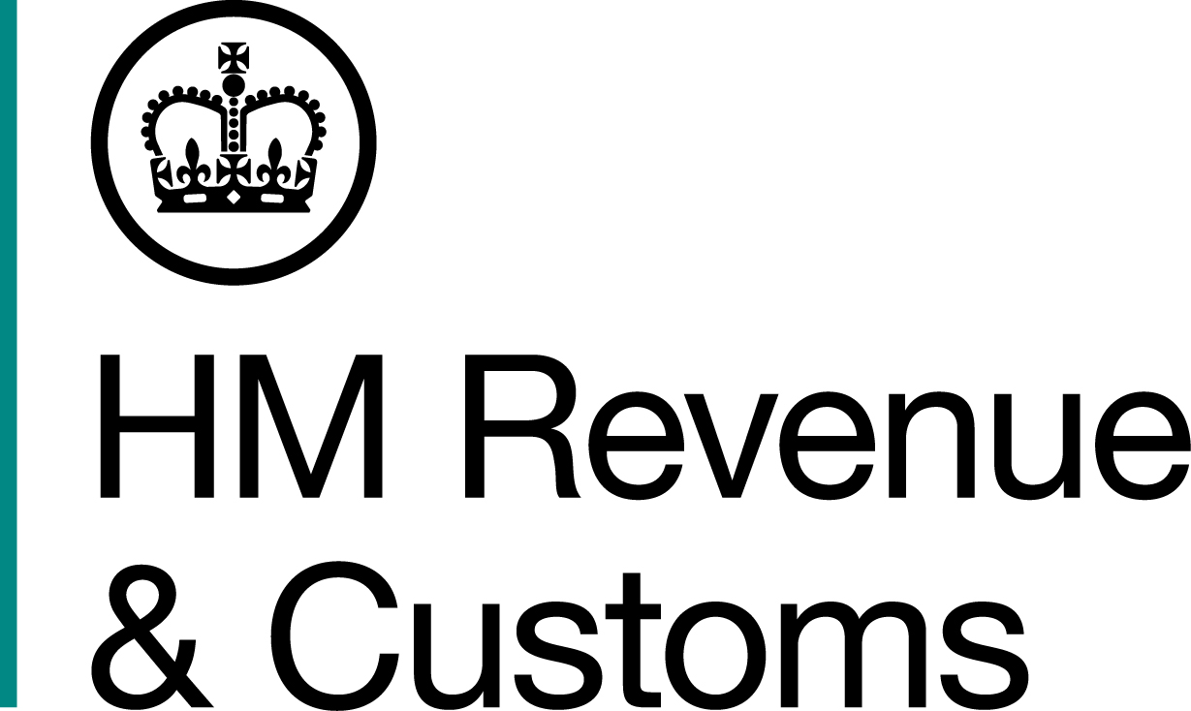
News Release

 | For the attention of News Desks |  | No. of pages: 3
 | Date: | 11 November 2016 | Ref: | LON 24 16
Money laundering pair snared by traffic jam

A London money launderer and his accomplice, whose bid to escape arrest by HM Revenue and Customs (HMRC) was thwarted by a traffic jam, have been jailed for a total of eight-and-a-half years for laundering £5.9m.

Shazad Malik, 43, funnelled the money through his sham company, Sky Drinks Ltd, on behalf of organised criminals across London and Essex.

In a plot designed to legitimise the illegal income, Malik’s associate, Asher Frank, 40, acted as a courier, collecting the cash from underworld associates and paying it into bank accounts controlled by Malik.

The 12-month scam unravelled when HMRC swooped on Frank’s Peugeot in Barking on 26 July 2012.

Frank tried to flee the scene by driving at officers before speeding away – only to be trapped by heavy traffic.

The runaway fraudster was arrested moments later, and more than £70,000 in cash and a paying-in book in the name of Sky Drinks Ltd were discovered in his vehicle.

Paul Barton, Assistant Director, Fraud Investigation Service, HMRC, said:

“This was an audacious attempt to launder the proceeds of crime. Malik and Frank believed they would go unnoticed moving large amounts of dirty cash around London and Essex. They were wrong, and today their greed has cost them their liberty.

“Money laundering facilitates organised crime, and it’s something HMRC takes very seriously. We use a wide range of tough sanctions and will not hesitate to prosecute those involved. I urge anyone with information on this type of fraud to contact our 24 hour Hotline on 0800 59 5000.”

In the days before his arrest, Frank was observed by HMRC visiting criminal associates and paying in £360,000 in cash at the ‘quick drop’ facilities of banks in Barking, Dagenham and Romford.

During interview, Frank said he was simply a courier and hadn’t stopped for HMRC because he believed he was being robbed. Meanwhile, enquiries linked the paying-in book to an account held by Malik.

Malik was interviewed by HMRC in October 2012 and claimed Sky Drinks acted as an agent for its sole customer, a Belgian company.

He said the Belgian firm would regularly send a courier – Asher Frank – to the UK with large amounts of sterling to pay him in cash and Frank would use his paying-in book to deposit the money into Sky Drinks’ bank account before returning to the Continent.

Malik could not provide credible business records to show the £5.9m paid into his accounts came from legitimate trade. Checks revealed Sky Drinks was not registered for tax.

Malik admitted the offence on the second day of the pair’s trial at Southwark Crown Court on October 18 2016. Frank was found guilty on 27 October 2016. Malik was sentenced to five-and-a-half years in prison and Frank to three years in prison by His Honour Judge Testar at the same court on 10 November 2016.

Notes to Editors

- Asher Frank, Harlow Gardens, Romford, Essex. DOB 06/06/1976;
- Shazad Malik, Cairo Road, Walthamstow, London. DOB 29/07/1973;
- Follow HMRC Press Office on Twitter @HMRCpressoffice;
- HMRC's Flickr channel: www.flickr.com/hmrcgovuk.

Issued by HM Revenue & Customs Press Office

Press enquiries only please contact:

Joshua Shrimpton-Dean
Tel: 03000 554556 / 07469 023445
Email: joshua.shrimpton-dean@hmrc.gsi.gov.uk
Or
Natalie Brown
Tel: 03000 519123 / 07464 982005
Email: natalie.brown@hmrc.gsi.gov.uk

Out of hours
Tel: 07860 359544

Website www.gov.uk/hmrc

