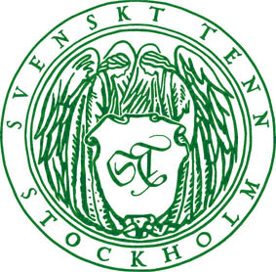
Press release
Stockholm, June 10 2014

To Mexico in Estrid Ericson’s footsteps – new exhibition at Svenskt Tenn
Svenskt Tenn’s founder Estrid Ericson travelled to Mexico in 1939. She brought 70 boxes of objects back to create an exhibition in the store in Stockholm. Today a new exhibition opens, showing products purchased during a trip in Estrid Ericson’s footsteps in 2013.

’’The world is a book and he who stays at home reads only one page was one of Estrid Ericson’s favorite quotations, which she had engraved on a pewter matchbox. Travel was one of her main sources of inspiration and she was constantly looking for new items for Svenskt Tenn, preferably things that could not be found elsewhere in Sweden’’, says Thommy Bindefeld, Marketing Director at Svenskt Tenn.

Ericson’s purchasing journeys took her to many countries and in the spring of 1939 she traveled with her friend Ragnhild Lundberg to Mexico. She looked up producers and placed orders with them directly. A few months later, boatloads of Mexican objects arrived, filling the store on Strandvägen in Stockholm. The show became one of the most appreciated events in the company’s history that far.

Today a new exhibition opens, displaying the handpicked items purchased during a trip to Mexico in Estrid Ericson’s footsteps. All items are for sale.

’’It has been very exciting to follow in Estrid Ericson’s footsteps. We have rediscovered some of the items she selected during her trip, and we have also found many other beautiful crafted products that we simply could not resist,’’ says Thommy Bindefeld.
The exhibition runs through August 17 in the store on Strandvägen 5 in Stockholm.

For further information, please contact:

Vicky Nordh, Marketing Assistant: +46 8-670 16 23 or vicky.nordh@svenskttenn.se

Thommy Bindefeld, Marketing Director: +46 8 670 16 02 or thommy.bindefeld@svenskttenn.se

Image bank: www.svenskttennpress.se User name: Press Password: Tenn

