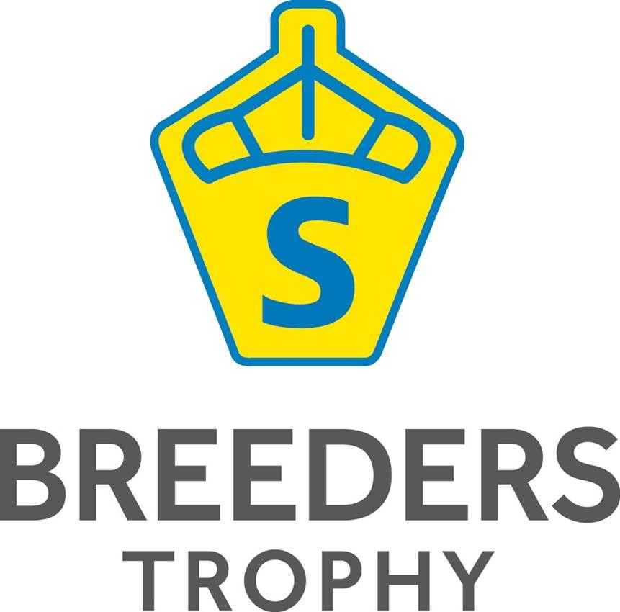
Charlotte Dujardin announced as test rider for the Young Horse Swedish Championships 2016
The Swedish Warmblood Association and the organizers of the Breeders Trophy are happy to announce that 2016’s test rider for four year old horses is Charotte Dujardin OBE.
Dujardin has not only won the Olympic Gold Medal in Dressage but also holds the world record in Grand Prix, Grand Prix kür and Grand Prix Special.
Breeders Trophy – the Swedish Federal Championship of Young Horses are to be held in Flyinge the 4th-9th of October 2016. Patrik Kittel has, as from the beginning agreed, been the test rider for three years. 2016 will see British Charlotte Dujardin take on the role.
- We are so very happy to welcome Charlotte. We saw her at the Danish Warmbloods Hingstekåring in Herning and she held a great clinic out of the show. She told the audience what she felt with the horses and brought many new ideas and knowledge to the audience, says Tomas Torgersen, manager of Breeders Trophy.
This year Breeders Trophy, the Swedish Federal Championship for Young Horses adapts the old system; only horses registered by the Swedish Warmblood association are allowed to compete.
- The competition were founded to benefit Swedish breeders and that’s still the mission, by changing the rules we are confident that the purpose of this competition will be more clear, says Tomas Torgersen.
- I am really looking forward to meeting the horses in October and want to thank the organisers for inviting me. It’s set to be a great show and I’m very excited indeed, says Charlotte Dujardin.

Contact:
Thomas Torgersen
+46 (0)761-96 83 23

