PRESS RELEASE | 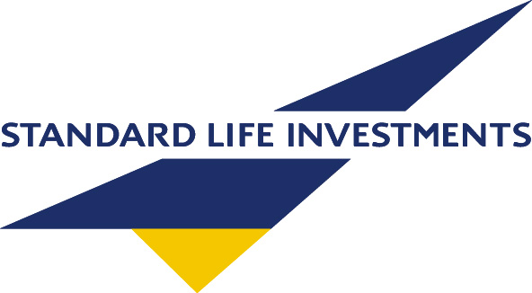
Global Outlook | 14 July 2010
 | For Immediate Release

RECESSION, REGULATION AND RECOVERY

Standard Life Investments, a leading investment house, believes that a return to recession is unlikely for the global economy as long as corporate profits grow, allowing the economic recovery to broaden out. However, there are growing risks for financial markets from the degree of the political and regulatory burden being seen in more countries.

In the latest edition of Global Outlook¹, the global fund manager examines the main economic and financial drivers of financial markets and the implications for investors.

Standard Life Investments does not see a high probability that the global economy falls back into recession, as many investors fear. While global leading indicators are decelerating, it explains, this is understandable at this phase of the cycle as stimulus is withdrawn. There is a major difference between the momentum of growth slowing, as Standard Life Investments expects, and a slide into a prolonged recession.

Standard Life Investments remains positive on sustained corporate profits growth. Having re-built profits and strengthened balance sheets, it believes that firms are starting to engage in capital spending and hiring. Many of the global emerging economies are showing strong growth, driven by long term structural trends, and there are few signs that inflationary pressures will bring this trend to an end.

Andrew Milligan, Head of Global Strategy, Standard Life Investments, warned:

“Although we believe a return to recession is unlikely for the global economy, there remain major uncertainties, some related to the economic cycle, but more to a variety of political issues. Regulation of financial services is a concern, as a stream of international and domestic proposals are making their way through legislative systems and technical committees, meaning an uncertainty risk premium will hang over markets for some time to come. Other examples include windfall taxes and levies on European utilities, Australian mining companies and UK banks. Looking ahead, the forthcoming US elections should be monitored to assess the degree of the backlash against big business. All in all, it is understandable that the time horizons of many investors are short term in the face of such an uncertain political and regulatory environment.”

“The broadly cautious stance in our House View, a diversified portfolio of income seeking assets, has proven correct in this volatile period. Valuations have been a useful trigger on occasion, for example we reduced our position in European government bonds when yields were considered too expensive, moving into more attractive high yielding corporate debt. While most of the major asset classes are relatively close to fair value on our measures, we are paying attention to behavioural finance signals, investor sentiment and positioning measures, in our tool kit, to ensure that we avoid value traps ahead of the next phase of the economic environment.”

For further information please contact:
Hilda Stewart, Press Manager, Standard Life Investments, +44 (0)131 245 3610
Richard England, Press Manager, Standard Life Investments, +44 (0)131 245 2750
To access our virtual press office, access the link below:
http://www.standardlifeinvestments.com/press_office/index.html

Notes to Editors:

- To give investors a first-hand insight into the issues currently driving markets, Standard Life Investments produces a global series of flagship publications. Its leading publication, Global Outlook, is a collection of articles written quarterly by its top investment directors from each of the main asset classes. On a monthly basis, there is Global Perspective, where Standard Life Investments’ global strategists combine valuable experience, thorough research and analysis to tackle major issues of the moment. Lastly, Global Horizons provides an in-depth perspective on long-term investment themes. It captures the major changes in the forces likely to influence financial markets in the coming years.

- With assets under management of £145.8bn (31/03/10), Standard Life Investments is one of Europe’s major investment houses.

- Standard Life Investments was launched as an investment management company in 1998. It is a wholly owned subsidiary of Standard Life Investments (Holdings) Limited, which in turn is a wholly owned subsidiary of Standard Life plc.

- Standard Life Investments operates in the UK, Canada, Ireland, Hong Kong and the USA, and has representative offices in Germany, France, South Korea and Beijing. Standard Life Investments also operates in India through a joint venture, HDFC AMC.

SLIPR568

