**Pole-position, track record and first STCC podium**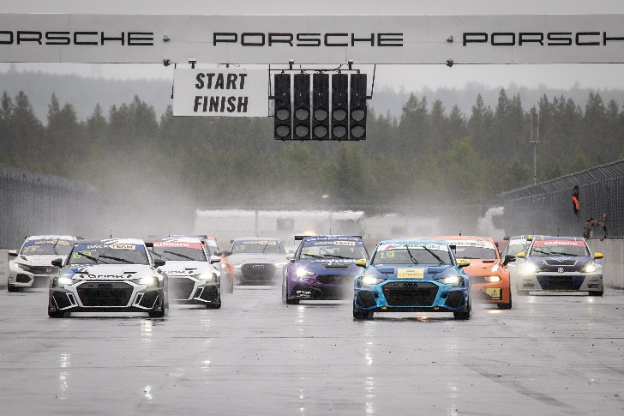Andreas Bäckman (start number 19) led towards the first corner from pole-position in the first race at Drivecenter Arena in Skellefteå, Sweden.  
Photo: STCC (Free rights to use the images)

**This year's second STCC event was held this weekend, June 17th-18th, at Drivecenter Arena. Andreas Bäckman showed good speed and got the pole-position and broke the track record in the qualifying. The race day went a bit up and down, but he leaves Skellefteå, Sweden with his first STCC podium.  
– Very mixed feelings from this weekend but very positive for the upcoming rounds, Andreas Bäckman says.**

This weekend, June 17th-18th, it was time for the second round of STCC, The Midnight Sun Race, at Drivecenter Arena near Skellefteå, and the Sweden National Team driver Andreas Bäckman was on the starting line, competing for Lestrup Racing Team in his Audi RS 3 LMS TCR car. This is the only event on this year's STCC calendar that is run in northern Sweden, so it meant home ground for Andreas Bäckman, even though it was his first competition on the track.

**Strong qualifying for Andreas**The weekend started with training on Thursday and Friday. Andreas learned the track during practice sessions on Thursday and Friday, and worked with the team to get the setup on the car as good as possible. In the last free practice before the timed qualifying, the car's balance felt good and then Andreas broke the track record for TCR cars and it was the first time that someone drove under one minute and 52 seconds on the Drivecenter Arena track.

Then in the Qualifying on Friday night, he followed it up by driving into pole-position in the first qualifying round Q1 and that time as well he drove faster than the previous track record. In the second qualifying round Q2 it did not go quite as far but he qualified in a good second place.

- It was a big step forward from the season opener at Ljungbyhed, I felt much more at home in the car and it was very fun to drive so fast at home and get both the pole position and the track record, **Andreas Bäckman** says.

**Good races but low points scoring for Andreas**In the first race on Saturday, Andreas started at the front in pole-position in the rain at Drivecenter Arena. Towards the first corner he was first but then he lost the car abruptly into the corner and lost the lead. After that he was in second place but did not have the right feeling in the car and the speed was lacking. He dropped to third place in the finish. But during the race, a 20-second penalty was awarded to the winner for a jump start in at the start of the race, so Andreas advanced to second place in the results list and got to step up to second step of the podium. However, a few hours after the race, the penalty for the jump start was withdrawn after protest from the punished driver's team and thus Andreas dropped down to a third place in the final result.

In the second race Andreas started second. The rain had increased further and the race control decided to start the race behind the safety car. Andreas was in second place for a long time, but when an opportunity came in the middle of the race, Andreas went for an overtaking for the lead which unfortunately did not go home, and he dropped down to sixth place which he then held on to the finish. After the finish, a 5-second penalty was awarded to a driver in front of him and he was promoted to a final fifth place in Race 2.

For Race 3, it was the reverse starting order for the first eight drivers from Race 2, which meant that he started in fourth place. Andreas got off to a good start and retained fourth place in the first corner. Then the hunt for the lead was taken up and the speed in the car was good. A few laps later he was up in third place and when there were two laps left, he was fighting for second place, but then he unfortunately suffered with a tire puncture and was forced to break the race with one lap left.

- A little disappointed with the race day, it was a bit of a roller coaster with a lot that happened in the three races. It was fun to take my first podium in STCC but there was potential for more podiums and a win if everything had gone right. But I am still very happy over the weekend, it is important to look at the positives and look ahead. I feel more at home in the car and we took big steps this weekend. Many thanks to my team Lestrup Racing Team, **Andreas Bäckman** says.

***Next up for Andreas is the third round of the STCC championship in five weeks time, July 22nd-23rd, at Ring Knutstorp, located near Helsingborg, Sweden.***

**Andreas’ results:**Official Test 1 (Test 1): 4th placeOfficial Test 2 (Test 2): 3rd place  
Free Practice 1 (Test 3): 11th place  
Free Practice 2 (Test 4): 1st place  
Qualifying (Q1): 1st place  
Qualifying (Q2): 2nd place

Race 1: 3rd place  
Race 2: 5th place  
Race 3: Retired (Tire puncture)

**STCC Championship Standings**

**STCC – TCR Scandinavia – Drivers’ Championship Standings – Overall (Top 3)**STCC 2022 (After 2 of 6 race weekends)

1: Robert Dahlgren (SWE), 71 p.

2: Hugo Nerman (SWE), 66 p.

3: Oliver Söderström (SWE), 64 p.

–

**6: Andreas Bäckman (SWE), 45 p.**

[See the full standings here](https://www.stcc.se/poang/stcc-2022/)

**STCC – TCR Scandinavia – Teams’ Championship Standings – Overall (Top 3)**STCC 2022 (After 2 of 6 race weekends)

1: Brink Motorsport, 125 p.  
2: CUPRA Dealer Team - PWR Racing, 110 p.

**3: Lestrup Racing Team, 109 p.**

[See the full standings here](https://www.stcc.se/poang/stcc-make-2022/)

**Did you miss this weekend’s STCC race?**

[Click here](https://plus.stcc.se/video/s-midnattsolsloppet-skelleftea-9n9wb4) to see the replay from this weekend’s STCC race at STCC+  
[Click here](https://plus.stcc.se/video/s-midnattssolsloppet-stcc-race-1-w66z4e) to see the replay from Race 1

[Click here](https://plus.stcc.se/video/s-midnattssolsloppet-stcc-race-2-koim6f) to see the replay from Race 2

[Click here](https://plus.stcc.se/video/s-midnattssolsloppet-stcc-race-3-y2i0md) to see the replay from Race 3

**Follow the STCC season at:**

Live-stream: [plus.stcc.se](https://plus.stcc.se/)

Other information: [stcc.se](https://www.stcc.se/)

Facebook: [facebook.com/STCCOfficial/](https://www.facebook.com/STCCOfficial/)

Twitter: [twitter.com/stcc_official](https://twitter.com/stcc_official)

Instagram: [instagram.com/stcc_official/](https://www.instagram.com/stcc_official/)

YouTube: [youtube.com/c/STCCTV](https://www.youtube.com/c/STCCTV)

***Free rights to use the images.***

***Download press-photos here:***[***http://bit.ly/jabaeckman-photos***](http://bit.ly/jabaeckman-photos)[***https://www.mynewsdesk.com/se/ja-backman/images***](https://www.mynewsdesk.com/se/ja-backman/images)

