Final - news release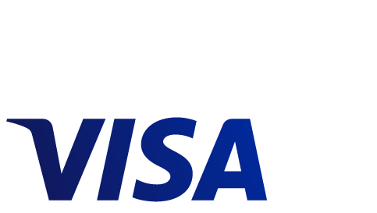

European Commission Approves Visa Inc.’s Acquisition of Visa Europe

Transaction expected to close before the end of June 2016

**San Francisco, CA, June 3, 2016** – Visa Inc. (NYSE: V) today announced that the European Commission has approved the proposed acquisition of Visa Europe Ltd. by Visa Inc. Visa has now received all regulatory approvals required for the acquisition. The transaction has already been cleared by both the Jersey and the Turkish competition authorities. The transaction is expected to close in Visa Inc.’s fiscal third quarter of 2016. Visa will announce the closing once it has occurred.

###

**About Visa Inc.**

Visa Inc. (NYSE: V) is a global payments technology company that connects consumers, businesses, financial institutions, and governments in more than 200 countries and territories to fast, secure and reliable electronic payments. We operate one of the world’s most advanced processing networks — VisaNet — that is capable of handling more than 65,000 transaction messages a second, with fraud protection for consumers and assured payment for merchants. Visa is not a bank and does not issue cards, extend credit or set rates and fees for consumers. Visa’s innovations, however, enable its financial institution customers to offer consumers more choices: pay now with debit, pay ahead with prepaid or pay later with credit products. For more information, visit usa.visa.com/about-visa, visacorporate.tumblr.com and @VisaNews.

**Forward-Looking Statements**

This release contains forward-looking statements within the meaning of the U.S. Private Securities Litigation Reform Act of 1995. Forward-looking statements generally are identified by words such as “will,” "is expected," and other similar expressions. Examples of forward-looking statements include, but are not limited to, statements Visa Inc. makes about the likelihood and timing of the closing of the acquisition.

By their nature, forward-looking statements: (i) speak only as of the date they are made; (ii) are not statements of historical fact or guarantees of future performance; and (iii) are subject to risks, uncertainties, assumptions or changes in circumstances that are difficult to predict or quantify. Therefore, actual results could differ materially and adversely from Visa Inc.’s forward-looking statements due to a variety of factors, including the risk that the transaction may not be consummated; matters arising in connection with the parties' efforts to satisfy the closing conditions relating to the transaction; and various other factors, including those contained in our Annual Report on Form 10-K for the fiscal year ended September 30, 2015, our Quarterly Report on Form 10-Q for the quarter ended March 31, 2016, and Visa Inc.’s other filings with the U.S. Securities and Exchange Commission.

You should not place undue reliance on such statements. Except as required by law, Visa Inc. does not intend to update or revise any forward-looking statements as a result of new information, future developments or otherwise.

**Contacts:**

Media Relations

Connie Kim, +1 212-521-3962, [globalmedia@visa.com](mailto:globalmedia@visa.com)

Investor Relations

Victoria Hyde-Dunn, +1 650-432-7644, [ir@visa.com](mailto:ir@visa.com)