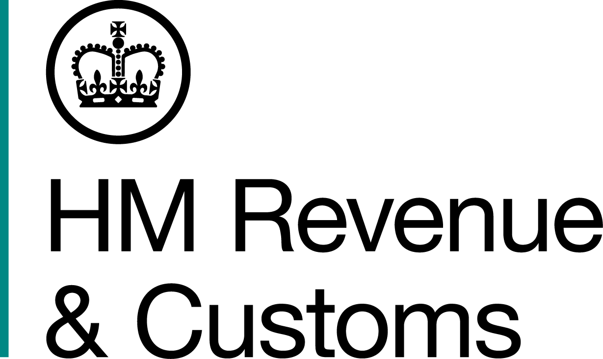
News Release

 | For the attention of News Desks |  | No of pages: 3
 | Date: | 08 10 2018 | Ref: | NW 14 18

Jet-setting pub couple ordered to pay back £355,000

A Liverpool couple who dodged tax and swindled benefits to fund a luxury lifestyle must repay £355,000 or face more time behind bars.

Bernard Knutsen, 69, and his wife Maureen, 63, who ran a pub and garage in the city, were jailed for a total of seven years for tax and benefit fraud following a joint investigation by HM Revenue and Customs (HMRC), the Department for Work and Pensions and Liverpool City Council.

They now face losing their family home and pub business – Chaplin’s Bar in Lodge Lane – as well as expensive jewellery and tens of thousands of pounds in savings.

At a confiscation hearing led by HMRC at Liverpool Crown Court on October 4, Bernard Knutsen was ordered to repay £323,195 within three months or spend another three years behind bars. £76,459 of this will be paid as compensation to the Department for Work and Pensions. Maureen Knutsen must repay £32,929 within three months or face another year in prison.

Debbie Porter, Assistant Director, Fraud Investigation Service, HMRC, said:

“The Knutsens lived a jet-set lifestyle paid for by a criminal income from cheating every honest tax payer. The Knutsens lost their liberty because of their greed and now face more time behind bars.

“HMRC will continue to pursue criminals after conviction to seize their ill-gotten assets. We urge anyone with information about tax fraud to contact HMRC online or to call our Fraud Hotline on 0800 788 887.”

Bernard and Maureen Knutsen, of Fell Street, Kensington, ran Chaplin’s Bar on Lodge Lane and a car repair garage on Hill Street, but failed to pay any VAT, National Insurance or Income Tax while also fraudulently claiming benefits.

HMRC investigators discovered that Bernard and Maureen Knutsen had enjoyed extravagant trips to the USA, Dubai, South Africa, the Far East, Argentina and Antarctica. They also spent £24,000 on a new kitchen.

A search of their home uncovered a wealth of jewellery, including Rolex watches and Royal Mint gold sovereign coins, as well as bundles of cash totalling almost £40,000 stashed in handbags.

Investigators also found that the couple had a £50,000 endowment policy, and had placed £20,000 into the bank accounts of their grandchildren.

The couple’s daughter Kelly Knutsen, 39, of Ellencliffe Drive, who was sentenced to 21 months suspended for two years for her involvement in the fraud, has been ordered to repay £5,010 within 28 days or face three months in jail.

Kelly Knutsen received unexplained money from both businesses into her bank account and owned a £4,000 Rolex watch. She also claimed benefit to cover her rent but failed to declare a second property she owned and rented out. The full £5,010 will be paid to Liverpool City Council as compensation.

Information about any type of tax fraud can also be reported to HMRC online at www.gov.uk/report-an-unregistered-trader-or-business

Notes to Editors

- Bernard Knutsen, DOB 22/01/1949, of Fell Street, Liverpool. He admitted benefit fraud and evading £346,075 tax at Liverpool Crown Court in April 2017 and was jailed for four years. He was ordered to repay £323,195, of which £76,459 will be paid to the Department for Work and Pensions as a compensation order.

- Maureen Knutsen, DOB 05/02/1955, of Fell Street, Liverpool. She was convicted on in March 2017 of the fraudulent evasion of £104,884 VAT due by Chaplin's Bar between 2007 and 2014 as well as making false representation to claim benefits after a trial at Liverpool Crown Court. She was jailed for three years. She was ordered to repay £32,929.

- Kelly Knutsen, DOB 11/10/1978, of Ellencliffe Drive, Liverpool. She was convicted in March 2017 of money laundering and dishonestly failing to report a change in her circumstances relating to her benefit claims after a trial at Liverpool Crown Court. She was jailed for 21 months suspended for two years. She has been ordered to repay £5,010 which will be paid to Liverpool City Council as a compensation order.

- The original press release on sentencing can be found here: http://www.mynewsdesk.com/uk/hm-revenue-customs-hmrc/pressreleases/liverpool-pub-couple-jailed-for-tax-fraud-2313113

- Follow HMRC Press Office on Twitter @HMRCpressoffice
- HMRC's Flickr channel: www.flickr.com/hmrcgovuk.

Issued by HM Revenue & Customs Press Office

Press enquiries only please contact:

Ed Casson
03000 524697
Ed.casson@hmrc.gsi.gov.uk

Or

Will Lyon
Tel: 03000 519451
Email: will.lyon@hmrc.gsi.gov.uk

Out of hours
Tel: 07860 359544

Website www.gov.uk/hmrc

