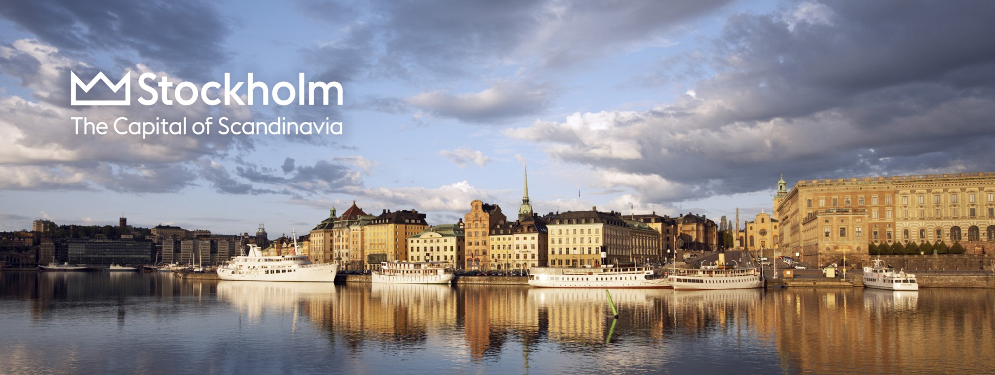

Foodie news in Stockholm

Guide Södermalm: Up and coming Hornstull
A new exciting neigborhood is taking form on the Södermalm district. Hornstull is home to the popular Debaser Hornstulls Strand, The Hornstulls Market, Linje 10/Tjoget and the new Hornhuset. The entire district is being improved.

Situated on the bohemian island Södermalm in Stockholm, Hornstull offers numerous independent shops and charming restaurants as well as some lovely park areas along the waterfront. Here are some of the key places.

- Debaser Hornstulls Strand: Adjecent to Calexico’s restaurant Debaser offers clubs as well as concerts. Bar Brooklyn offers acoustic gigs.
Address: Hornstullsstrand 4, Södermalm, www.debaser.nu
- Hornhuset: One new building, Mediterranean influences on three floors including a roof top bar. At night all three floors transforms into a bar area.
Address: Långholmsgatan 15B, www.hornhuset.se
- Käk: A fast food joint founded in part by Swedish hip hop artist Petter. The name roughly translates to "grub".
Address: Hornsbruksgatan 24-26, www.facebook.com/KAKhornstull
- Linje 10/Tjoget: Popular bar and restaurant.
Address: Hornsbruksgatan 24, www.linjetio.com
- Hornstulls Marknad (Hornstull Market): Open every Sunday 11-17 from May to September, Hornstulls Marknad has become one of Stockholms favorite Sunday activities.
Address: Hornstullsstrand. www.hornstullsmarknad.se

MORE HORNSTULL
http://www.visitstockholm.com/en/Dine/Tips/Hornstull-is-hot/

Guide Gamla Stan: The New Old Town
Stockholmers claim their Old Town back. In the past few years Gamla Stan has transformed from a typical tourist attraction to a culinary destination in Stockholm. Home to a two star Michelin restaurant as well as several new restaurants and bars. Here is our guide to the New Old Town.

- The Flying Elk: Björn Frantzén, of the two star Michelin restaurant Frantzén is behind this popular luxury pub with a lake side view. Don’t miss the Gaston Vinbar and the Corner Club bar which are part of the same group.
Address: Mälartorget 15/Lilla Nygatan 16. www.theflyingelk.se, www.cornerclub.se

- Tweed: A relaxed and comfortable liquor bar is the latest addition to the empire of Collector’s Hotel Group. Already a favorite.
Address: Lilla Nygatan 5, www.tweedbar.se

- Pharmarium: The drinks are the main act here. Inspired by old pharmacies, they serve medium size dishes composed by seasonal ingredients and medicinal herbes.
Address: Stortorget 7, www.pharmarium.se

MORE ON FOOD GAMLA STAN
http://visitstockholm.com/Eat--drink/Guides/Foodie-hot-spot-Old-Town-/

Guide: New and trendy
- Broms: A bistro, bakery, café and deli offering breakfast, brunch and even flowers.
Address: Karlavägen 76, Östermalm, www.bromskarlaplan.se

- Gro Restaurant: Ambitious cuisine with a veggie focus.
Address: Sankt Eriksgatan 67, Vasastan, www.grorestaurang.se

- Lilla Ego: Star chefs Daniel Räms and Tom Sjöstedt have opened neighborhood restaurant with a focus on Scandinavian cuisine in the Vasastan district. The name “Lilla Ego” (Tiny Ego) is derived from a song by the Swedish pop group Kent.
Address: Västmannagatan 69, Vasastan. www.lillaego.se/

- Restaurant Farang: Share-the-food concept based on Southeast Asian flavors.
Address: Tulegatan 7, Vasastan www.farang.se

- The Flying Elk, see New Old Town

- Wienercafeet : A new "grand café" has opened in the Stureplan area on Östermalm. Address: Biblioteksgatan 6-8, Östermalm www.wienercafeet.com

- Voltaire: Calling themselves a food-spa, Voltaire serves modern vegetarian food complemented by fish and seafood.
Address: -1 floor, PUB, Hötorget/Drottninggatan 72, www.pub.se

- K-märkt
Part of the former garrisson, Garnisonen, is being transformed to a lunch restaurant, bakery and patisserie and an evening venue and bar for up to 700 people. Three renowned Swedes, Johan Gottberg, chef, Jens Dolk, sommelier and Daniel Roos, Olympic gold winner pastry chef are behind the new initiative.
Address: Karlavägen 100, Östermalm.www.kmarkt.se

MORE ON NEW AND TRENDY
http://visitstockholm.com/Eat--drink/Guides/Guide-New-and-trendy/

Value for money: "Back pockets" and casual bistros
It has become quite trendy for the gourmet restaurants to open casual bistros or bakeries connected to the gourmet restaurant. Perfect for foodies on a budget: "back pockets".
http://visitstockholm.com/Eat--drink/Guides/Value-for-money-Back-pockets-and-casual-bistros/

Guide: New Nordic cuisine in Stockholm
Scandinavian culinary tradition in an innovative version, carefully selected raw ingredient, and focus on locally produced, organic foods. Here is a selection of interesting newcomers!
http://visitstockholm.com/Eat--drink/Guides/New-Nordic-Cuisine/

Guide: Food trucks
The island of Södermalm and particularly during the weekend Street Food Market on Katarina Bangata and the Hornstull market are the best places to find the most active food trucks.
http://visitstockholm.com/Eat--drink/Guides/Guide-Food-trucks/

Guide: Swedish Classics
Enjoy herring, salmon and many other delicacies - and Swedish meatballs, of course!

http://visitstockholm.com/Eat--drink/Guides/Swedish-classics/

For more information

Sabina von Greyerz, PR Manager, Stockholm Business Region AB

sabina.von.greyerz@stockholm.se
+46 (0) 8 508 28 069

www.visitstockholm.com
press.stockholmbusinessregion.se

