Press Release 2013-02-01

Vandra Rugs introducing Vandra Wool Collection

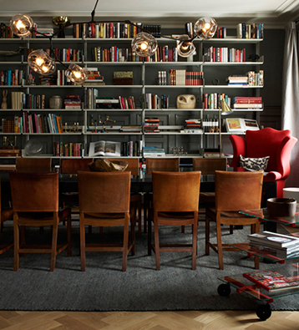

Vandra Rugs is delighted to introduce the new *Vandra Wool Collection* with a range of rugs hand-woven in traditional rag rug techniques with wool on linen yarn.

The *Vandra Wool Collection* has been developed following a demand from architects and interior decorators searching for a rug with the look, feel and durability of a wool rug while maintaining the handcrafted touch of a traditional rag rug.

Vandra Wool Collection is offered in the patterns Vertical Herringbone and Diamond Twill. The color range of the samples shown at Stockholm Furniture Fair will include beautiful light and charcoal greys, natural beiges, browns and varying shades of blues. In total 30 color ways are offered. The yarn can be selected in your choice of colors natural linen, brown, off white and black. The rugs are woven in the size of your specification, with the maximum width of 4 meters.

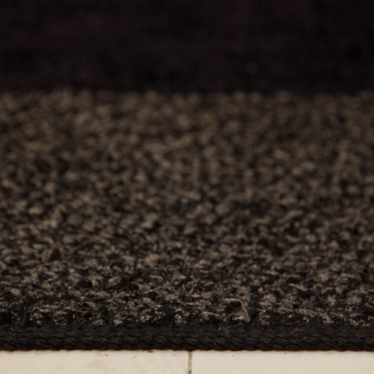

Find more information and high definition pictures of Vandra Wool Collection on [www.vandra-rugs.com](http://www.vandra-rugs.com) under downloads, password: press123.

For more information, please call Marie Wallenberg Olsson +46-70 852 74 46 or Cia Attling +46-70 8957212 at Vandra Rugs.

***Vandra Rugs***

*Vandra Rugs is a modern weaving atelier that combines modern design with handicraft knowledge. All rugs are woven in a rag-rug technique on traditional floor looms. We use the highest quality natural materials cotton and linen as well as wool and high tech materials in our rugs. Vandra Rugs is found in private homes as well as hotels, stately homes, beach houses and even yachts. Vandra Rugs are available either through collections or custom made as Vandra Bespoke. The production takes place primarily in the weaving atelier in the Ukraine. The company was founded in 2007 but has its roots in Svenskt Tenn’s textile department in the 1940’s. Today, Vandra Rugs are sold all over Europe as well as in the US.*