Press release
Düsseldorf, 23/07/2024
New directions in bus production: Auction following restructuring of Swedish city bus manufacturer’s plant in Słupsk, Poland
Due to technological advancements and the ongoing impacts of the COVID-19 pandemic, bus manufacturing faces significant challenges, necessitating a realignment of business strategies. A leading Swedish manufacturer has ceased the production of complete buses and instead focuses on producing chassis with various drivetrains at its plant in Słupsk, Poland. As part of this restructuring, around 1,150 items have been sorted out and will be auctioned by August 13 to 15.
The transformation of drivetrain technologies and the prolonged effects of the COVID-19 pandemic are the biggest challenges facing bus manufacturing. The drop in passenger numbers during the pandemic has severely affected the bus industry. Although the market is recovering, it is doing so slowly. In this difficult environment, public funds for public transport are limited in many places. This further intensifies the competition among bus manufacturers. Supranational legislative changes aiming for EU-wide CO2 neutrality also complicate the situation. All this has led some bus manufacturers to rethink and adjust their business strategies.
New itinerary for the future
A renowned Swedish bus manufacturer has responded to these challenges and last year initiated a comprehensive restructuring of its plant in Słupsk, Poland. As part of a sustainable business strategy, the in-house production of buses was discontinued. Instead, the company increasingly relies on cooperation with selected, local bodybuilders and industry partners. This approach has already been successfully implemented in most of the bus business and is now being expanded. The company focuses on manufacturing chassis with a wide range of drivetrains, while body production will be discontinued by the first quarter of 2024.
Three-day auction for over 1,000 sorted items
Against this backdrop, the auction house Surplex is organising a three-day auction from August 13 to 15. “As part of the restructuring of the plant, almost 1,150 items were sorted out, which are now going under the hammer. Therefore, we decided to spread the auction over three days,” explains Marcin Kocurek, Country Manager of Surplex in Poland. “The auction catalogue does not contain any large machines, but rather many small lots such as hand tools, power tools, and more. Of course, there are also larger items such as lifting equipment, work platforms, welding machines, welding lathes, and forklifts.”
Highlights of the auction include:
- ELUMATEC CNC Universal Machining Centre
- Various electric forklifts
- Various metal saws
- Welding equipment
- Cranes and lifting devices
- Also available: additional machine tools and accessories, and workshop equipment
A viewing of the machines is possible by prior appointment.
Surplex has acquired the sorted machines
“Surplex has purchased the sorted machines and items,” explains Kocurek. “At Surplex, sellers can choose between two selling options. One option is to sell machines directly to us. Fair prices and quick payment processing then ensure immediate liquidity. Alternatively, sellers can also utilise the sales force of the auction platform by commissioning us to handle the sale of machines and equipment.”

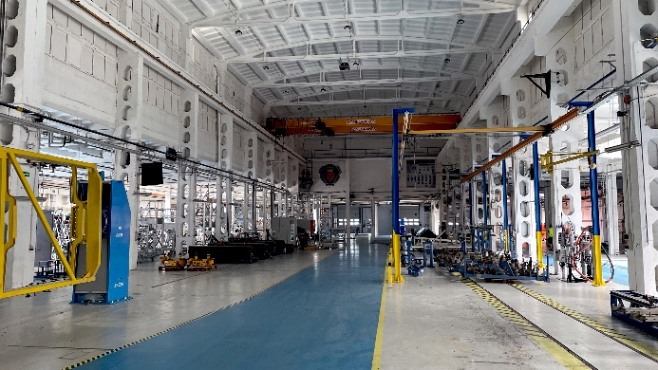 | Photo 1  The plant in Słupsk, Poland, plays a central role in the restructuring plans of the Swedish bus manufacturer. Here, drivetrains will primarily be manufactured in the future.  (© Surplex).
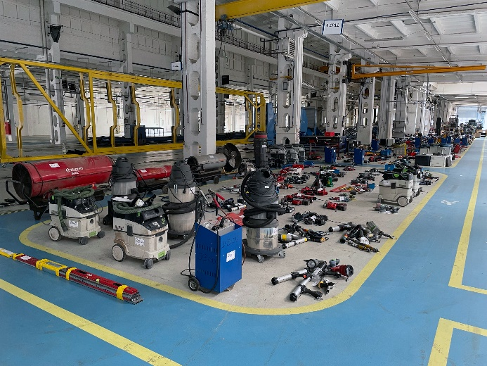 | Photo 2  Since almost 1,150 lots, mostly small items such as hand tools and power tools, are being auctioned, the event will last for three days.  (© Surplex).

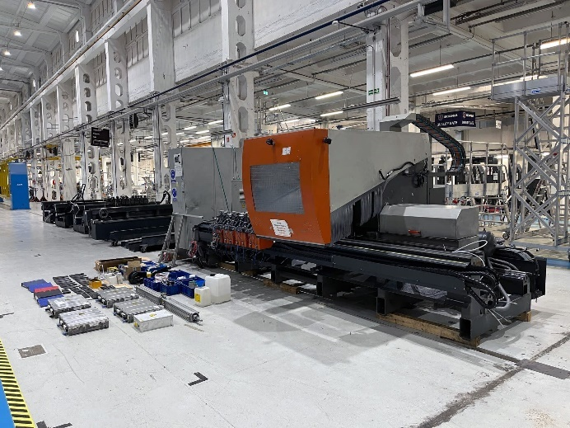 | Photo 3  Since the production of bus bodies has been outsourced to external companies, specialised equipment such as the 5-axis machining centre for aluminium or PVC profiles ELUMATEC SBZ 150 is also up for auction.  (© Surplex).

