Press Information
Salone del Mobile 2018: Experience a new dimension in bathroom design
Strong Brand Appearance by AXOR and hansgrohe
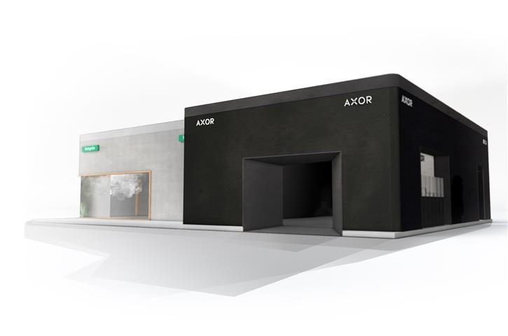
Copyright: Hansgrohe SE
From 17 to 22 April 2018, industry professionals and design-conscious consumers will be able to discover the many new innovations by AXOR and hansgrohe within their respective brand worlds at the Rho exhibition centre. Booth location: Hall 22, F23/27.

Schiltach/Milan, February 2018. When the world’s leading trade fair for furniture and design opens its doors in April, the international furnishing and design industries will gather in Milan. At this year’s Salone del Mobile, AXOR and hansgrohe, the two brands of the Hansgrohe Group, will visually impact visitors with ground-breaking bathroom and kitchen innovations. From 17 to 22 April 2018, industry professionals and design-conscious consumers will be able to explore new products presented by the two brands at the Rho exhibition centre in Hall 22.
“With our strong brands AXOR and hansgrohe, we have consistently and steadily made a name for ourselves as a leader in innovation, quality and design,” Thorsten Klapproth, Chairman of The Executive Board of Hansgrohe Group explains. “For decades, delivering good design has been a top priority — one of our mantras is: ‘beauty is a point of honour’. But we go far beyond aesthetically pleasing design: we think of water in the bathroom and kitchen in completely new dimensions, adding functional value, thereby creating an emotional water experience. This is deeply anchored in our company’s DNA. That’s why this year we are once again presenting high quality, functional design objects at the Salone del Mobile. By the way, this doesn’t just apply to our new products; the Hansgrohe Group booth itself is also sure to be an impressive attraction for our guests,” Klapproth promises.
AXOR: 25 Years of Bathroom Individualisation
For 25 years, AXOR (www.axor-design.com) has been a pioneer in the development and production of avant-garde design objects for luxury bathrooms and kitchens. The AXOR taps, shower heads and accessories embody the brand’s claim to perfection in design and function. Reason enough to celebrate its 25th anniversary at the centre of the international design scene. Fittingly on this special occasion, we are exclusively premiering AXOR M.E (“My Edition”). This latest collection of taps was created in collaboration with the Stuttgart-based design studio Phoenix and is an expression of personality, self-realisation and individual creativity. A variety of surface colours and patterns lend the tap an exceptional look, which, together with a new and sensuous way of experiencing water, form the point of departure for AXOR M.E.

hansgrohe: An Exceptionally Gentle Showering Experience and New Materials for the Kitchen

With its many award-winning innovations and designs, the premium brand hansgrohe shapes the flow of water in the kitchen and bathroom – spaces where people spend the time they treasure most and experience precious moments in interaction with water. For example, in the shower, when an innovative shower spray technology covers the body with a warm and misty summer rain. This experience is made possible by a new series of shower heads, which hansgrohe will present for the first time to an international audience at the Salone. Also new at the Salone: a material, seemingly inspired by nature, which hansgrohe uses to give the kitchen centrepiece, the sink, a warm and homely feel, stylish colouring and exceptionally robust suitability for everyday use.
About the Hansgrohe Group
With its brands AXOR and hansgrohe, the Hansgrohe Group, based in Schiltach/Southern Germany, enjoys a reputation as a leader in innovation, quality and design within the bath and kitchen industry. The Hansgrohe Group brings form and function to water with taps, showerheads and shower systems. The 116-year history of the company is marked by innovations such as the first hand-held shower with multiple spray types, the first pull-out kitchen tap, and the first wall bar to hold a hand-held shower. The company holds more than 16,000 active property rights. The Hansgrohe Group stands for long-lasting quality products. With 34 subsidiaries and 21 sales offices supplying products in more than 140 countries, the company is a reliable partner to its customers around the world. The Hansgrohe Group, its brands and products have won numerous awards, including more than 500 design prizes since 1974. Sustainable production of resource-conserving products is central to the company’s business activities around the globe. The products of the Hansgrohe Group are featured in projects around the world, such as the luxurious ocean liner Queen Mary 2, and the world’s tallest building, the Burj Khalifa in Dubai. The Group’s high quality standards are ensured by five wholly-owned production facilities: two in Germany, one each in France, the United States and China. In 2016, the Hansgrohe Group generated a turnover of EUR 1.029 billion. It employs more than 4,800 people worldwide, about 60 percent of whom work in Germany.

Find out more about the Hansgrohe Group and its brands AXOR and hansgrohe on:
www.facebook.com/axor.design
www.facebook.com/hansgrohe
www.twitter.com/Hansgrohe_PR

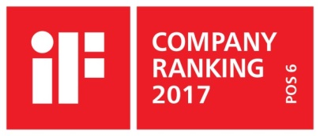 | iF Design Leader in the Sanitation Industry  In the current ranking of the International Forum Design (iF) of the best companies in the world for design, the Hansgrohe Group, with its brands AXOR and hansgrohe, ranks 6th among 2,000 listed companies. The 1040 points earned by the Schiltach-based fixtures and shower specialist outperform famous brands such as Audi, BMW or Apple and reconfirm the company’s leading position in the sanitation industry.  www.hansgrohe.com/design

Further Information: | Hansgrohe Finland  - Marketing -  Sonja Nurminen  +358 50 351 4941  sonja.nurminen@hansgrohe.fi  www.hansgrohe.fi

Copyright: We must draw your attention to the fact that we have only limited usage rights for the images provided; extended image rights, however, belong to the respective photographers. The images with a Hansgrohe SE copyright may therefore only be published free of charge if they clearly and expressly serve to portray or advertise the performances, products or projects of Hansgrohe SE and/or its brands (AXOR, hansgrohe). All other images shall only be used in connection with the corresponding press release. Any other form of publication requires the approval of the respective copyright owner and remuneration must be made in agreement with said copyright owner.

