PRESS RELEASE  
For Immediate Release

**Hop on the Magical Festive Express at PARKROYAL on Beach Road**

Savour a delectable feast at Ginger and Si Chuan Dou Restaurant along with

gourmet festive takeaways and a magical staycation to remember

**[Singapore, 14 November 2019]** Usher in the festive season with your loved ones at **PARKROYAL on Beach Road** as the hotel lobby transforms into a magical Christmas realm with an interactive Polar Express-themed train!

Bond over a sumptuous feast at **Ginger**, our all-day dining restaurant, featuring a ‘no pork, no lard’ buffet menu with a plethora of Asian and Western delicacies; or opt for a unique twist of the festive tradition with a seven-course Sichuan Christmas set menu at **Si Chuan Dou Hua Restaurant**. Spread the joy of Yuletide with our wide selection of festive takeaway goodies or revel in merry moments with celebration packages available at **Club 5** and **The Ballrooms**. For the ultimate indulgence, book yourself a **Magical Festive Getaway** with exclusive perks or celebrate me-time at the award-winning **St. Gregory spa**.

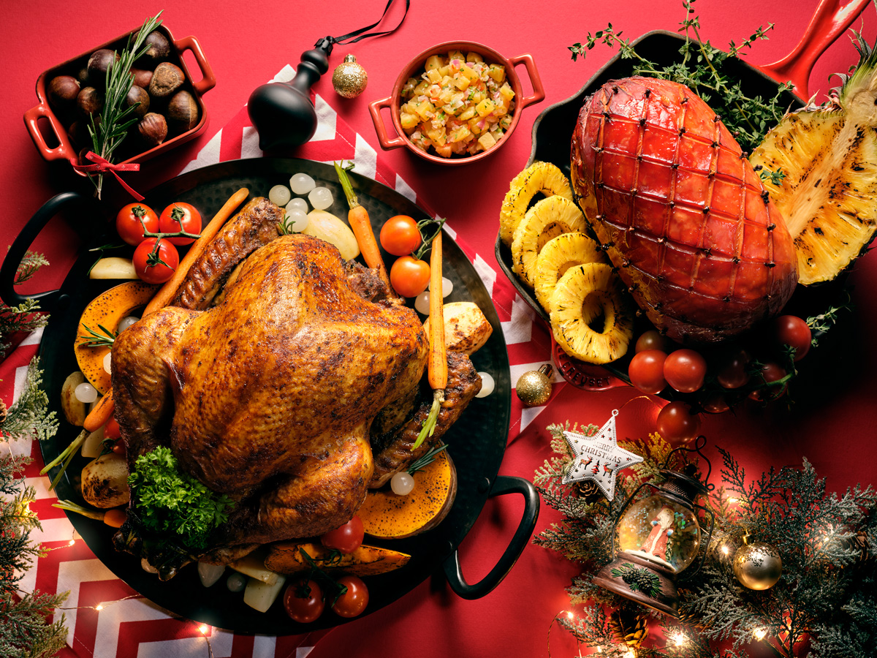

**Merry Feasting at Ginger**

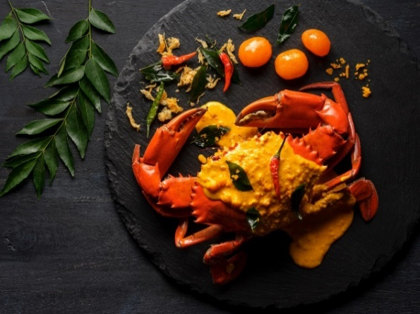Claw your way into the Yuletide season with a medley of crab dishes, prepared in a myriad of cooking methods to showcase its finest flavours. Taking the centre stage at Ginger’s Crabs Galore is the crowd-pleasing *Claypot Crab with Pumpkin Broth*, alongside the much-loved *Singapore Chilli Crab*, as well as a Featured Crab of the Day available on a rotational basis, including the *Salted Egg Yolk Crab* and *Cheese Crab*. From 9 to 30 December 2019 (excluding 24 and 25 December), the Claw-Inspiring Crabs Galore will be complemented with an array of classic festive treats.

**Available from 9 to 30 December 2019 (excluding 24 and 25 December):**

|  |  |  |  |
| --- | --- | --- | --- |
| **Festive Weekday Lunch Buffet** | | **Per Adult (SGD)** | **Per Child (SGD)** |
| 9 to 23 December,  26 to 30 December 2019 | Lunch  12:00pm to 2:30pm | 58 (Mon-Fri) | 29 (Mon-Fri) |
| **A Claw-Inspiring Festive Crabs Galore** | | **Per Adult (SGD)** | **Per Child (SGD)** |
| 9 to 23 December, 26 to 30 December 2019 | Lunch  12:00pm to 2:30pm | 68 (Sat-Sun) | 34 (Sat-Sun) |
| Dinner  6:00pm to 10:00pm | 78 (Mon-Thu) | 39 (Mon-Thu) |
| 88 (Fri-Sun) | 44 (Fri-Sun) |

*\*Highlighted crab dishes are on rotation and are subject to change.*

Get ready for Christmas and New Year’s feasting at **Ginger** as Executive Chef Vincent Aw and his culinary team unveil signature highlights such as the *Traditional Whole Roasted Turkey with Cranberry Sauce*, *Turkey Salad with Sun Dried Tomatoes*, *Herb-Crusted Salmon with Seafood Ragout, Roasted Winter Vegetables with Herbs,* and local favourites such as *Singapore Chilli Crab* and *Grilled River Prawns with Sambal Belachan*.

Tuck into the medley of sweet treats at our dessert corner including *Christmas Log Cake*, *Christmas Cookies* and *Ginger Fruitcake*.

**Available on 24 and 25 December 2019:**

|  |  |  |
| --- | --- | --- |
| **Festive Buffets** | **Per Adult (SGD)** | **Per Child (SGD)** |
| Christmas Eve Lunch  24 December 2019, 12:00pm to 2:30pm | 68 | 34 |
| Christmas Eve Dinner  24 December 2019, 6:00pm to 10:00pm | 98 | 49 |
| Christmas Day Brunch  25 December 2019, 12:00pm to 5:00pm | 88 | 44 |
| Christmas Day Dinner  25 December 2019, 6:00pm to 10:00pm | 88 | 44 |
| New Year’s Eve Lunch  31 December 2019, 12:00pm to 2:30pm | 68 | 34 |
| New Year’s Eve Dinner  31 December 2019, 6:00pm to 10:00pm | 98 | 49 |
| New Year’s Day Brunch  1 January 2020, 12:00pm to 5:00pm | 68 | 34 |
| New Year’s Day Dinner  1 January 2020, 6:00pm to 10:00pm | 68 | 34 |

Top up **SGD50 per person** for unlimited servings of house pour wine, sparkling wine, spirits and beer.

Dining reservations at Ginger can be made at [**dining.prsin@parkroyalhotels.com**](mailto:dining.prsin@parkroyalhotels.com), or please speak with us at **+65 6505 5710**.

*\*All prices are subject to a 10% service charge (for dine-in) and GST, unless otherwise stated. Child prices apply to six to 12 years old.*

**An Oriental Christmas at Si Chuan Dou Hua Restaurant**

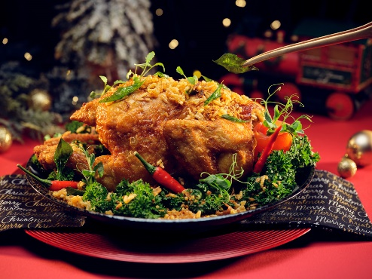There is more to the Yuletide season than turkeys and hams. Celebrate the festivities with a spicy twist, featuring a seven-course Sichuan Christmas set menu at our award-winning Si Chuan Dou Hua Restaurant.

Break away from tradition and sample our very own Sichuan rendition of a Christmas Turkey – *Chilled Turkey in signature mala Sichuan Pepper Sauce*. Alternatively, tuck into the delectable *‘Bi Feng Tang’ Roasted Crispy Chicken*, available for both dine-in and takeaway.

|  |  |
| --- | --- |
| **Seven-Course Christmas Set Menu**  Daily, 18 to 25 December 2019 | **Lunch**,11.30am to 2.30pm  **Dinner**, 6.30pm to 10.30pm  SGD68 per set  *\*Minimum two to dine* |

Dining reservations at Si Chuan Dou Hua Restaurant can be made at [**dining.prsin@parkroyalhotels.com**](mailto:dining.prsin@parkroyalhotels.com), or please speak with us at **+65 6505 5722**.

*\*All prices are subject to a 10% service charge (for dine-in) and GST, unless otherwise stated.*

**Hearty Festive Treats**

Bring the party to everyone with our delectable festive treats from **Ginger** and **Si Chuan Dou Hua** **Restaurant**, perfect for any celebratory gatherings during the merry season.

Complete your festive platter with our *Traditional Whole Roasted Turkey with Cranberries and Pan Jus* and *Manuka Honey Glazed Ham with Oriental Salsa*, and end it on a sweet note with the good ol’ *Classic Chocolate and Hazelnut Log Cake*! Feeling adventurous this festive season? Spice up your holiday feast with Si Chuan Dou Hua’s *‘Bi Feng Tang’* *Roasted Crispy Chicken*, bound to sizzle and whet your appetite!

**Festive Takeaways (Available from 1 to 26 December 2019)**

|  |  |
| --- | --- |
| **Festive Treats** | **Price (SGD)** |
| Traditional Whole Roasted Turkey with Cranberries and Pan Jus | 138 |
| Manuka Honey Glazed Ham with Oriental Salsa | 68 |
| Classic Chocolate and Hazelnut Log Cake | 68 |
| ‘Bi Feng Tang’ Roasted Crispy Chicken | 58 |
| Christmas Stollen with Confit Orange and Lemon | 48 |
| Ginger Fruitcake | 48 |
| Mixed Nuts Tart | 48 |
| Cornflakes Wreath | 18 |
| Almond Gingerbread Cookie | 10 |
| Gingerbread Cookie (Boy or Girl) | 8 |

Get started on checking off your festive goodies list early! Enjoy **25% savings\*** for orders placed with full payment from 25 November to 8 December 2019.

For those who need a little more time deciding what to include in your Yuletide feast, we have got you covered too! Enjoy **20% savings\***for orders placed from 9 December to 26 December 2019.

Takeaway orders can be made at [**dining.prsin@parkroyalhotels.com**](mailto:dining.prsin@parkroyalhotels.com), or please speak with us at **+65 6505 5710**. Advance orders of three working days are required for festive takeaway treats.

*\*Offer is only valid when payment is made with a UOB, Citibank, OCBC or Maybank Debit or Credit Card. All prices are subject to GST, unless otherwise stated.*

**Merrymaking at Club 5**



The best way to conclude a hearty feast is an evening of endless celebratory toasts! Shimmy down to Club 5 to continue with the merrymaking accompanied by live band performances on every Friday in the month of December, as well as on Christmas and New Year’s Eve Countdown!

Package is valid from 1 December 2019 and includes unlimited servings of house pour spirits, wine and beer, as well as single serving of bar snacks set.

|  |  |
| --- | --- |
| **Valid from 1 December 2019** | **Price (SGD)** |
| Group of Four | 260 |
| Group of Six | 390 |
| Seven Persons and Above | 60 per adult |
| Six Persons and Below | 65 per adult |

Bookings and dining reservations at Club 5 can be made at [**dining.prsin@parkroyalhotels.com**](mailto:dining.prsin@parkroyalhotels.com), or please speak with us at **+65 6505 5699**.

*\*All prices are subject to a 10% service charge (for dine-in) and GST, unless otherwise stated.*

**Celebrate Me-Time at St. Gregory**

Immerse in the holiday season at St. Gregory spa by treating yourself and your loved ones to a series of relaxing therapies, specifically curated to rejuvenate your mind and body holistically.

Looking for the perfect Christmas gift? Surprise your loved ones with our range of Elemis Christmas Gift Sets, priced from SGD80nett.

|  |  |  |
| --- | --- | --- |
| **Holiday Season Special Spa Treatment Package** | **Duration (Mins)** | **Promotional Price (SGD)** |
| **Me-Time Relaxation**   * Choice of one 60-minute body massage (Balinese Massage or Aromatic Body Bliss Massage) * One 30-minute Foot Massage * One-day complimentary access to Wellness Floor facilities | **90** | **155 (U.P 300)** |
| **Me-Time Celebration**   * Choice of one 30-minute body exfoliation (Elemis Devil’s Mint Body Glow or Elemis Intensive Cleaning Salt Scrub with Exotic Lime and Ginger) * One 30-minute Anti-Stress Back Bliss Massage * One 75-minute Elemis Skin Specific facial treatment * One-day complimentary access to Wellness Floor facilities | **135** | **238 (U.P. 440)** |

For orders, reservations and enquiries, please speak with us at **+65 6505 5755** or email us at [**stgregory.prsin@parkroyalhotels.com**](mailto:stgregory.prsin@parkroyalhotels.com).

*All spa prices quoted are in Singapore dollar and nett prices.*

**A Magical Festive Getaway at PARKROYAL on Beach Road**Bask in the spirit of the holiday season with a festive staycation at PARKROYAL on Beach Road as our hotel lobby transforms into a magical Christmas realm where your little ones can dress up as train conductors and play with an interactive Polar Express-themed train.

Relax and refresh your senses with a dip in our outdoor swimming pool with a scenic view of the Singapore skyline on our Wellness floor, and explore the little alleys in the adjacent Haji Lane while soaking up the perfect mix of heritage and hip culture in the Kampong Glam vicinity. Enjoy a memorable festive getaway with up to *20% savings* on Best Available Rate, *complimentary breakfast for two persons* and *late check-out till 4pm*\*.

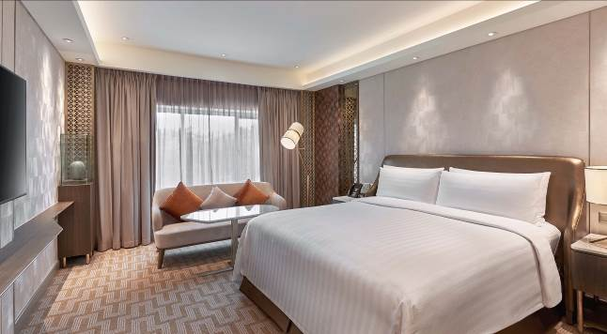

For room reservations and enquiries, please speak with us at **+65 6505 5656** or email us at [**reserve.prsin@parkroyalhotels.com**](mailto:reserve.prsin@parkroyalhotels.com).

*\*Subject to availability. Black out dates apply.*

**Group Celebrations at The Ballrooms**

A perfect celebration is the marrying of a stunning venue, delectable cuisine and infinite amounts of laughter for everyone. We have decked out our ballrooms to ensure just the perfect celebration for all festive occasions for everyone. Select from either of our pillar-less ballrooms – the Grand Ballroom or Sky Ballroom with natural daylight and enjoy a host of privileges.

|  |  |
| --- | --- |
| **Dinner & Dance\***  Valid for bookings until 31 March 2020 | Celebrate your company’s dinner and dance in style with a special package that caters to all of your needs, including delectable cuisine and state-of-the-art event facilities.  Weekday Celebration *(Mondays to Thurdays, excluding public holidays and eve of public holidays)*   * From SGD75 per person for an International buffet spread * From SGD750 per table of 10 persons for a Chinese sit-down menu   Weekend Celebration *(Fridays to Sundays, including public holidays and eve of public holidays)*   * From SGD85 per person for an International buffet spread * From SGD850 per table of 10 persons for a Chinese sit-down menu |
| **Auspicious Celebration Packages\*** 6 January to 8 February 2020 (excluding 24 to 27 January 2020) | Usher in new beginnings on an auspicious note with us and feast on a delectable eight-course Cantonese cuisine in one of our stunning pillar-less ballrooms!  Priced from SGD898 per table of 10 persons for a eight-course Cantonese cuisine* |
| **Prosperous Reunion Gatherings** Lunar New Year Eve Reunion Dinner at The Ballrooms  24 January 2020 | Renew bonds and strengthen relations with your loved ones this Lunar New Year! Book your reunion dinner celebration with us on 24 January 2020, at the Grand Ballroom at PARKROYAL on Beach Road and toast to a prosperous Year of the Rat!  Priced at SGD118 per adult and SGD60 per child   Auspicious Early Bird Savings:   * 20% savings for bookings and full payment made by 30 November 2019 * 10% savings for bookings and full payment made by 17 January 2020 |

For bookings and enquiries, please speak with us at **+65 6505 5697** or email us at [**celebrate.prsin@parkroyalhotels.com**](mailto:celebrate.prsin@parkroyalhotels.com)

*\*Valid with a minimum booking of 15 tables. All prices are subject to a 10% service charge and GST, unless otherwise stated.*

**– END –**

**Note to editors:**All letters of the PARKROYAL brand should be capitalised. If your publication’s house style does not allow this, please ensure that PARKROYAL appears as one word – ‘Parkroyal’.

**For high resolution images, please download them** [**here**](https://www.dropbox.com/sh/h3ut02ye06swfef/AACMN6h3mXVvD0sny3dFZbtga?dl=0)**.**

**For media enquiries, please contact:**  
Tricia Quak  
Senior Marketing Communications Manager  
PARKROYAL on Beach Road, Singapore  
DID: +65 6505 5608  
Email: [tricia.quak@parkroyalhotels.com](mailto:tricia.quak@parkroyalhotels.com)

Regine Goh  
Assistant Marketing Communications Executive  
PARKROYAL on Beach Road, Singapore  
DID: +65 6505 5678  
Email: [regine.goh@parkroyalhotels.com](mailto:regine.goh@parkroyalhotels.com)

**PARKROYAL Hotels & Resorts**A big city or cosy enclave – where there is a PARKROYAL hotel, resort or serviced suite, there is a celebration of people. Our passion for creating real connections and joyous moments can be felt when you enter any of our properties across Asia and Australia. After all, this is the place to bring out the best of you, by us.

**About Pan Pacific Hotels Group**

Pan Pacific Hotels Group is a wholly-owned hotel subsidiary of Singapore-listed UOL Group Limited, one of Asia’s most established hotel and property companies with an outstanding portfolio of investment and development properties.

Based in Singapore, Pan Pacific Hotels Group owns and/or manages more than 40 hotels, resorts and serviced suites including those under development in 24 cities across Asia, Oceania, North America and Europe.

Voted “Best Regional Hotel Chain” by readers in Asia-Pacific in 2017 and 2018, Pan Pacific Hotels Group comprises two acclaimed brands: its signature brand, Pan Pacific and its deluxe brand, PARKROYAL.

Sincerity is the hallmark of Pan Pacific Hotels Group. The Group is known to its guests, partners, associates and owners for its sincerity in people and the sense of confidence which alleviates the stresses of today’s complex world.

Visit us at www.panpacific.com.