With Great Power Comes Great Entertainment

Sony introduces new High Power Home Audio Systems with Bluetooth, huge bass and fun lighting effects

- GTK-XB7 with immense power, dynamic EXTRA BASS and new lighting effects.
- MHC-GT4D with powerful sound, versatile 3-way speaker settings and Gesture Control
- MHC-V11 high power ‘one-box’ system with CD, USB and Bluetooth Playback options, MEGA BASS, DJ and karaoke functions

The fun starts here: three new High Power Audio Systems from Sony pump up the party with huge sound, soul-shaking bass and thrilling synchronised lighting effects. Everything’s on board for instant entertainment that’s easy to carry from room to room.

GTK-XB7
One box, boombastic bass. With fabulous sound, bags of power and massive low frequency response from two large 16cm woofers, the XB7 turns nights at home into a premium clubbing experience.

Sony’s unique EXTRA BASS technology uses DSP technology that cleverly processes frequencies according to the source while maintaining excellent audio quality. Music sounds and feels even more powerful, with punchy and deep bass notes that define today’s pulsing electronic dance tracks.

Exciting 3-way multi-colour illumination; line lights, flashing strobes and speaker lights pulse in synch with the music, bringing that festival vibe right into your room

Play things your way: Multi Layout lets you position the XB7 vertically or on its side, enjoying sensational stereo sound in either orientation. There’s also a handy Speaker Add function, allowing you to hook up a second XB7 unit via Bluetooth and instantly double your music power.

Stunning sound, no wires: One-touch listening lets you stream your favourite tracks and playlists via Bluetooth with a single touch of your NFC smartphone or tablet. And if you want to get even more hands on, add cool DJ-style effects controlled with Sony’s SongPal app on your mobile. You can charge your phone or tablet’s battery over USB while you’re playing music. There’s also an audio input for connecting MP3 players or just about any other sound source.

MHC-GT4D
The power-packed GT4D is made to entertain, with three different ways to enjoy fabulous sound just the way you want to in any situation.

The all-in-one system goes wherever the party is, with handy wheels and a grab handle for moving effortlessly from room to room. Independent line-array speaker sections give expansive sound and more set-up flexibility. Attach both speakers to the main unit’s integrated handle and spread loud, powerful sound right across the dancefloor.

TV lovers are generously catered for, too. It’s easy to configure the GT4D sound bar-style, with its HDMI output connected to your television and the line array speakers beneath your screen for extra volume and presence while you’re watching movies on DVD, sport and more. And for even more entertainment options, simply place both speakers on a table for everyday listening.

The GT4D gives loads of entertainment options, whether you’ve got a roomful of party guests or just relaxing on your own. Make a wireless connection with your NFC phone and stream tunes over Bluetooth. Slip in a CD; connect a USB drive full of MP3 and WAV files; hook up your MP3 player via the audio input, or tune in to the radio.

There’s no shortage of searing power on tap, with MEGA BASS taking your low end to crazy levels at the touch of a button. Speaker lighting adds atmosphere pulsing in sync with every beat. If you’re watching movies, S-Force Front Surround creates an immersive multi-channel soundstage that wraps right around you.

Get the dance floor jumping with scratching, sampling and other creative DJ effects. Gesture Control lets you skip tracks, adjust volume or add effects with an effortless wave of a hand. Want to go louder still? It’s easy to hook up multiple GT4D systems with Party Chain for even bigger sound, with speaker lights synchronised to the beat of the music

MHC-V11
Treat yourself to super-sized, powerful sound – even if you’re tight on space. The compact V11 features a space-saving ‘one box’ design that’s easy to carry wherever it’s needed.

Enjoy music from Bluetooth, CD, USB or radio sources, with the 20cm woofer and MEGA BASS ensuring impressively deep lows. Every beat’s lit up with pulsing blue LED speaker illumination that flashes in time to the music.

You’ve got even more entertainment options with karaoke and DJ effects: or join extra systems together with Party Chain and take the fun to the next level.

Detailed specs on the new products can be seen here:
- GTK-XB7
- MHC-GT4D
- MHC-V11

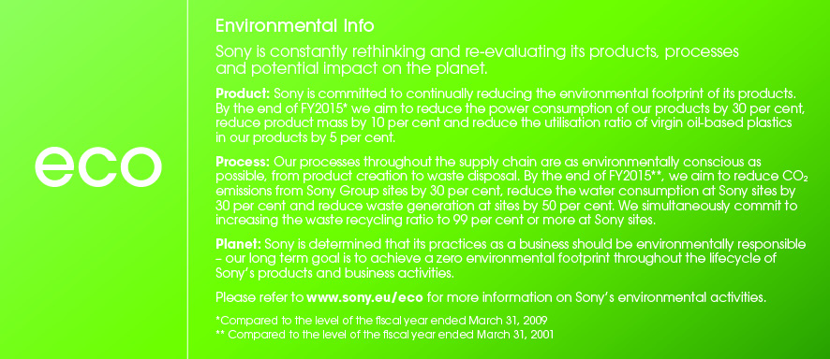

For mere information, kontakt venligst:
Mika Ilves, Nordic Product Manager, Headphones, Traditional Personal Audio & Systems
mika.ilves@eu.sony.com /+358 4054 81680

Eller (og for produkttest):
Ekaterina Bakhbava, kommunikationsrådgiver for Sony, Discus Communications
sony@discus-communications.dk / 33 38 43 01

Om Sony
Sony udvikler og leverer produkter inden for lyd, video, kommunikation og informationsteknologi til forbrugere og professionelle. Med en unik global position er Sony en førende pioner indenfor elektronik- og underholdningsindustrien med særlig fokus på musik, foto og spil. Sony leverede i regnskabsåret 2014 et resultat på godt 68 milliarder dollars. Læs mere om Sony på sony.net og om Sony Danmark på sony.dk.

