KING CHULALONGKORN MEMORIAL PAVILION – A SYMBOL OF THE THAI SWEDISH FRIENDSHIP OF OVER 100 YEARS! A PLACE WHERE HISTORY COMES ALIVE.

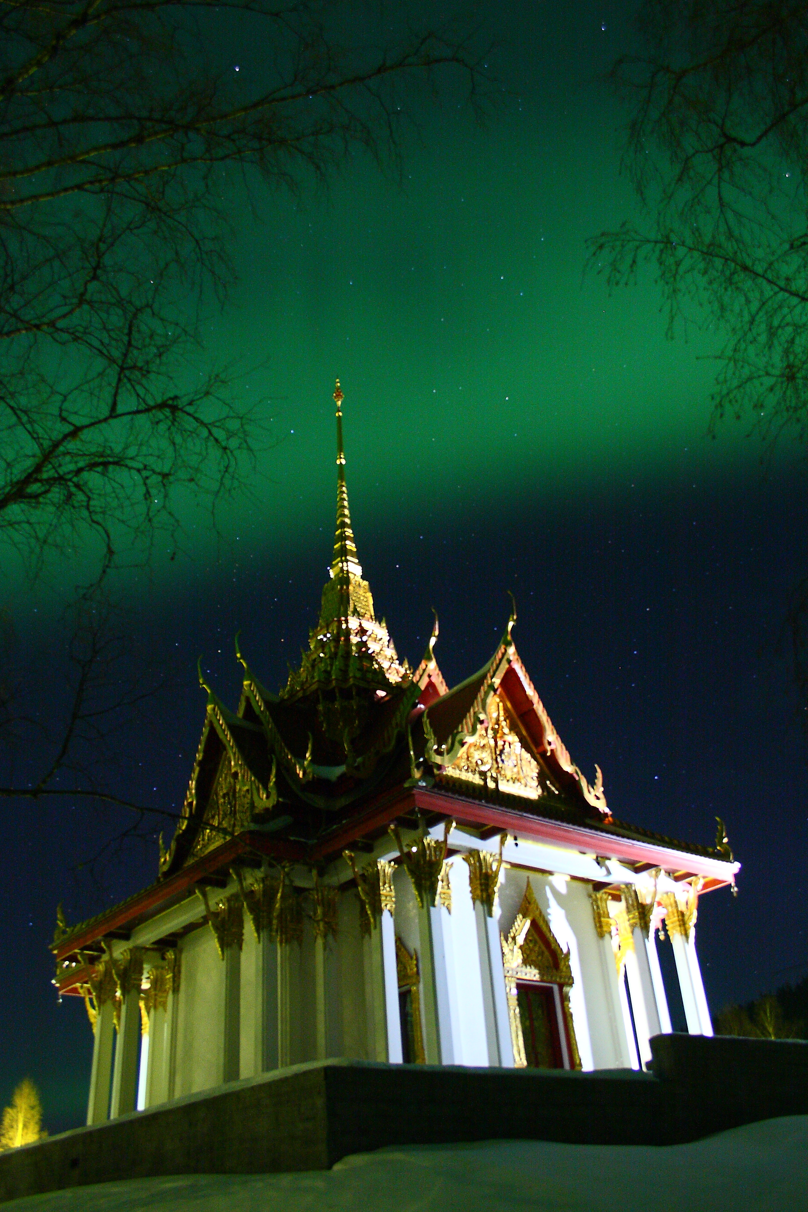
Photo: AG Wildlife Experience
Destination Ragundadalen on behalf of Ragunda municipality and Solleftea municipality participated in a week long trip to Bangkok. The purpose of the trip was to visit the various contacts such as Thai-Swedish Relationship Foundation 1897 (TSFR-1897) who started the initiative to create the Memorial Thai Pavilion in Sweden. Together with all interested parties we now want to strengthen and develop the cooperation with regards to the Thai Pavilion and its brand.

During the visits with General Chettha Thanajaro TSFR- 1897, Bangkok Municipality, ATTA, The Embassy, Ministry of Culture many great ideas came to light regarding the development of the Thai Pavilion, which Destination Ragundadalen believe will assist to strengthen the bonds between Thailand and Sweden, Ragunda and region Jämtland Härjedalen and Västernorrland.

Swedish visitors come to the Thai Pavilion to experience a part of Thailand in Sweden and Thai visitors who reside in Sweden who wish to honour the beloved King Chulalongkorn as well as Thai children who wish to experience Thai traditions and culture. Other visitors include germans, dutch, norwegians and many others who want to experience this gem and the history around it.

- The trip resulted in excellent meetings and contacts. It was great to meet with General Chettha Thanajaro, the Thai - Swedsih Relationship Foundation 1897 (TSFR-1897) to discuss future plans in cooperation with Thai people who has the Thai Pavilion’s future interests at heart. Without TSFR and other interested parties this project would not have been possible says Åsa Lind Chong CEO of Destination Ragundadalen.

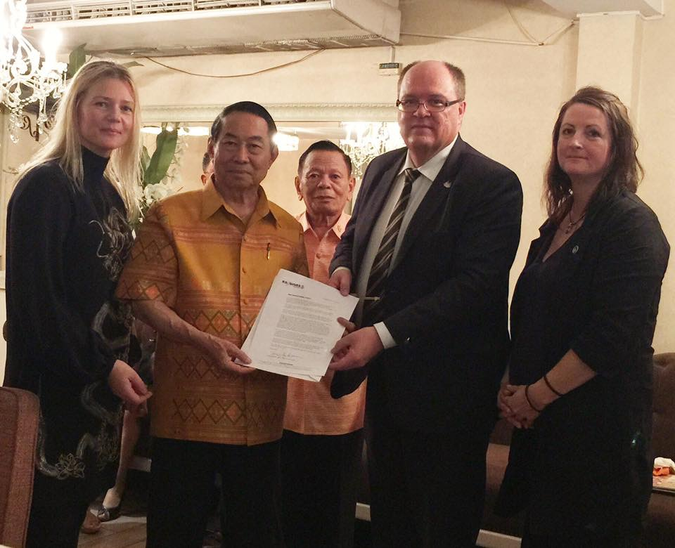
Destination Ragundadalen, General Chetta Thanjaro TSFR 1897 Solleftea Municpality

The result of the trip means that Ragunda together with TSFR 1897 will create a strategy for the future development of the Thai Pavilion which will include education and cultural events. When one visits the Thai Pavilion and the area around it, one experiences the unexpected as history comes alive.

The Pavilion is a memorial building in honour of King Chulalongkorn who visited the area on invitation from King Oscar II. Ragunda’s vision and goals for the future is to show that something great and wonderful happened here and that it created strong bonds of friendship between Thailand and Sweden.

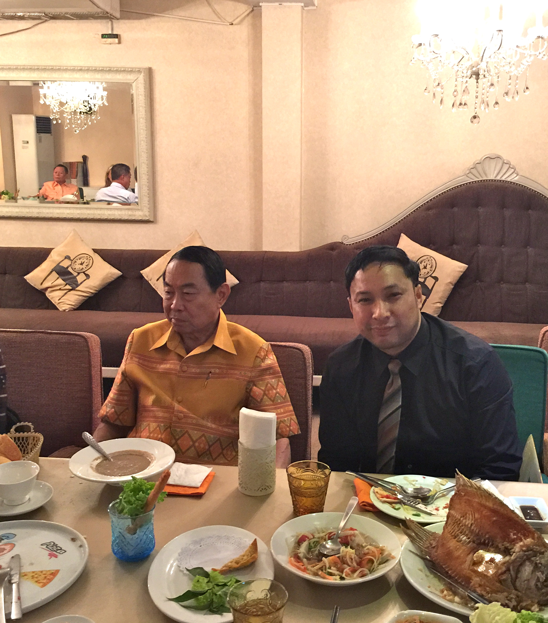
General Chettha Thanajaro and Chai Kayankarn
During the recent visit, Destination Ragundadalen was also assisted by Chai Kayankarn from Östersund municipality and the plan is for Destination Ragundadalen to continue this cooperation in order to develop cultural events and ceremonies.
-I hope that the Thai Pavilion will become better known to the Thai who reside in Sweden. I also wish that every visitor to the pavilion will have a long lasting memory of the experience that they will retell to their friends: the story of the visit by King Chulalongkorn and the creation of the magnificent building: an extraordinary experience.
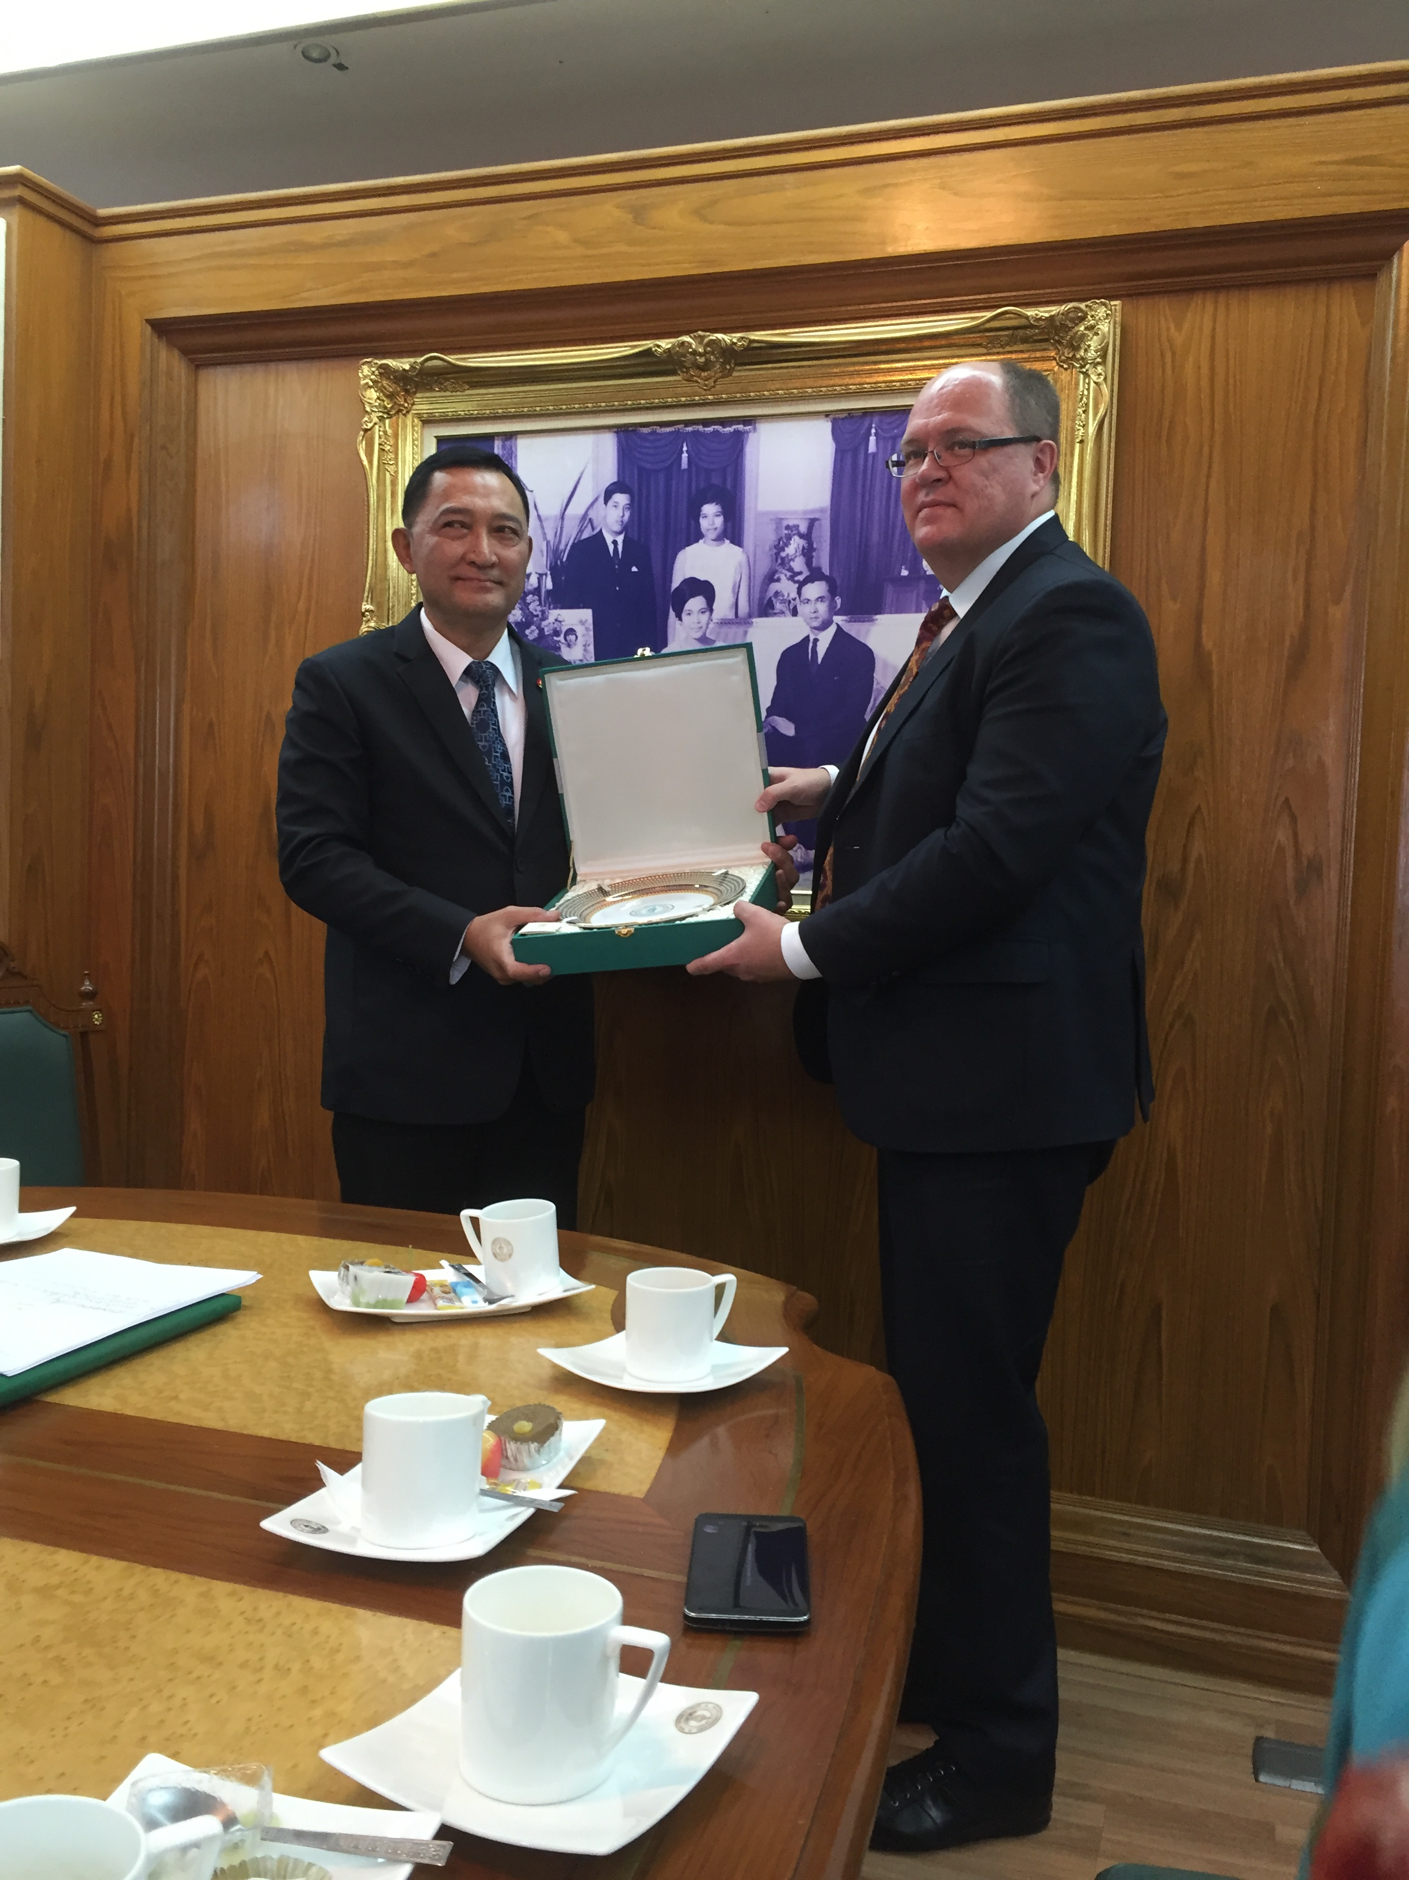
Bangkok Metropolitan Council with Sollefea Municipality

The most important mission for Ragunda has been to bring the history to light and to strengthen the bonds between the two nations as well as retell the story behind why there is a Royal Thai Pavilion in Jämtland and that it is the only one of its kind outsi
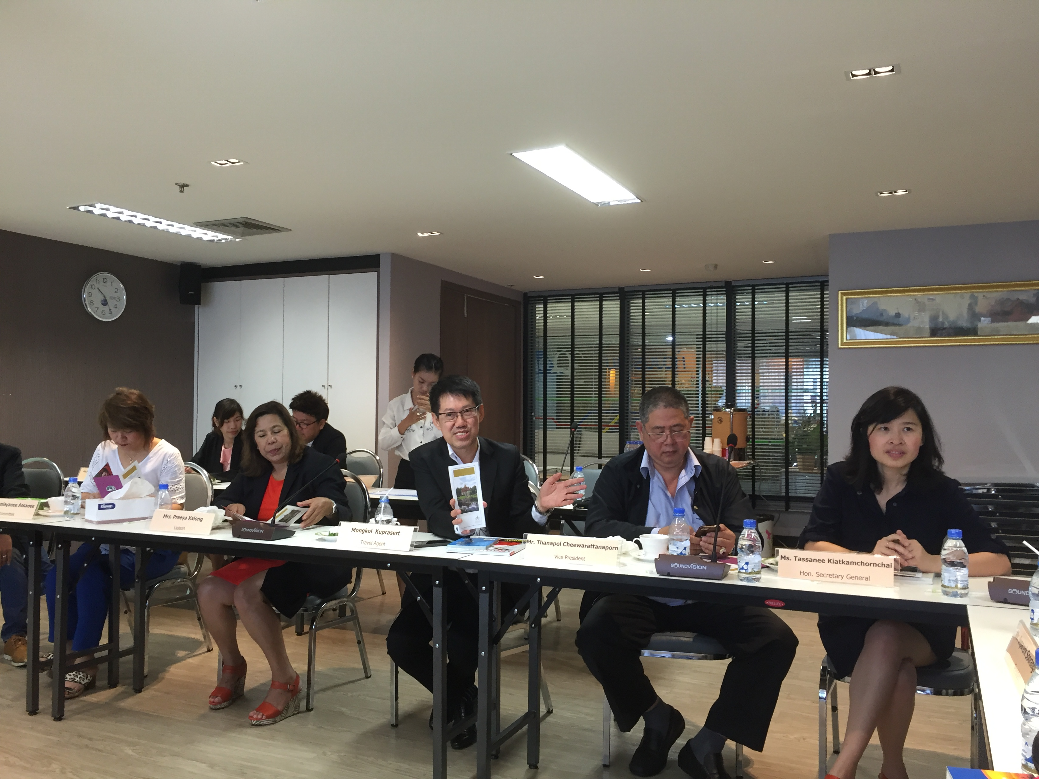
Meeting with TTAA
-Destination Ragundadalen and Ragunda Municipality feel deeply grateful to all who have participated in honouring the Pavilion and King Chulalongkorn. We wish to develop more cultural events and tell others of the Thai traditions and history. This place holds fantastic memories and history from both nations that have been carried forward from generation to generation says Gun Marie Persson, COO of Destination Ragundadalen.

Thank you kindly for a fantastic time in Bangkok! With the photo of the King Chulalongkorn's Pavilion in Sweden surrounded by snow and northern light we would like to send winter greetings from Sweden to the Thai people and wish everyone a Merry Christmas!

ABOUT THE THAI PAVILION
Ragunda municipality has received the Pavilion as a gift of friendship from Thailand. Together with General Chettha Thanajaro, the Thai Army, Thai Government, Ministry of foreign affairs, Thai people from both nations as well as Thai embassies in various countries its creation was possible.

It was an honour for the people of Thailand to build this memorial to honour the memory of King Chulalongkorn, the highly revered King Rama V.
It has also contributed to bring to light the culture and traditions of both nations.

In the agreement “Joint plan of action”, signed by both the Thai and Swedish governments, the Thai Pavilion is recognised as a very important cultural meeting place for both Thai and Swedish persons.

Ragunda municipality and Östersund municipality have strong bonds of friendship with Thailand and have during the last few years in cooperation with Sollefteå municipality participated in a youth exchange project together with Bangkok.

