**Bäckman's selected for the National Team for the second year in a row**

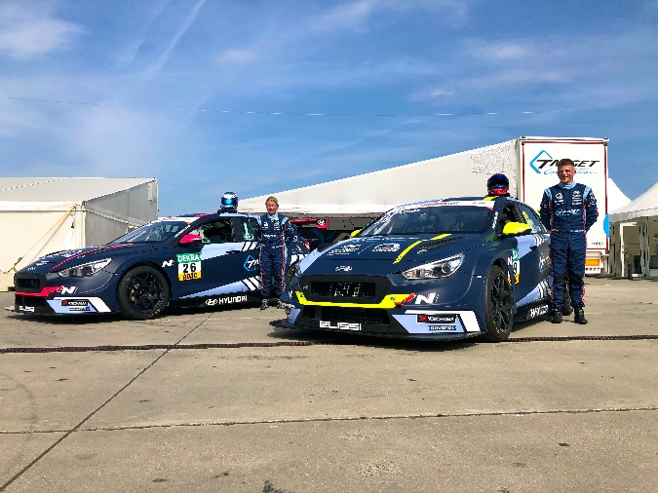Jessica and Andreas Bäckman with their racecars in 2020. Photo: Private (Free rights to use the image)

**Today it was announced that the Bäckman siblings Andreas and Jessica Bäckman from Sweden has been selected for the Swedish National Team for car racing for the second consecutive year.  
- This is a great opportunity for us to continue our development as racing drivers and we are extremely proud to once again be part of the Swedish National Team this season, Andreas Bäckman says.**

Today, the Swedish Automobile Sports Federation announced its National Team drivers for 2021. Among all the talented drivers from Sweden, the siblings Andreas and Jessica Bäckman from the North of Sweden were among the names of the selected drivers. Andreas will once again be part of the Senior National Team “Sweden National Team”, while Jessica will be part of the Junior National Team “Sweden Junior Team”.

- Very happy and grateful that the Swedish National Team wants to continue to invest in us. It is an important piece of the puzzle for us to be able to continue our path towards competing in the World Cup. Being part of the National Team will also help us to develop as a driver and everything that comes with being an elite racing driver, **Jessica Bäckman** says.

The main purpose of the National Team is to develop the drivers and give them as many tools as possible to reach the top in car racing.

- This is a great opportunity for us to continue our development as racing drivers and we are extremely proud to once again be part of the Swedish National Team this season, **Andreas Bäckman** says.

 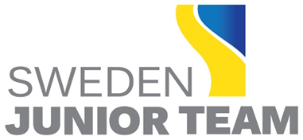

**The National Team's elite investment in car racing talents**The Sweden National Team captain Pier Steffansson are looking forward to continuing to work with Andreas and Jessica:

- Great fun working with Andreas & Jessica! They have developed, gathered experience, and worked hard to reach their goal of competing at the World Cup level, WTCR. We continue the work together with the National Team and with the siblings' drive, focus, commitment and the overall package Andreas and Jessica have around them, we put the puzzle together to take the next step, **Pier Steffansson** says.

Andreas and Jessica are looking forward to being developing more at all levels in 2021 and are hoping to become more complete as racing drivers with the help of this initiative:

- Before 2020, it came as a positive surprise when we found out that we have been selected for the National Team. Many of the National Team activities were cancelled in 2020 for obvious reasons, but it was still an educational year to be part of the National Team. As an athlete in car racing, there is so much behind the few opportunities in the racing season when you must perform on the track, and there the National Team is an important part of our efforts, **Andreas Bäckman** says.

***Free rights to use the images.***