CI EUROPE APRIL HIGHLIGHTS

THE FIRST 48 PRESENTS: CRITICAL MINUTES
Brand New & Exclusive | Thursdays from 8th April at 21:00

The First 48 Presents: Critical Minutes looks back at some of the most unforgettable moments in the series history.
Hosted by former The First 48 detectives, each episode presents different cases previously featured on the show, all with a common theme such as The Case That Haunts Me, Heat of the Moment, Shocking Confessions, Rookie Detectives, Women of Homicide and Caught on Camera.

I SURVIVED A CRIME
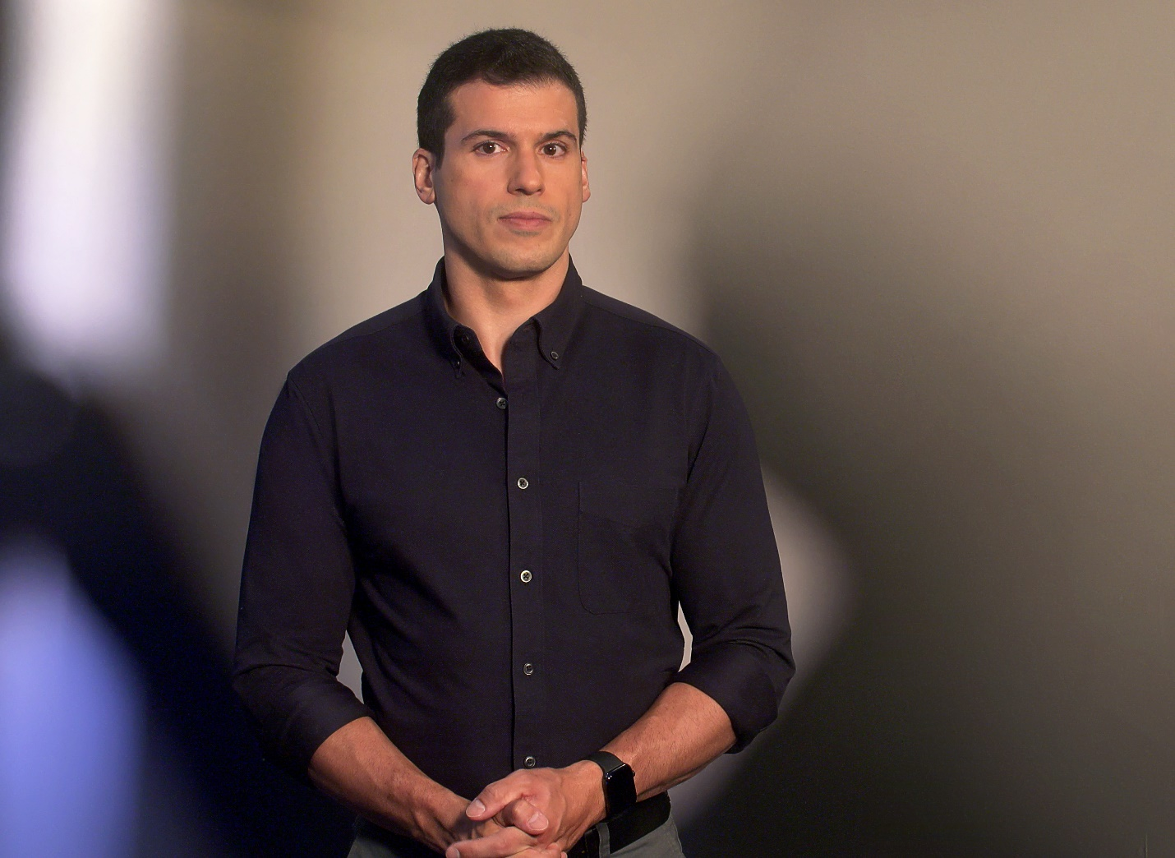
Brand New & Exclusive | Continues Fridays at 22:00
Hosted by award-winning ABC News reporter Gio Benitez (pictured), I Survived a Crime takes viewers on a journey into the experience of being a victim of a sudden crime from the moment those attacked first perceive the danger through the potential long-lasting effects.
Using surveillance and cell phone footage captured during the crime, the series follows individuals going about their daily lives who were confronted with a dangerous situation and forced to make a quick decision on how to protect themselves or their families.
Survivors join Gio Benitez to reflect on the incidents and have their voices heard.

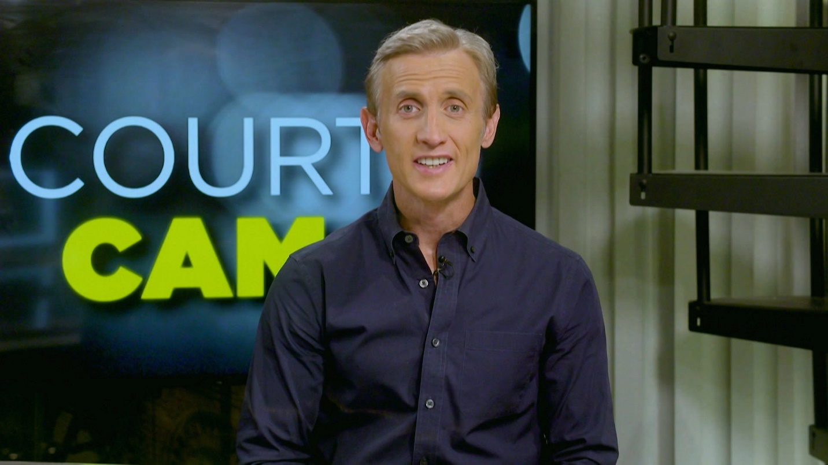
COURT CAM
Brand New & Exclusive | Continues Fridays at 21:00
Court Cam continues with series 3 and takes you inside America's most dramatic courtroom moments. From frightening outbursts to furious judges, this series brings you back to where it happened for the story behind the story.
Hosted by Dan Abrams (pictured), Court Cam will also include interviews with judges, witnesses, and victims to tell the true crime story behind the wildest, most emotional court moments caught on video.

KIDS BEHIND BARS
Brand New Stunt| Continues Mondays at 21:00
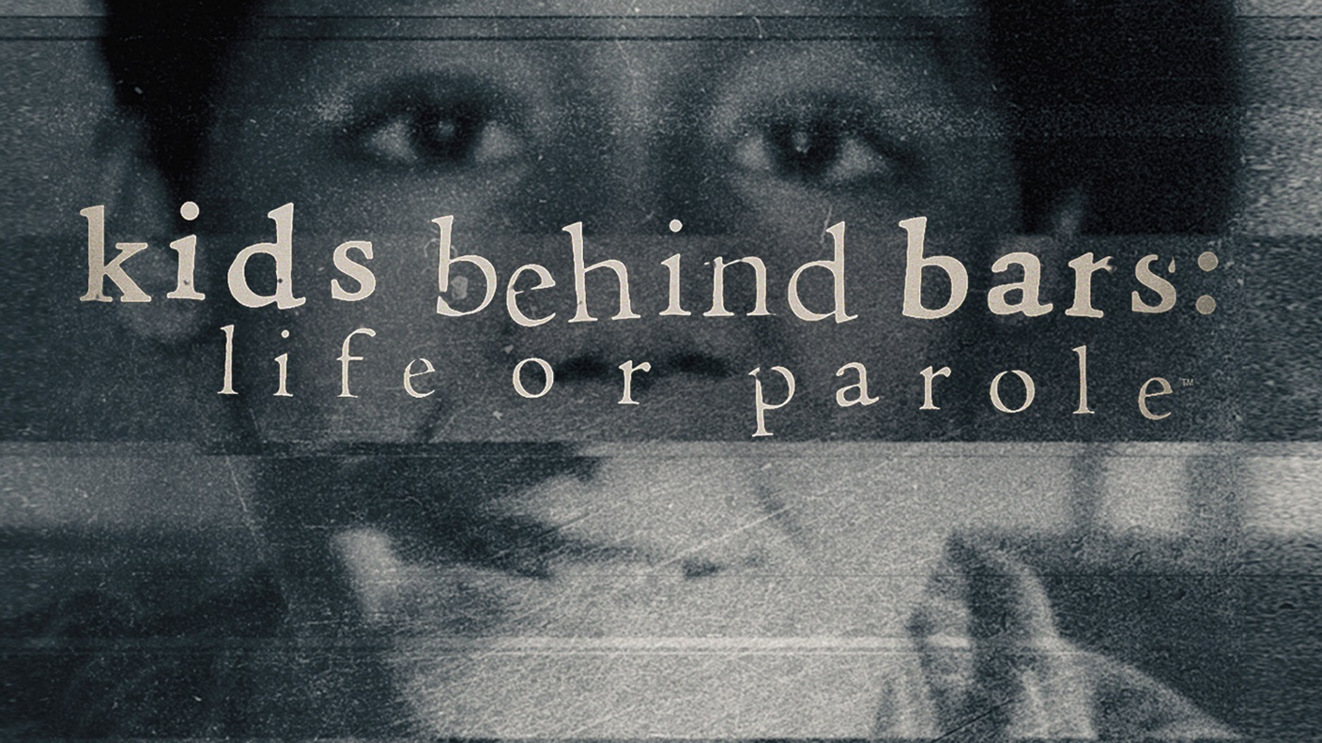
Since the United States Supreme Court ruled that mandatory life terms without the possibility of parole for juveniles is a violation of the 8th Amendment, this docuseries spotlights eight convicted child offenders who are now seeking resentencing.
The focus is split between the facts of the crimes when they were originally committed, combined with new evidence that has come to light, and the real-time updates regarding potential releases, parole hearings, and resentencing as they currently unfold.
Each episode includes exclusive commentary from the convicted offenders from prison plus perspectives from leading psychologists, law enforcement and reporters closest to each case.
Killer Kids will air afterwards at 22:00.

