APPROVED PRESS RELEASE (3.1164) 4th September 2020
Rotork intelligent electric actuators with gearboxes used to provide flood protection in Texas
Rotork intelligent electric IQ actuators with motorised IB multi-turn bevel gearboxes have been installed on sluice gates adjacent a large river in order to protect the residents and businesses living in a nearby community, with a population of almost 14,000. Community meetings were held for this development and it was decided to enhance the existing flood protection systems.
These sluice gates were constructed following discussions caused by Hurricane Harvey in 2017, which caused over $125 billion dollars’ worth of damage in the Houston area. During this time many locations in the 7-county region experienced serious flooding.
Storm water facilities were upgraded throughout the billion dollar golfing community and in other areas within the surrounding development. As the area is very flat, possible flooding can be a concern, as storm water flows into these facilities and down to the sluice gates, connecting to the nearby river. The gates remain open at all times so that water can flow into the river. However, during periods of excessive rainfall and heavy storms, when the river itself poses a flood risk, the actuators close the gates and seal the development from the river. The runoff water is then pumped away over the top of a nearby levee, allowing it to eventually run back into the river.
The installation of the actuators helps to ensure that the people of this community remain safe from the damage which could otherwise be caused by water infiltration into the development.
Rotork Site Services was responsible for commissioning the actuators with gearboxes and the start-up, ensuring that all products were fully operational.
Intelligent electric IQ actuators were chosen for this application due to the remote location of the sluice gates, which would have prohibited an hydraulic or pneumatic solution. Additionally, the close proximity of an electrical generator meant that a power supply was readily available.
Rotork’s IB gearboxes are suitable for use on sluice gates and for the most demanding motorised applications. They’re made with cast steel and when combined with the IQ actuator they can reach a torque of up to 44,000 Nm (32,452 lbf.ft).

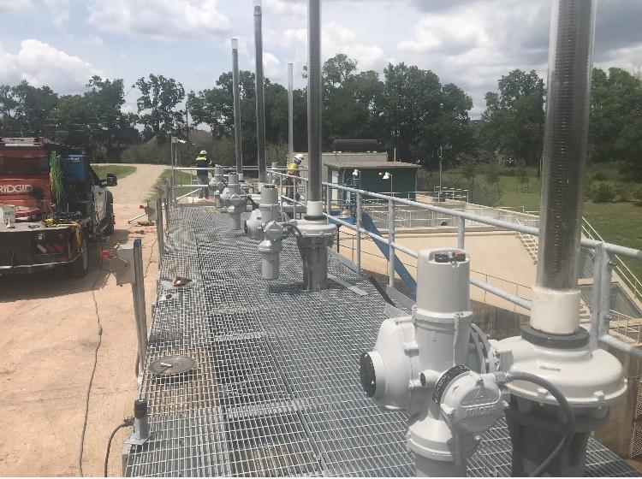

END
Photo captions
Intelligent electric IQ actuators with IB gearboxes on top of the sluice gate, ready to close it in order to prevent flooding.

For further information please contact Rotork PLC
Sarah Kellett Brassmill Lane
Group Marketing Communications Manager Bath
Telephone: +44 (0) 1225 733492 BA1 3JQ
Email: Sarah.Kellett@rotork.com UK

About Rotork
Rotork is a market-leading global provider of mission-critical flow control and instrumentation solutions for oil and gas, water and wastewater, power, chemical process and industrial applications. We help customers around the world to improve efficiency, reduce emissions, minimise their environmental impact and assure safety.

