Kongsberg Digital unveil first K-Sim Fishery
simulator at Lofoten Vocational School

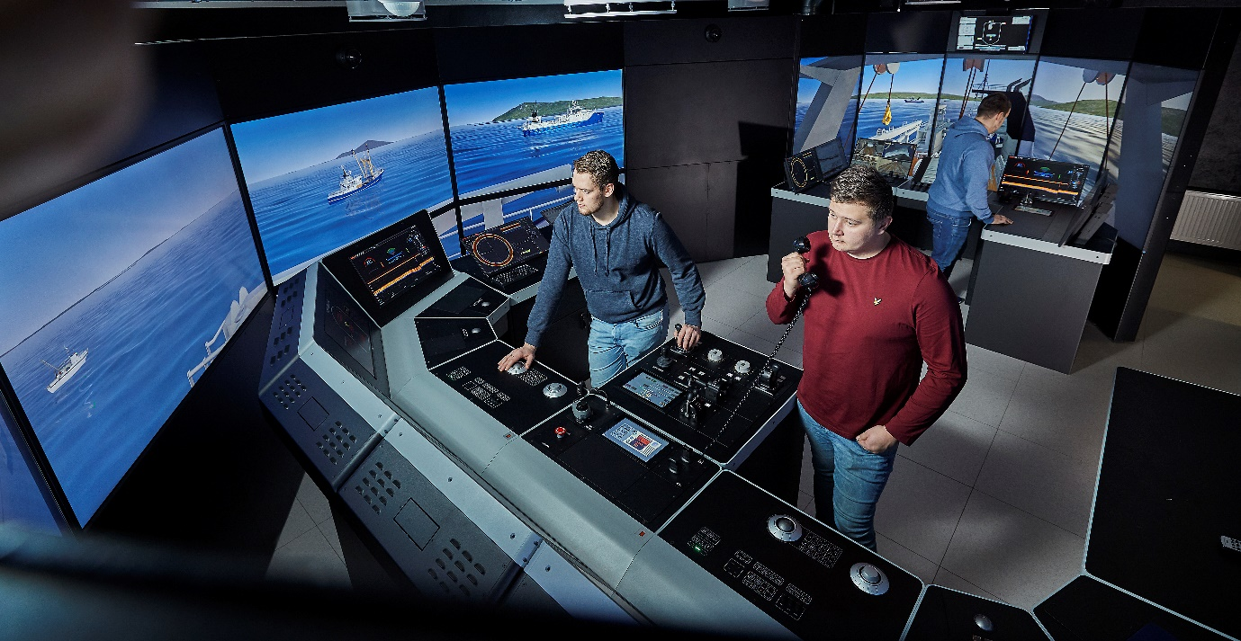
Students at Lofoten Vocational School will use the brand-new K-Sim Fishery simulator
to build competence that improves safety, efficiency and sustainability in fisheries

Asker, Norway, February 20th, 2020 – Kongsberg Digital (KDI) is delighted to announce the delivery and commissioning of the first K-Sim® Fishery simulator. The installation, which leads the way in bringing this type of training to the fishing industry, was unveiled today at a short ceremony at Lofoten Vocational School’s new facility in Leknes, Norway.
The brand-new K-Sim Fishery simulator is developed with input from Lofoten Vocational School with the aim of using modern simulation technology to build competence that improves safety, sustainability and quality in fishery. The simulator provides a full-scale training environment with realistic vessel behavior due to the advanced physical engine. It is designed as a fishing vessel bridge with all necessary equipment to carry out a fishery scenario. Integrated with Kongsberg Maritime (SIMRAD) professional fishery equipment, including echo sounder, sonar and trawl monitoring systems, it enables fish finding and catching training to secure the right catch and reduce possible by-catch.
K-Sim Fishery is therefore a complete system for the education and competence development of fishing vessel crew, helping them to become familiar with and operate different types of equipment whilst building an understanding of a variety of fishing techniques and their applications. Students will perform exercises where they learn to safely use the equipment and vessel, efficiently store the fish, carry out maneuvers to control the gear and ensure the quantity and quality of the catch, and optimize working hours and fuel consumption.

Finn Axel Hartvigsen, Manager Maritime department, Lofoten Vocational School, said: “We are very pleased and proud to be the first training center with the K-Sim Fishery simulator. The system is perfectly in step with the industry’s technology, allowing us to deliver training which is completely relevant and immediately applicable to our students’ everyday working lives. We firmly believe that, through this approach, we can help make the fishing industry both safer and more sustainable.”
K-Sim Fishery complies with the latest STCW-F and DNV GL certification standards for training. K-Sim Fishery has also been sold to several other training institutes including the Norwegian Seafood Research Fund (FHF), the Flemish Service for Employment and Vocational Training (VDAB) and the Greenland Maritime Center.
Tone-Merete Hansen, Sr. Vice President Maritime Simulation, Kongsberg Digital, added: “Improving the safety and productivity of fishing through targeted training is directly relevant to over 50 million people who rely on fisheries and aquaculture for their livelihoods. Safety, efficiency and sustainability go hand in hand: by equipping fishermen with the knowledge and equipment they require to increase the quality and repeatability of their catch, we can help to reduce the risk of overfishing, while experience with the vessel and equipment involved increases safety. We are delighted to be able to facilitate these goals through K-Sim Fishery and look forward to supporting Lofoten Vocational School and other schools as they develop their training strategy using the new system.”

Ends

For further information, please contact:

Anne Voith
Kongsberg Digital
Maritime Simulation
Tel: +47 48084640
Email: anne.voith@kdi.kongsberg.com

Anne.voith@kdi.kongsberg.com
About Kongsberg Digital
Kongsberg Digital is a provider of next-generation software and digital solutions to customers within maritime, oil and gas, and renewables and utilities. The company consists of more than 500 software experts with leading competence within the internet of things, smart data, artificial intelligence, maritime simulation, automation and autonomous operations.
Kongsberg Digital is subsidiary of KONGSBERG (OSE-ticker: KOG), an international, knowledge-based group delivering high-technology systems and solutions to clients within the oil and gas industry, subsea, merchant marine, defence and aerospace. KONGSBERG has 11.000 employees located in more than 40 countries.
www.kongsberg.com/en/kongsberg-digital/
www.kongsberg.com

