### PRESS RELEASE

### POP UP MY BATHROOM ISH 2015 (10. -14.03.2015)

### Pop up my Bathroom

02.12.2014

**Freedom for the Bathroom:  
a “Freibad” for Every Home**

* Pop up my Bathroom 2015 presents the ideal bathroom – from the perspective of children, singles, families and older generations
* The trend towards bathroom design geared to specific life stages goes hand in hand with innovative floor plans and renovation techniques
* “Freibad”, the Pop up my Bathroom motto for the ISH 2015, provides new impetus for the idea of a barrier-free bathroom by promoting variability and new room concepts

**A lifetime in the same profession, with the same company. A lifetime in the same city, in the same house or apartment. A lifetime with the same bathroom.**

This classic bathroom concept has already ceased to reflect the reality of people’s lives. We are changing jobs, professions, homes, social networks and even family structures more often than ever before. We need more (barrier-free) housing for people who live alone, as well as bigger shared units that can accommodate patchwork families, multigenerational models and shared homes for seniors. It’s not just the workplace that’s changing: the organisation models for our private lives are changing too. So in view of all this, how contemporary is our traditional picture of the bathroom? And how is modern bathroom design adapting to future life models and changing expectations?

In the run-up to the ISH 2015, the Pop up my Bathroom trend platform initiated by the German Sanitary Industry Association [Vereinigung Deutsche Sanitärwirtschaft e.V. (VDS)] explores the needs that should be taken into account by any bathroom concept designed for a specific life stage. In future, variable floor plans and modern installation systems will be able to increase the bathroom’s versatility to such an extent that, provided the renovation options and space available meet the necessary requirements, it will be more than able to adapt to its users’ lives. The four concept bathrooms shown in the photos are based on the Pop up my Bathroom motto for 2015: “Freibad” – a German word that usually means an outdoor pool but has been coined here to symbolise freedom in what was once the smallest room in the house. Besides advocating more acceptance for barrier-free bathrooms, the motto also calls for the necessary freedom to implement new bathroom concepts in which it is users’ needs that determine the design.

**The bathroom doesn’t just help us cope with the day, it helps us cope with our entire lives**

The furnishing culture of industrial nations is shaped by two complementary life patterns: the desire for self-fulfilment through an individual way of life and furnishing style and the quest for a sense of security and scope for personal development in one’s private life – otherwise known as the homing trend. Because at the end of the day, we want a nice home, and we want the outside world to identify us with the image of our home too.

In the bathroom, this culture comes face to face with key needs: hygiene, relaxation and the opportunity to experience one’s own body. Especially in view of an ageing society’s desire to remain independent for as long as possible, this functional side to the bathroom is of prime importance. So how can the many and varied requirements of such an individualistic culture be met within a single room? And met for a considerable period of time, during which its users’ needs and expectations sometimes change dramatically? Because the bathroom doesn’t just help us cope with the day, it helps us cope with our entire lives – a complex function that turns the design of this space into a highly challenging assignment.

The bathroom is a striking illustration of how life changes for people in the course of its various stages. The trend platform Pop up my Bathroom has investigated the changing requirements and corresponding bathroom concepts and expressed them in idealised images. Each and every one of them articulates the outlook on life that comes with a certain phase and a certain family constellation – factors that have an impact not just on how the bathroom is perceived but on how it is designed as well.

**Adventure: children need the bathroom as a space for ex-periences**

For children, the bathroom – at least in an ideal world – is a place for having fun, a place where they can splash around with water and mess about with rubber ducks, shampoo bottles and sponges, where mum towels them off and dad gets soaked by their squirt guns. But it is by no means unusual for children to see the bathroom as an anxiety-ridden place too: they might be apprehensive of water, embarrassed about going to the toilet or just fed up with having to clean their teeth. In this case, an atmosphere of security can often be far more helpful than a set of colourful plastic beakers, and if anything happens to go wrong it needn’t be a problem for either the children or their parents.

More than anything else, children need space, safety and secure-ty. But they also want to be part of what happens out of their reach. If they are to feel part of things, they need furniture, toilets and washbasins that are in line with their size. If that isn’t possible, helpful aids should be provided so as to bring them up to eye-level with the grown-ups. All it takes to make allowances for this when planning a bathroom is a little empathy – and of course a little more space.

**A place for individualists to dream and relax**

For most people who live alone, the bathroom is a place for indulging in dreams, beautifying themselves, getting the day off to an energetic start and winding down in the evenings. They don’t need to be considerate of other people’s needs. But what they do need is space for individual touches: sporty exercise equipment or accessories, a wall for self-painted pictures or a lifebelt brought back from holiday, or perhaps a shelf for speakers, lotions or flowerpots. They want a bathroom full of colour that can be changed whenever the fancy takes them, fashionable accessories and technical gimmicks. They want freedom to experiment in their search for a lifestyle or, once they reach a certain age, the optimal conditions for indulging deep-seated habits. People of all ages want unlimited freedom for their individual preferences: younger singles demand it in the form of flexibility, older individuals expect it to be expressed in terms of comfort. Essentially, they all want a private spa that unites body and soul in harmony through personal rituals and sophisticated aesthetics.

**Families need space for improvisation**

When several people live together, the bathroom becomes a place of communication – especially when it is where several generations begin their day, learn and practise rituals, take care of one another and all have to make compromises in order to get along. As a rule, this usually means couples or families with children, but it could also mean families who live together with care-dependent relatives. In busy families where everybody has his or her own life to lead, the kitchen and bathroom are often the last remaining spaces for shared rituals and occasional gatherings; they are where we talk about how the day has gone and any problems that might be troubling us. More than anything else, the sanitaryware and furnishings in this kind of “Busy Bathroom” have to provide space and scope for improvisation. Here it’s not so much perfect styling that matters as the ability of the space and its occupants to tolerate the inevitable chaos. The equanimity to let things take their course and “clear the decks” afterwards is a particularly useful asset for anyone who lives with children.

So as to structure the chaos, multifunctional elements are a great help. They can take the form of walk-in showers, splash-proof bathtubs that can endure skylarking without flooding the floor or double vanities that are the right height for everyone and accessible from all sides. Anybody with enough space is well advised to plan zones for different activities that can be undertaken simultaneously. This mainly means thinking about the toilet, but it could also mean creating a washing area with a corner for the parents (or alternatively one specially for the children), a bathing and dressing zone separated off by pre-wall elements or shelving, or even a spacious splash-proof shower alcove. If there is room for plenty of storage space – ideally, every person who uses the bathroom should have their own storage area – plus a little space for snuggling up, the Busy Bathroom becomes a place of intimacy where the family can experience a sense of togetherness and security.

**A bathroom designed for ease – at any age**

When every step requires careful consideration so as not to stumble, security and safety mean freedom. Freedom from bothersome safeguards and inconvenient fuss, freedom of movement and the freedom that comes with numerous options. A finely-meshed safety net made up of familiar surroundings, technical equipment and barrier-free housing gives people a sense of security and ease. And that sense of ease should be expressed in the design of the Easy Bathroom too: for all its technical sophistication, it must be simple and intuitive to use as well.

People who have to cope with physical or age-related limitations of any kind know just how important a freely accessible, safe and easy-to-use bathroom is when it comes to their independence, fitness and wellbeing. They enjoy the effect the water has on their health and soul, the comfort and convenience of a shower toilet, the feeling of safety and security that comes from furniture, seating and grab rails designed to provide support and the benefits of good, possibly even sensor-controlled lighting systems. Level-access showers and enough space to ensure freedom of movement are basic prerequisites for allowing elderly people to furnish their bathrooms in a way that accommodates not just their individual preferences but their (future) needs as well. Just in case.

**“Freibad” aims to open the bathroom up to new ideas and generation-specific solutions**

The aim of campaigns like “Freibad” by Pop up my Bathroom is to encourage people to question boundaries and eliminate them – not just in terms of breaking down barriers but in the sense of tackling seemingly fixed usage concepts for the bathroom as well. Because there’s much more to the idea of freedom in the bathroom than barrier-free accessibility: it involves ergonomics, multifunctionality and aesthetics too. It is this thought that forms the basis of the concept bathrooms conceived by Pop up my Bathroom. The four ideal bathrooms that accompany people in every stage of their lives promote the barrier-free bathroom as a customisable concept for everybody.

The initiators have very deliberately chosen the German title "Freibad" as the motto for Pop up my Bathroom 2015. The German word usually refers to an outdoor swimming pool, but when used in the unusual context of interior design, this borrowing from outdoor culture performs the function of a proper noun. “Frei”, or “free”, becomes synonymous with “freedom”, independence and joie de vivre.

There is one crucial prerequisite for bathrooms that can accommodate their users’ most important, life-stage-related needs: more space. Zone-defining pre-wall systems or power and water connections in the floor instead of the wall, barrier-free concepts, space-structuring bathroom furnishings and snug designs only really make sense in conjunction with a bigger floor plan or alterable layout. An innovative sanitary industry’s response to tomorrow’s demands will lie in standardised technology and intelligent, low-mess renovation solutions.

Further information: **www.pop-up-my-bathroom.com**

For further information on the world-leading ISH trade fair go to: **www.ish.messefrankfurt.com**

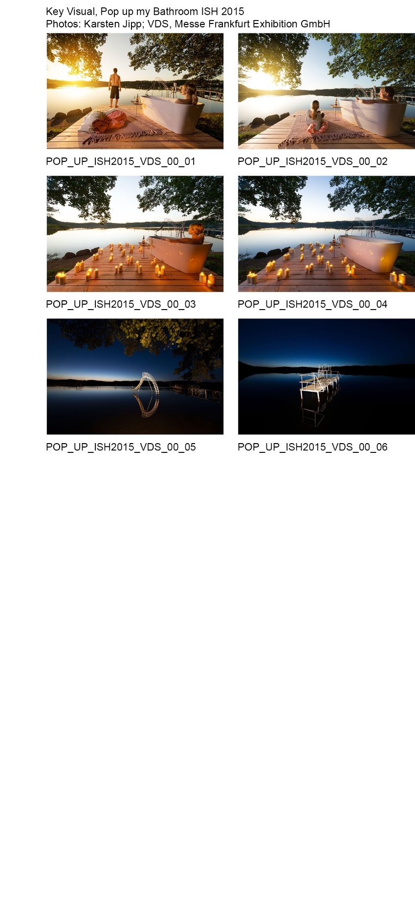

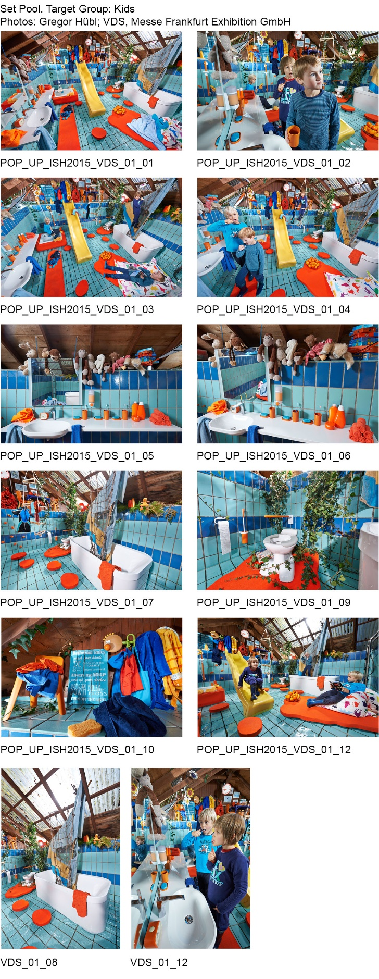

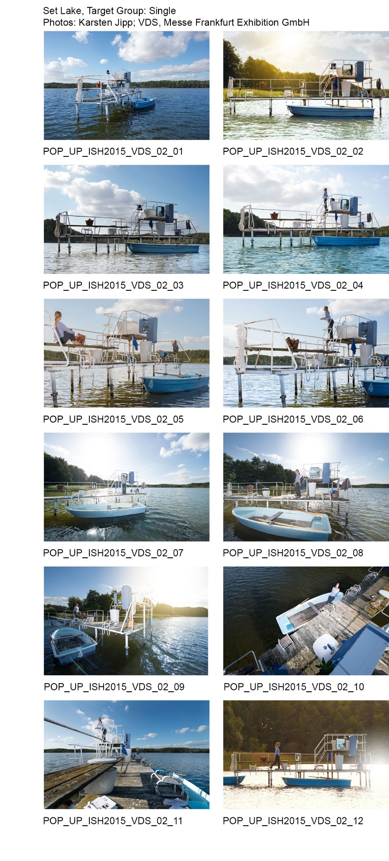

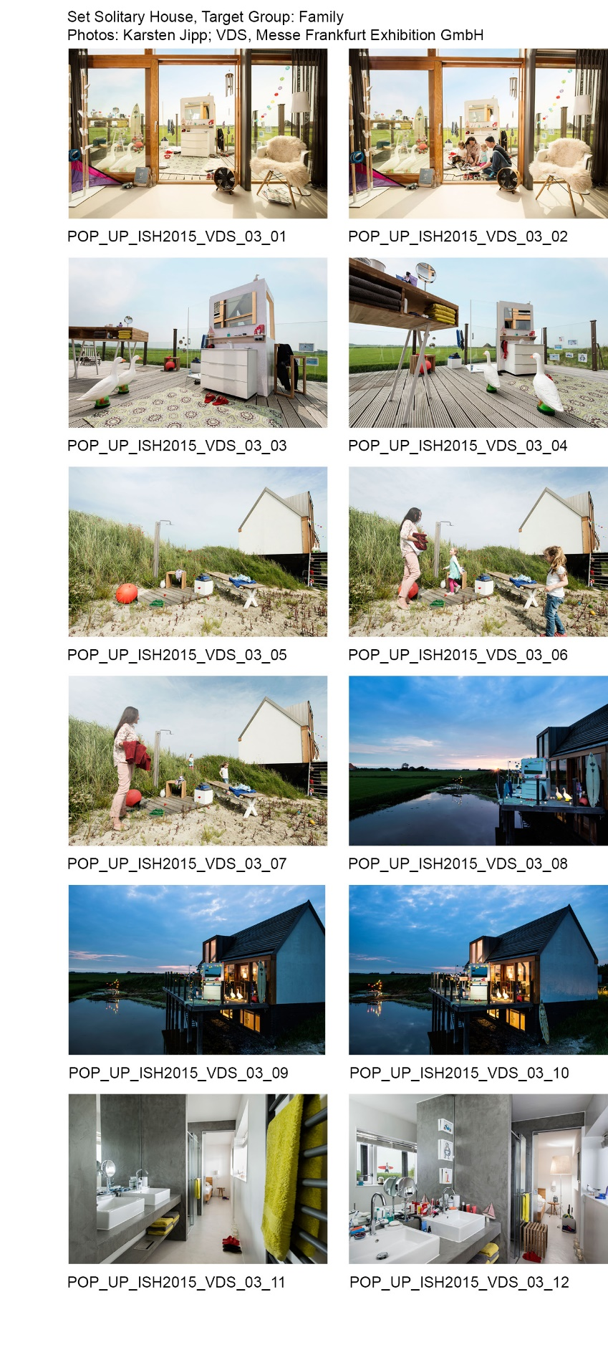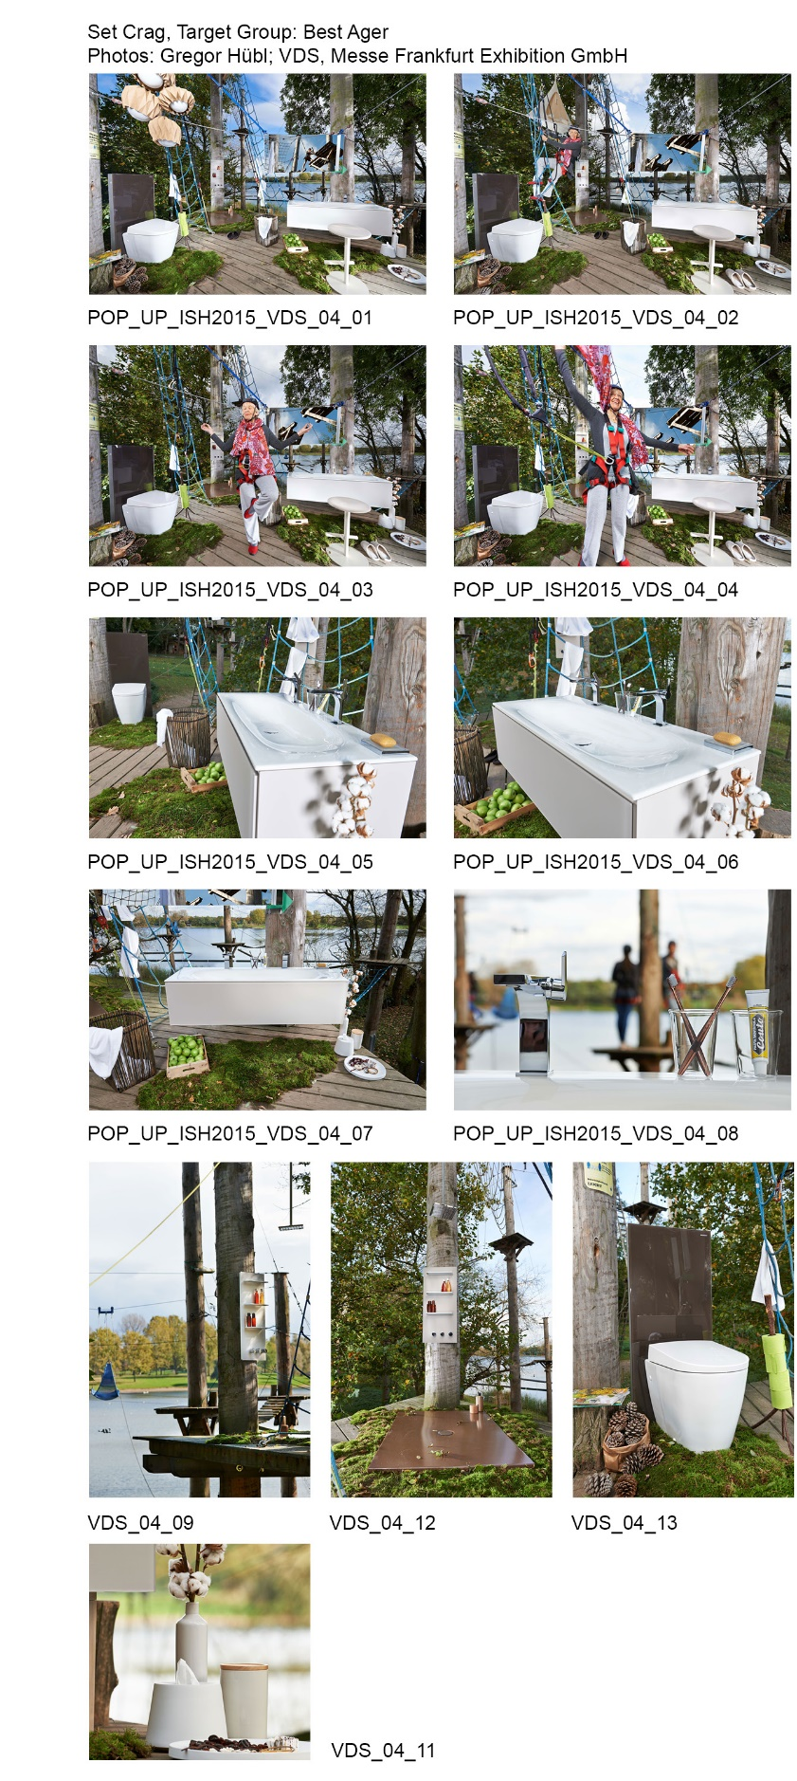

The German Sanitary Industry Association [Vereinigung Deutsche Sanitär-wirtschaft e.V. (VDS)] is the umbrella organisation for German companies in the bathroom and sanitary sectors and consists of 10 member associations from industry, specialist wholesale and specialist trades. For further informa-tion on the VDS go to: [www.sanitaerwirtschaft.de](http://www.sanitaerwirtschaft.de).

**Free for reprint - complimentary copy requested.**

**Published by:**

Vereinigung Deutsche Sanitärwirtschaft e. V. (VDS)

Rheinweg 24

53113 Bonn, Germany

T +49 (0) 2 28.92 39 99 30

F +49 (0) 2 28.92 39 99 33

info@sanitaerwirtschaft.de

www.pop-up-the-bathroom.de

**Editorial team:**

far.consulting

Frank A. Reinhardt

Dillenburger Str. 83

51105 Köln

T +49 (0) 221.620 18 02

F +49 (0) 221.962 45 39

reinhardt@far-consulting.de

**Imprint:**

All contributions are protected by copy-right and are for press use only. Journalists can use all articles and photos free of charge on condition that they provide two specimen copies of the corresponding publication. It is not obliga-tory to name the authors. Image copy-rights are held by the originators and by VDS as tagged. We thank the photographers, designers and manufacturers for kindly providing the pictures and request that they be credited accordingly. The place of performance and jurisdiction is Bonn.