Kongsberg Maritime signs 200 MNOK contract to supply propeller systems for five Spanish Naval frigates
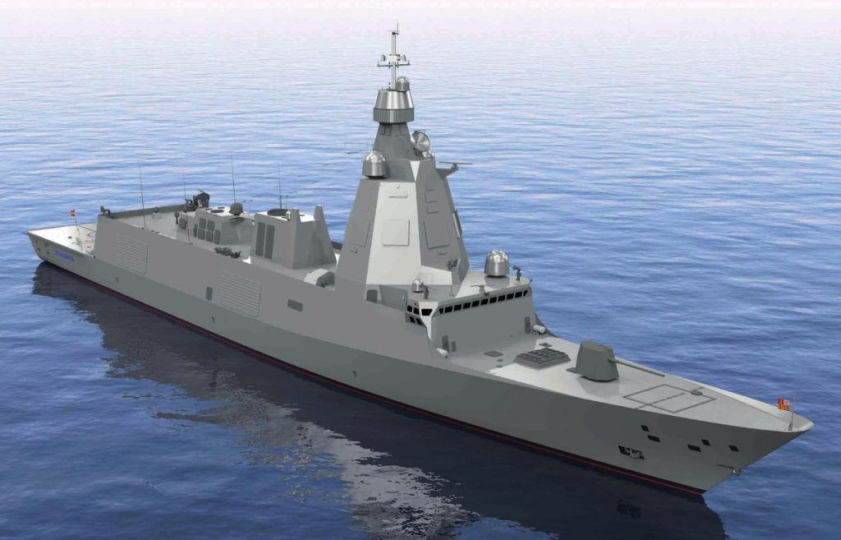
The Spanish Navy’s forthcoming F110 frigates will be equipped with twin Kongsberg Kamewa CPP systems
Kongsberg, Norway, 18th November 2020 – Kongsberg Maritime has secured a contract worth NOK 200 million with Spanish shipbuilder Navantia to supply propeller systems for five F110 frigates, currently in construction for the Spanish Navy. These next-generation vessels are designed to follow on from Navantia’s successful F100 frigate, bringing together state-of-the-art technologies to create a ship for the 21st century.
Destined for Anti-Submarine Warfare (ASW) operations, each vessel will be fitted with twin Kongsberg Kamewa Controllable Pitch Propeller (CPP) systems, specifically developed for minimum noise and vibration throughout the system; from the propeller blades through the shaft-line to associated equipment such as the bearings and hydraulic power unit. Vessels engaged in ASW must meet exacting requirements on Underwater Radiated Noise (URN), Cavitation Inception Speed (CIS), pressure pulses and efficiency in order to operate effectively, and Navantia’s selection process for the propellers for the F110 frigates included model scale tests at Marin in the Netherlands and at CEHIPAR in Spain to verify that the performance targets were met.
Egil Haugsdal, President, Kongsberg Maritime, says: “We are very pleased to be working with Navantia on this project. They are a top-rated company and experts in the naval shipbuilding arena. This order again confirms the shipbuilding industry’s recognition of KONGSBERG as the world leader of naval propulsion equipment.”
KONGSBERG is well placed to deliver propulsion systems to meet the most stringent specifications, thanks to the unique Kongsberg Maritime Research Centre (KHRC) in Kristinehamn, Sweden. Known worldwide for more than 80 years for its ground-breaking work in hydrodynamics and advanced designs, KHRC boasts an unparalleled capability to develop and deliver highly customised, tailor-made propeller designs for demanding projects at the leading edge of propulsion technology.
Ends

For further information, please contact:
Gunvor Hatling Midtbø, VP Communication
Kongsberg Maritime
Tel: +47 9921 4209
gunvor.hatling.midtbo@km.kongsberg.com
David Pugh
Saltwater Stone
Tel: +44 (0)1202 669244
d.pugh@saltwater-stone.com

About Kongsberg Maritime
Kongsberg Maritime is a global marine technology company providing innovative and reliable ‘Full Picture’ technology solutions for all marine industry sectors including merchant, offshore, cruise, subsea and naval. Headquartered in Kongsberg, Norway, Kongsberg Maritime has manufacturing, sales and service facilities in 34 countries.
Kongsberg Maritime solutions cover all aspects of marine automation, safety, manoeuvring, navigation, and dynamic positioning as well as energy management, deck handling and propulsion systems, and ship design services. Subsea solutions include single and multibeam echo sounders, sonars, AUV and USV, underwater navigation and communication systems.
Training courses at locations globally, LNG solutions, information management, position reference systems and technology for seismic and drilling operations are also part of the company’s diverse technology portfolio. Additionally, Kongsberg Maritime provides services within EIT (Electro, Instrument & Telecom) engineering and system integration, on an EPC (Engineering, Procurement & Construction) basis.
Kongsberg Maritime is part of Kongsberg Gruppen (KONGSBERG), an international, knowledge-based group that celebrated 200 years in business during 2014. KONGSBERG supplies high-technology systems and solutions to customers in the oil and gas industry, the merchant marine, and the defence and aerospace industries.
Web: Kongsberg Gruppen | Kongsberg Maritime
Social media: LinkedIn | Twitter | Facebook

