KONGSBERG partners with CEMS, Singapore to raise the bar for cooperative maritime safety and innovation

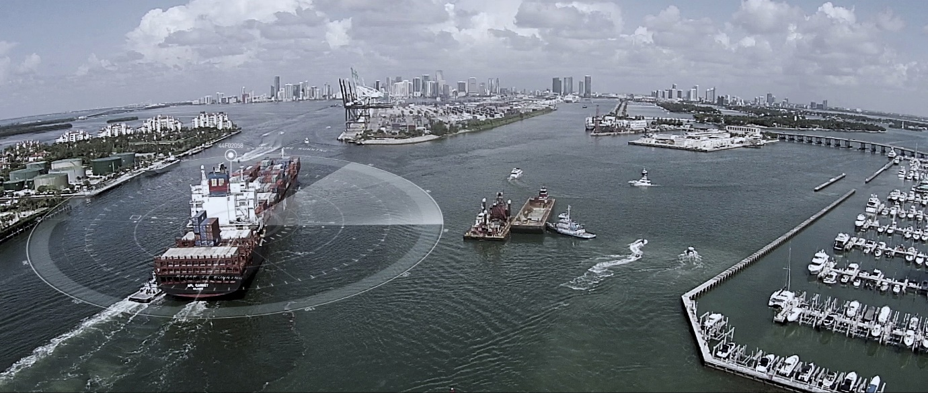
Kongsberg Digital’s ANRS simulator will aid in training mariners in safe navigation of Singapore port
Kongsberg, Norway, September 30th, 2020 – Kongsberg Digital is pleased to announce the signing of a contract to deliver an Advanced Navigation Research Simulator (ANRS) to the newly-established Centre of Excellence in Maritime Safety, CEMS, in Singapore. This collaboration between Norway’s leading provider of next-generation maritime digital solutions and one of the most forward-looking educational establishments in Singapore clearly illustrates the growing cooperation between the two countries in the maritime field.
Set up as a joint venture between the Singapore Maritime Institute and Singapore Polytechnic with the intention of creating a world-class assessment and research facility, CEMS is one of several centers in Asia that is committed to the digital transformation of the maritime safety domain. The delivery of KONGSBERG’s ANRS is scheduled for Q1 2021, and an official opening will be held during Singapore Maritime Week 2021. Based on K-Sim Navigation and integrated with the K-Sim VTS (Vessel Traffic Service) simulator, the ANRS creates a holistic solution in support of the CEMS initiative, which aims to enhance safety and efficiency of vessel traffic while safeguarding the environment.
As Singapore’s leading center for maritime safety research and innovation, CEMS conducts research on crew behavior, using Artificial Intelligence to enhance training and assessment with a goal to contribute towards the International Convention on Standards of Training, Certification and Watchkeeping for Seafarers (STCW). Other research interests at CEMS include the study of e-Navigation and the validation of new designs and operational concepts, including smart and autonomous ships.
CEMS’ research and development efforts to keep Singapore’s port waters safe will become even more critical when the new mega-port currently under construction at Tuas is built and ready for operation. The new mega-port’s capacity to accommodate more vessels will require new cutting-edge technology and consequent complexity of operations, increasing demand for training to ensure that vessels navigate safely within Singapore port waters.
To this end, the new KONGSBERG ANRS lab delivery will include simulation research and development tools for ship modeling and geographical sailing areas, in addition to its primary systems. These incorporate VTS and Remote Operation Center simulation, a scalable/multi-modal navigation bridge simulator and Instructor/Assessor/Research and Development stations. Technologies including eye tracking to assist human-computer interaction will be incorporated into the simulation domain.
“CEMS is an enabler, improving maritime safety and operational excellence through a combination of simulation technology, the use of digital twins and new training methods,” says Andreas Jagtøyen, EVP of Digital Ocean, Kongsberg Digital. “The powerful maritime cluster in Singapore, consisting of world-class education and research institutes, equipment manufacturers, shipyards, ship owners and ship operators, is without question one of the most important global locations for KONGSBERG as a working environment where we can test and further develop our digital solutions in the maritime domain.”
Daniel Zhang, Centre Director of CEMS, said: “One of the critical factors that underpins Singapore’s success as a major global maritime hub is our highly-trained and skilled workforce that is ready to meet the new challenges in the maritime world. Our partnership with Kongsberg Digital will empower Singapore Polytechnic staff and learners of all ages to pick up new digital skills and domain knowledge that will strengthen the capabilities of our maritime workforce. This is a strategic collaboration that enables both organizations to co-create and develop more innovative digital solutions that will continue to keep our ships and crew safe, and sharpen our competitive edge as a leading sea transport hub.”
Ends

For further information, please contact:

Anne Voith
Marketing and Communications Manager, Simulation
Kongsberg Digital
Tel: +47 4808 4640
anne.voith@kdi.kongsberg.com
David Pugh
Saltwater Stone
Tel: +44 (0)1202 669244
d.pugh@saltwater-stone.com

About Kongsberg Digital
Kongsberg Digital is a provider of next-generation software and digital solutions to customers within maritime, oil and gas, and renewables and utilities. The company consists of more than 500 software experts with leading competence within the internet of things, smart data, artificial intelligence, maritime simulation, automation and autonomous operations.
Kongsberg Digital is subsidiary of KONGSBERG (OSE-ticker: KOG), an international, knowledge-based group delivering high-technology systems and solutions to clients within the oil and gas industry, subsea, merchant marine, defence and aerospace. KONGSBERG has 11.000 employees located in more than 40 countries.
Web: Kongsberg Gruppen | Kongsberg Digital
Social media: LinkedIn | Twitter | Facebook

