PRESS RELEASE
For Immediate Release

A Claw-Inspiring Crabs Galore at Ginger
Return of the highly-anticipated crab-centric buffet with the freshest catch.

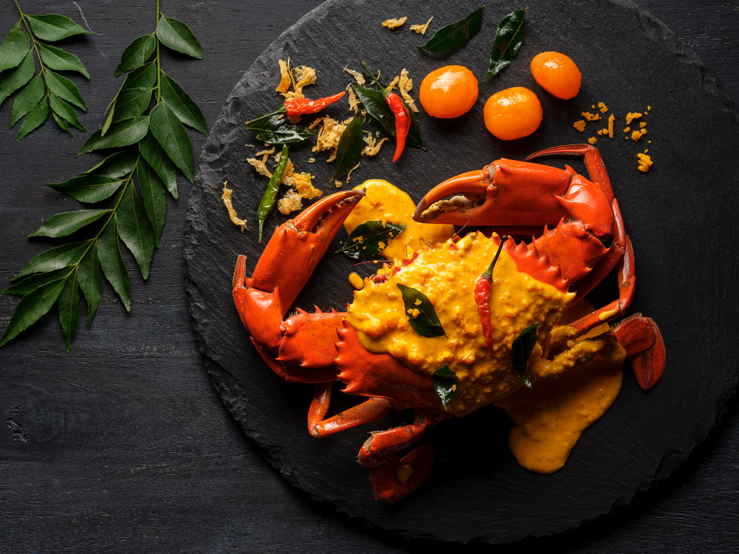

[Singapore, 10 October 2019] Ginger at PARKROYAL on Beach Road brings back its well-loved crab-themed buffet, masterfully prepared by Executive Chef Vincent Aw and his culinary team. Featuring a ‘no pork, no lard’ buffet menu, the famed crustacean will make a grand return from 14 October to 22 November 2019, where fans can claw their way into a medley of crab dishes prepared in a myriad of cooking methods to showcase its finest flavours.

Taking the centre stage at Ginger’s Show Kitchen is the crowd-pleasing Claypot Crab with Pumpkin Broth that skillfully marries the succulent texture of fresh crabs with generous servings of pumpkin puree infused with locally-sourced herbs; alongside the much-loved Singapore Chilli Crab with aromatic wok-hei and spicy sauce that serves as a divine pairing dip for deep-fried buns, as well as the Crispy Soft Shell Crab enveloped in Chef’s specially concocted wasabi mayo.

The claw-esome crab journey continues at the hot food isle, featuring the palatable Crab Meat Fried Rice and Stir-fried Crab in Salted Egg Yolk Sauce – a gourmet highlight not to be missed for the salted egg yolk fanatics!

Seafood-enthusiasts may delight in a variety of ocean gems including Flower Clams, Cooked Prawns, Black Mussels and Mud Crab with Ginger and Vinegar Sauce at the Seafood on Ice station.

The freshest unique flavours are best accompanied by an array of classic favourites. Tuck into a range of Ginger’s trending heritage delicacies such as the signature Chicken Rice, Prawn Noodles and assorted Grilled Satay, as well as create your own Kueh Pie Tee and Rojak at the live station.

Crabs Galore at Ginger
14 October to 22 November 2019

Weekend Lunch | Saturdays, Sundays and Public Holidays  12:00pm to 2:30pm | SGD58 per adult  SGD29 per child
Daily Dinner | Mondays to Thursdays  6:00pm to 10:00pm  Fridays to Sundays and Public Holidays  6:00pm to 10:00pm | SGD58 per adult  SGD29 per child  SGD68 per adult  SGD34 per child

NB: All prices are subject to 10% service charge (for dine-in) and GST, unless otherwise stated. Food items on the buffet line are served on a periodic and rotational basis, to provide an all-new dining experience upon every visit.

For dining reservations or enquiries, please speak with us at 6505 5710 or email dining.prsin@parkroyalhotels.com.

– END –
Note to editors:
All letters of the PARKROYAL brand should also be capitalised. If your publication’s house style does not allow this, please ensure that PARKROYAL appears as one word – ‘Parkroyal’.

For media enquiries, please contact:
Tricia Quak
Senior Marketing Communications Manager
PARKROYAL on Beach Road, Singapore
DID: +65 6505 5608
Email: tricia.quak@parkroyalhotels.com

Shi Min
Marketing Communications Executive
PARKROYAL on Beach Road, Singapore
DID: +65 6505 5678
Email: ho.shimin@parkroyalhotels.com

PARKROYAL Hotels & Resorts
A big city or cosy enclave – where there is a PARKROYAL hotel, resort or serviced suite, there is a celebration of people. Our passion for creating real connections and joyous moments can be felt when you enter any of our properties across Asia and Australia. After all, this is the place to bring out the best of you, by us.

About Pan Pacific Hotels Group
Pan Pacific Hotels Group is a wholly-owned hotel subsidiary of Singapore-listed UOL Group Limited, one of Asia’s most established hotel and property companies with an outstanding portfolio of investment and development properties.

Based in Singapore, Pan Pacific Hotels Group owns and/or manages more than 40 hotels, resorts and serviced suites including those under development in 24 cities across Asia, Oceania, North America and Europe.

Voted “Best Regional Hotel Chain” by readers in Asia-Pacific in 2017 and 2018, Pan Pacific Hotels Group comprises two acclaimed brands: its signature brand, Pan Pacific and its deluxe brand, PARKROYAL.

Sincerity is the hallmark of Pan Pacific Hotels Group. The Group is known to its guests, partners, associates and owners for its sincerity in people and the sense of confidence which alleviates the stresses of today’s complex world.
Visit us at www.panpacific.com.

