Kongsberg Digital to host a webinar week, with Power Hours on key topics for digital maritime technologies

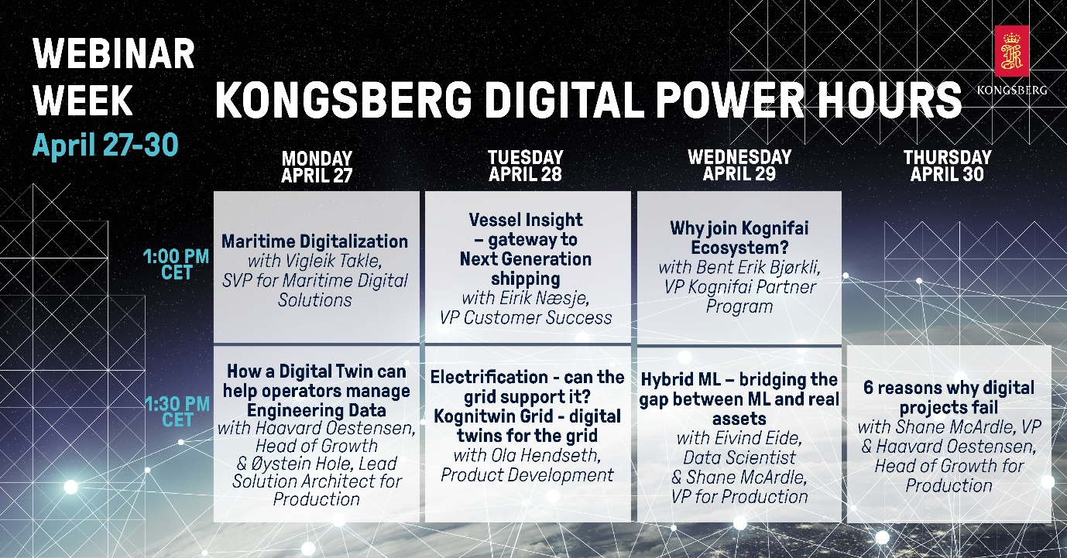
Experts from Kongsberg Digital will host a series of Power Hours for digital maritime technologies

Kongsberg, Norway, April 16th, 2020 – Kongsberg Digital are delighted to announce a week of live webinars, helping maritime professionals to stay informed and continue their professional development, wherever they are working. Open to everyone, especially those within the maritime, energy or utilities industries, the sessions offer interested parties a chance to obtain the latest information about Kongsberg Digital’s wide range of digital solutions, and to learn how digitalization can help your business.
Hosted by some of the leading experts in the industry, the webinars – which run from Monday 27th April to Thursday 30th April inclusive – take the form of lunchtime ‘Power Hours’ with two consecutive half-hour sessions, the first starting at 1:00pm CET and the second immediately afterwards at 1:30pm CET. On Thursday there is a single session at 1:30pm CET. An opportunity for Q&A is included within each webinar, making them a time-efficient way to keep abreast of current developments.
Topics include:
- Maritime Digitalization
Vigleik Takle, SVP for Maritime Digital Solutions
- How a Digital Twin can help operators manage Engineering Data
Haavard Oestensen, Head of Growth & Øystein Hole, Lead Solution Architect
- Vessel Insight – gateway to Next Generation shipping
Eirik Næsje, VP & Head of Customer Success for Maritime Digital Solutions
- Electrification – can the grid support it? Kognitwin Grid – digital twins for the grid
Ola Hendseth, Utilities Product Development
- Why join Kognifai Ecosystem?
Bent Erik Bjorkli, VP Kognifai Partner Program
- Hybrid ML – bridging the gap between ML and real assets
Eivind Eide, Data Scientist & Shane McArdle, VP of Production
- 6 reasons why digital projects fail
Shane McArdle, VP, & Haavard Oestensen, Head of Growth

The webinars are open to all, and there are no restrictions on how many you can attend. For those unable to join the live sessions, recordings will be made available.
For more information and to register your interest, click here.
Ends

For further information, please contact:

Mathilde Vik Magnussen
VP Communications & Marketing
Kongsberg Digital
Tel: +47 4567 8255
mathilde.magnussen@kdi.kongsberg.com

David Pugh
Saltwater Stone
Tel: +44 (0)1202 669244
d.pugh@saltwater-stone.com

About Kongsberg Digital
Kongsberg Digital is a provider of next-generation software and digital solutions to customers within maritime, oil and gas, and renewables and utilities. The company consists of more than 500 software experts with leading competence within the internet of things, smart data, artificial intelligence, maritime simulation, automation and autonomous operations.
Kongsberg Digital is subsidiary of KONGSBERG (OSE-ticker: KOG), an international, knowledge-based group delivering high-technology systems and solutions to clients within the oil and gas industry, subsea, merchant marine, defence and aerospace. KONGSBERG has 11.000 employees located in more than 40 countries.
Web: Kongsberg Gruppen | Kongsberg Digital
Social media: LinkedIn | Twitter | Facebook

