

News Release

Yanmar Presents X47 Express Cruiser with America’s Cup
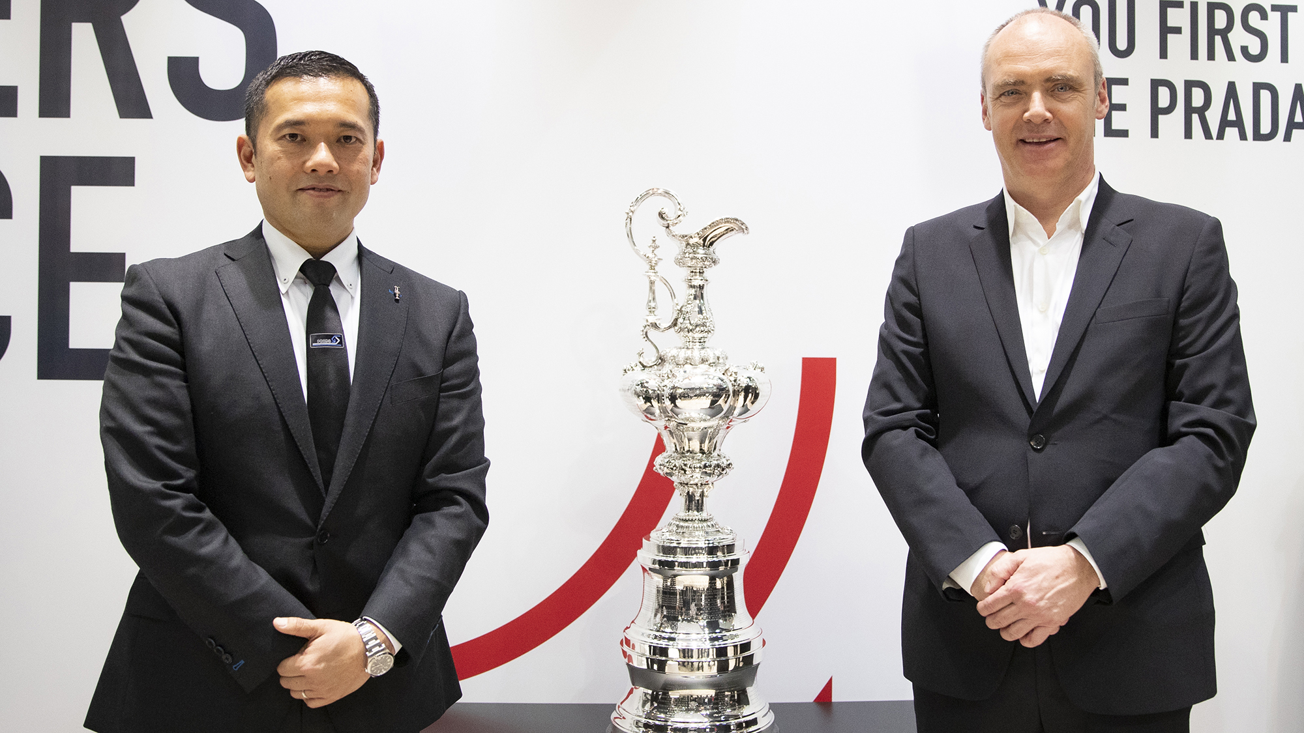
Yanmar’s Yotaro Tsuchiya and Mirko Groeschner of the Challenger of Record 36 srl
DUSSELDORF, Germany (January 19, 2020) – Yanmar – Official Marine Partner of the 36th America’s Cup presented by Prada – has revealed the first images of the company’s X47 Express Cruiser, the competition’s Official VIP Cruiser, at a media day during Boot Dusseldorf, the world’s leading water sports fair.

Yotaro Tsuchiya, head of the Yanmar Design Strategy Office joined with and Mirko Groeschner – Commercial Director at Challenger of Record 36 srl – the organisation responsible for organising the America’s Cup World Series events in Sardegna and Auckland and the Prada Cup Challenger Selection Series – to reveal this first glimpse the new X47 EXPRESS CRUISER which will support the upcoming America’s Cup events in its role as Official VIP Cruiser.

The media event also featured the first ever appearance at Boot Dusseldorf of the world’s oldest sporting trophy, the America’s Cup – courtesy of its current holders Emirates Team New Zealand – and a moderated America’s Cup panel discussion about the forthcoming 36th America’s Cup edition.

Also on display was the newest trophy in the America’s Cup family – the highly distinctive, Marc Newson-designed Prada Cup, which will be awarded to the eventual winner of the Challenger Selection Series taking place in Auckland, New Zealand in January and February of 2021, prior to the Match for the 36th America’s Cup.

Yanmar has a long association with the America’s Cup and is widely recognised for its support for the world of sailing as part of its efforts to create a society that offers exciting lives filled with rich and fulfilling experiences.

“Yanmar is a proud partner of the 36th America’s Cup presented by Prada,” said Yanmar Yotaro Tsuchiya, head of the Design Strategy Office. “Through our support as Official Marine Partner and with our flagship Express Cruiser, the X47, Yanmar is ready to contribute to the success of the America’s Cup, and seeks to share the thrill and excitement of the sea as widely as possible.”

In response, Groeschner said that the X47 was a fantastic boat and great fit for the America’s Cup.

“Yanmar has really pulled out all the stops to deliver a top-level experience,” he said. “We really appreciate the support on the water that Yanmar brings to the table, both with clean and reliable marine diesels for our support vessel and with the tremendous performance and luxury of the X47 VIP Cruiser.”

The expert panel discussion featured renowned yacht designer Dr. Martin Fischer (GER) – Co-Design Coordinator at the Italian Challenger of Record Luna Rossa Prada Pirelli Team, Thomas Riedel (GER), CEO of Riedel and Circle-O – the America’s Cup host broadcaster, and Hasso Hoffmeister (GER) – an expert in the assessment of marine structures, yachts and rigs and a member of the AC75 Class Rules Committee.

During the moderated session the trio gave their unique individual insights into the challenges facing both the teams and the event organisers as they prepare for what will be the most highly technologically advanced and spectacular edition ever of the America’s Cup.

The X47 will make its first public appearance in Cagliari, Italy on April 23 – 26 at the opening event of the three-regatta America’s Cup World Series, where the luxury craft will be front and centre as the Defender and Challenger teams race their revolutionary foiling monohull AC75s for the very first time.

Video of the Yanmar X47 Express Cruiser: https://youtu.be/x7koyfMMk_8
X47 Express Cruiser website: https://www.yanmar.com/global/about/x47/

The X47 Express Cruiser – Official VIP Cruiser of the 36th America’s Cup
Length overall (incl. pulpit) | 14.53m (47’ 8”)
Hull length | 14.25m (46’ 9”)
Beam | 4.25m (13’ 11”)
Draft (incl. props at full load) | 1.13m (3’ 8”)
Displacement (at full load) | 14.7t (32,408lbs)
Engines | Yanmar 8LV-370 x 3
Maximum speed | 40kts
Cruising speed | 33kts
Fuel capacity | 1,200L (317gal)
Exterior design | Ken Okuyama Design  Yanmar
Interior design | Ken Okuyama Design  Yanmar / Azimut
Builder | Azimut Yachts

<About Yanmar>
With beginnings in Osaka, Japan, in 1912, Yanmar was the first to succeed in making a compact diesel engine of a practical size in 1933. Then, with industrial diesel engines as the cornerstone of its enterprise, Yanmar has continued to expand its product range, services, and expertise to deliver total solutions as an industrial equipment manufacturer. As a provider of small and large engines, agricultural machinery and facilities, construction equipment, energy systems, marine equipment, machine tools, and components, Yanmar’s global business operations span seven domains.

On land, at sea, and in the city, Yanmar’s mission of “providing sustainable solutions focused on the challenges customers face, in food production and harnessing power, thereby enriching people's lives for all our tomorrows” is a testament to Yanmar's determination to provide us with “A Sustainable Future.”
For more details, please visit the official website of Yanmar Co., Ltd.,: https://www.yanmar.com/global/about/

＜NOTE＞
The contents of this news release reflect what was mentioned in the press announcement. Please be aware that the contents of this release may differ with new information and developments.

